Member Communities  Towns of Adams Boylston Florence Harrisburg Lewis Leyden Lorraine Martinsburg Montague Osceola Pinckney Redfield Rodman Turin West Turin Williamstown Worth Villages of Adams Constableville Lyons Falls Port Leyden Turin  Website: tughillcouncil.com | 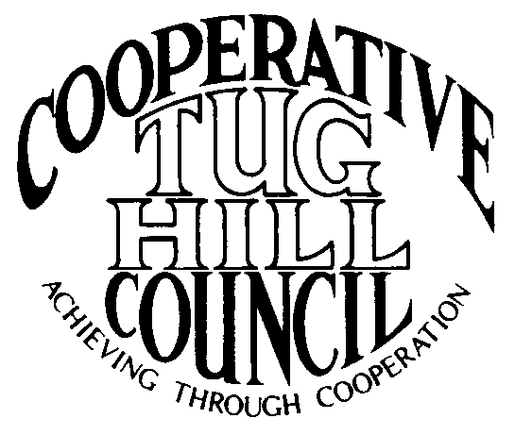 | Executive Committee  ROGER TIBBETTS, Chair  DOUGLAS DIETRICH, Vice Chair  CARLA BAUER, Secretary  IAN KLINGBAIL, Director  STEPHEN BERNAT, Director  PAULETTE WALKER, Director  FRAN YERDON, Director  Contact: Angie Kimball, Circuit Rider  PO Box 34, Redfield NY, 13437  Email: angie@tughill.org  Cell 315-599-8825

CTHC Executive Committee Meeting Minutes 3/4/2024

The meeting was held at Boylston Town Hall. The meeting was called to order at 7:02 p.m. by Chairman R. Tibbetts. Also present for the meeting were Carla Bauer, Secretary; Fran Yerdon, Director; Ian Klingbail, Director; Steve Bernat, Director; Paulette Walker, Director; Matt Johnson, Tug Hill Commission and Angie Kimball, Circuit Rider.

Minutes: The minutes of the November 28, 2023 Executive Committee meeting were reviewed by the Committee. A motion was made by R. Tibbetts (Rodman) and seconded by I. Klingbail (Lewis) to accept the minutes. All were in favor (see attached minutes).

Reports: A) Financial Report – Chairman R. Tibbetts (Rodman) presented the financial report as of January 31, 2024. Year-to Date Carry Over - $32,666.36; Receipts to date - $116.37; Distributions to Date - $1,157.38; Net Funds Available - $31,625.35. A motion was made by I. Klingbail (Lewis) and seconded by S. Bernat (Harrisburg) to accept the report as presented. All were in favor (see attached report). The proposed dues structure going forward, and the circuit rider comparison were reviewed as well (see attached). Chairman Tibbetts reported he thought that keeping the dues at $600/year should be fine for 2024.
B) Reports of Towns – A. Kimball (CR) presented the report of the Towns and reviewed the pertinent information for each (see attached report).

Tug Hill Commission Topics: A) Commission Board Appointments and New Staff- M. Johnson (THC) reported that four of the existing Commission Board members have had their appointments renewed. A new Commissioner, Bob Keller, has also been appointed and they are working on the remaining two existing appointments that need to be renewed by the Senate. A new staff person has also started named Jillian Lee. She is a project specialist and is originally from the Catskills region.
B) Outside Region Requests – There have been initial requests from Richland and Lacona, but no official requests to join a COG yet. There are also a couple of new towns who have been accepted in the RACOG area, Croghan and Watson. The latest COG map was shared (see attached). The Committee discussed if they would be interested in more communities, such as Richland or Lacona joining the CTHC, and their feelings were mixed. They didn’t know if the full council would turn down anyone asking to join but felt that the CTHC was stretched fairly thin already and more communities might require more Associate assistance.
C) Tug Hill Housing and Heating Analysis paper- They are working on this paper now. It is out for comments from various people (including Roger) and once they have these incorporated, the paper should be available soon. The Committee discussed the issues with the state push toward electrification, especially in the rural areas, including wood and other heating sources used and the cost to convert, upgrading electrical systems of old houses and grid issues.
D) 480a – They are working on an update to that paper as well, so they have the most recent numbers on hand when they speak to Legislators in Albany to continue pushing for reform of the existing legislation.
E) Planning Updates – Matt (THC) reported that they are working with Florence (solar), Lewis (zoning), Martinsburg (solar), Rodman (comp plan), Turin (solar), and Williamstown and C’Ville (first zoning laws).
F) Any Other Tug Hill Updates –None

Old Business: A) Cooperative ZBA – The draft IMAs to split into two boards are done and Angie (CR) will be visiting the towns soon about their interest in splitting into two boards. There are specific timing requirements in the current IMA for when changes can be made.
B) Any Other Old Business - none

New Business: A) Associates 2024 – A. Kimball (CR) reported Associate Beth Steria-Rush has indicated that while she is willing to work when she is in the area and available, she is looking to gradually ease out of the job. She has signed a meeting-to-meeting contract for this year. She would like to start getting the word out, just by word of mouth for now and then start to advertise if necessary. A motion was made by R. Tibbetts (Rodman) and seconded by F. Yerdon (Osceola) to start the process of looking for a new Associate Circuit Rider to replace Beth Steria-Rush. All were in favor.
B) Spring Meeting – The Committee decided on a tentative date of May 16th and approved to investigate holding the event at the Florence Hotel (as it was held at the Steak and Brew the last two events). If that venue isn’t a possibility, the Steak and Brew will be the fallback location. They discussed finding a speaker who can discuss Section 94c, solar and ag soils or another renewable topic. A. Kimball (CR) will work on setting things up.
C) 2024 Goals – The goals from 2023 were reviewed and changes were made for the proposed 2024 goals to be presented to the Council (see attached).
D) Road Issues – A. Kimball (CR) reported on some ongoing road issues in Martinsburg (individuals plowing town roads); Montague (request classification change of MM road); Redfield (logging company wanting to plow town road); Lorraine (progress getting new legislation set and process with re-approving MM roads laws) and Florence (subdivider having a contractor plow town road).
E) Any Other New Business – None

With no more business before the committee a motion was made by F. Yerdon (Osceola) and seconded by P. Walker (Boylston) to adjourn the meeting at 8:09 pm. All were in favor.

