Member Communities  Towns of Adams Boylston Florence Harrisburg Lewis Leyden Lorraine Martinsburg Montague Osceola Pinckney Redfield Rodman Turin West Turin Williamstown Worth Villages of Adams Constableville Lyons Falls Port Leyden Turin  Website: tughillcouncil.com | 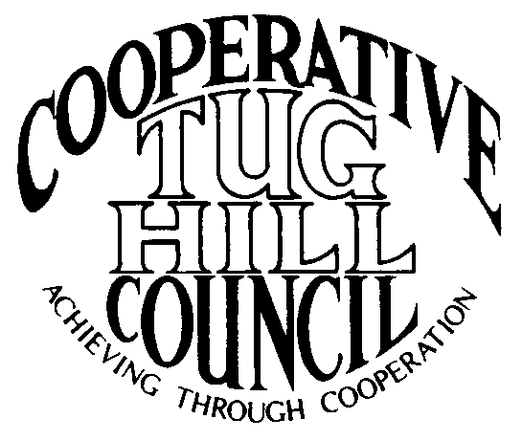 | Executive Committee  ROGER TIBBETTS, Chair  DOUGLAS DIETRICH, Vice Chair  CARLA BAUER, Secretary  IAN KLINGBAIL, Director  STEPHEN BERNAT, Director  PAULETTE WALKER, Director  FRAN YERDON, Director  Contact: Angie Kimball, Circuit Rider  PO Box 34, Redfield NY, 13437  Email: angie@tughill.org  Cell 315-599-8825

CTHC Executive Committee Meeting Minutes 11/28/2023

The meeting was scheduled to be held at the Harrisburg Municipal Building, but due to the weather the meeting was switched to a Zoom meeting. The meeting was called to order at 7:12 p.m. by Chairman R. Tibbetts. Also present for the meeting were Doug Dietrich, Vice Chairman; Fran Yerdon, Director; Ian Klingbail, Director; Steve Bernat, Director; Paulette Walker, Director; Katie Malinowski and Matt Johnson, Tug Hill Commission and Angie Kimball, Circuit Rider.

Minutes: The minutes of the August 1, 2023 Executive Committee meeting were reviewed by the Committee. A motion was made by D. Dietrich (Martinsburg) and seconded by I. Klingbail (Lewis) to accept the minutes. All were in favor (see attached minutes).

Reports: A) Financial Report – Chairman R. Tibbetts (Rodman) presented the financial report as of October 31, 2023. Year-to Date Carry Over - $37,916.56; Receipts to date - $13,705.99; Distributions to Date - $16,162.49; Net Funds Available - $35,460.06. A motion was made by D. Dietrich (Martinsburg) and seconded by I. Klingbail (Lewis) to accept the report as presented. All were in favor (see attached report). The proposed dues structure going forward, and the circuit rider comparison were reviewed as well (see attached).
B) Reports of Towns – A. Kimball (CR) presented the report of the Towns and reviewed the pertinent information for each (see attached report).

Tug Hill Commission Topics: A) Lorraine MM Roads bill – K. Malinowski (THC) reported that the minimum maintenance roads bill for Lorraine is hopefully near the finish line. The Governor’s office has proposed a chapter amendment, which was sent back to the Senate and Assembly for approval. The amendment has been approved and now we are waiting for the Governor to call the bill up. The bill must be signed by 12/31/23 or we start over.
B) Forest Carbon and Newly Elected Officials Workshops – These two workshops are coming up soon. The Forest Carbon workshop will have a landowner focus. It’s being held in Boonville on Dec. 4th. The Newly Elected workshop is with the Association of Towns, and it will be on Dec 6th, online only. They are trying to get the word out to our new officials.
C) December Commission meeting – The December Commission meeting will be Monday Dec. 11th at the Village of West Carthage.
D) Open Space Plan update – The last update of the Open Space plan was in 2016 and they are working on a new one now. She is sitting on the Region 6 and 7 committees, which are looking for priorities to add to the plan. If anyone has any ideas of projects/issues they want included, let Katie know and she will get the info to the committees.
E) G&W Workshop Review - This went well. It was held in person at West Leyden Elementary and online via Zoom. The in-person session was packed with about 175 attendees and a lot of people watching online as well.
F) Any Other Tug Hill Updates – M. Johnson (THC) reported on planning work being done in the CTHC municipalities. Constableville is working on a moratorium for certain uses while they work on their first zoning law. They may be interested in joining the Cooperative ZBA once they have zoning in place. Florence is working on zoning amendments for solar. Montague is working on zoning amendments. Osceola is working on zoning amendments for renewables and working on updating their subdivision law. Rodman is working on a comp plan, with their survey coming up soon. West Turin is working on zoning amendments regarding campgrounds. Worth is working on a zoning re-write and will be updating their subdivision law as well. They have a new planner on staff now, Chris Barboza, a former intern.

Old Business: A) Cooperative ZBA – We have interest from several other municipalities. We are looking at splitting the board into two boards, one with 4 members and one with 5 (possibly). We have talked to Phil Street and Dept. of State’s Local Government folks to get their thoughts. A. Kimball (CR) will be working with M. Johnson (THC) to get new draft IMAs prepared and hammer out the details of the new Boards.
B) Any Other Old Business - none

New Business: A) Associates 2024 – A. Kimball (CR) reported Associate Beth Steria-Rush has agreed to sign a meeting-to-meeting contract for this year to cover meetings when she is available, in the months when she is not down south or traveling. Associate Christine Healt will sign a normal Associate contract with specified meetings but has said she is amenable to covering other meetings as needed. Heidi Tompkins has also agreed to a meeting-to-meeting contract and will cover meetings as she is available and when we need help. Both Christine and Heidi have been very helpful and flexible with shifting meeting coverages as necessary and while Beth is gone. The Committee discussed raising the hourly rate for C. Healt and H. Tompkins as both are doing a good job and are flexible with helping cover meetings. A motion was made by F. Yerdon (Osceola) and seconded by S. Bernat (Harrisburg) to raise the hourly rate for Christine Healt and Heidi Tompkins to $20/hour to match Beth Steria-Rush and raise the face value of C. Healt’s contract to $5,500 to cover added meeting coverage. All were in favor.
B) Election Results to date – A. Kimball (CR) reported on the election results which are available so far (see attached sheet). There will be new Supervisors in Osceola, Redfield and Worth and a new Mayor in Port Leyden (but we don’t know who yet). There are new Town Clerks in T/Adams, Florence, Martinsburg, Montague, and Osceola. There are a couple of new Highway Superintendents and assorted new Board members. There are still several races which haven’t been called yet.
C) Newly Elected letters – The letters are ready to go out as soon as the final election results are certified (see attached letter).
D) Any Other New Business – D. Dietrich (Martinsburg) reported that a new thing, a Dollar General Market, the first in the area, is proposed to be coming to Glenfield.

With no more business before the committee a motion was made by D. Dietrich (Martinsburg) and seconded by I. Klingbail (Lewis) to adjourn the meeting at 7:44 pm. All were in favor.

