Member Communities  Towns of Adams Boylston Florence Harrisburg Lewis Leyden Lorraine Martinsburg Montague Osceola Pinckney Redfield Rodman Turin West Turin Williamstown Worth Villages of Adams Constableville Lyons Falls Port Leyden Turin  Website: tughillcouncil.com | 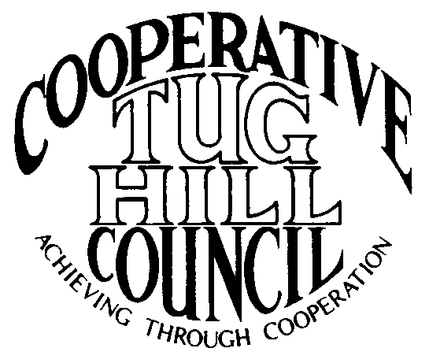 | Executive Committee  ROGER TIBBETTS, Chair  DOUGLAS DIETRICH, Vice Chair  CARLA BAUER, Secretary  IAN KLINGBAIL, Director  STEPHEN BERNAT, Director  PAULETTE WALKER, Director  FRAN YERDON, Director  Contact: Angie Kimball, Circuit Rider  PO Box 34, Redfield NY, 13437  Email: angie@tughill.org  Cell 315-480-6857  Home 315-599-8825

CTHC Executive Committee Meeting Minutes 1/26/2023

The meeting was held via Zoom due to inclement weather and was called to order at 7:12 p.m. by Chairman R. Tibbetts. Also present for the meeting were Carla Bauer, Secretary; Fran Yerdon, Director; Ian Klingbail, Director; Steve Bernat, Director; Paulette Walker, Director; Katie Malinowski and Matt Johnson, Tug Hill and Angie Kimball, Circuit Rider.

Minutes: The minutes of the August 23, 2022 Executive Committee meeting were reviewed by the Committee. A motion was made by C. Bauer (Redfield) and seconded by P. Walker (Boylston) to accept the minutes. All were in favor (see attached minutes). The minutes of the October 4, 2022 Executive Committee minutes (interview of associate circuit rider) were reviewed by the Committee. A motion was made by C. Bauer (Redfield) and seconded by F. Yerdon (Osceola) to accept the minutes. All were in favor (see attached minutes).

Reports: A) Financial Report – Chairman R. Tibbetts (Rodman) presented the financial report as of January 25, 2023. Year-to Date Carry Over - $37,916.56; Receipts to date - $0.00; Distributions to Date - $1,450.22; Net Funds Available - $36,466.34. F. Yerdon (Osceola) asked about the interest rate that the CDs with reserve funds are drawing and Chairman Tibbetts reported the 12 month CD is at .3% and the 24 month is at .41%. A motion was made by F. Yerdon (Osceola) and seconded by I. Klingbail (Lewis) to accept the report as presented. All were in favor (see attached report). The proposed dues structure going forward should be OK to leave dues at the current level for now and Chairman Tibbetts reported he had sent out the circuit rider comparison for review.
B) Reports of Towns – A. Kimball (CR) presented the report of the Towns and reviewed the pertinent information for each (See attached report).

Tug Hill Commission Topics: A) Planning Updates - M. Johnson (THC) discussed planning projects going on in the CTHC including zoning and subdivision work in Worth, zoning updates in Montague, solar and wind zoning updates in Osceola, a comp plan in Rodman and word of a possible comp plan in Adams. The mini-comp plan adoption process is moving forward.
B) 50th Anniversary – K. Malinowski outlined some plans that are in the works for the Commission’s 50th anniversary year. They include a poster contest at the schools, “throw back Thursdays” on social media, the Secretary of State will be the speaker at the Annual dinner on 10/19/23, a PBS video on the Commission and a memory recording for people to use near the time of the annual dinner.
C) MM Roads Update – The statewide low volume roads bill was reintroduced. The Climate Action Plan, which was recently released has a recommendation for the state to adopt legislation to allow MM Roads designations, which may help get some traction. Additionally, they are working on a “plan B” using the Town of Lorraine and a Home rule request for an exception to Highway Law Section 140. Assemblyman Barclay and Senator Walczyk are both on board with the new strategy. There will be resolution from Lorraine’s Board and a letter from their Highway Superintendent delivered to the legislators soon.
D) Local Leaders Survey – The survey is required by the Commission’s legislation to be conducted every five years and it is due in 2023. The survey should be out at the end of April or early May. The questions will be the same, so the results can be compared from survey to survey, they are working on delivery method.
E) Local Government Conference – Things are moving full steam ahead for the event. The dates are April 5th for an afternoon session on drones and the reception and the full day of classes on April 6th.
F) Any Other Tug Hill Updates – R. Tibbetts (Rodman talked about the green energy push in the Climate Action Plan and concerns with the cost effects on home heating in the region while trying to comply with the goals in the Climate Action Plan. He wondered about a white paper with data about costs of upgrading all of the heating systems and other home upgrades that would necessitate. K. Malinowski has started some work on this subject and shared some preliminary information.

Old Business: A) Christine Review and new schedule – A. Kimball (CR) reported that Christine Healt the newest Associate seems to be working out well at this point. Her meeting notes are prompt and very well written. The new schedule, which has had meeting coverage shifted again to take into account Christine’s location was given to the committee to review (see attached).
C) Any Other Old Business – None

New Business: A) Spring Meeting – The Committee approved to hold the spring meeting and dinner at the Steak and Brew on either April 20th or 27th A. Kimball (CR) will make the arrangements. She will talk to Kathy Saville from NYCLASS, an investment consortium, about being the speaker for the meeting.
B) Proposed Goals – The proposed 2023 goals were presented and reviewed by the committee (see attached goals). A motion was made by I. Klingbail (Lewis) and seconded by C. Bauer (Redfield) to approve the proposed goals and present them to the full council for approval. All were in favor.
C) Interest in Running for Executive Committee in 2023 – All of the existing officers present agreed to run for election for their current offices again for 2023.
D) Meeting to Meeting Contract With Another Associate – A. Kimball (CR) spoke about Heidi Kelley, who will be signing a contract with the NorCOG and SRCOG as an associate and that she would like to offer her a meeting to meeting contract to fill in when one of our Associates or herself were unable to cover a meeting. The contract would be like the one we had with Karleigh Stuckey when she stayed over a few months while we were looking for a new Associate. The committee was fine with the contract being offered if Ms. Kelley is agreeable.
E) COG Chairs – A. Kimball (CR) reported that the COG Chairs meeting was scheduled for 1/30 in Lorraine and asked if the Committee if they had anything they wanted Roger to share with the other Chairmen. I. Klingbail (Lewis) mentioned the closing of the biomass plant at Fort Drum and thought this played into the discussion about heating issues and the Climate Action Plan. He thought K. Malinowski should share the preliminary information she has been working on and had shared with them tonight.
F) Any Other New Business- A. Kimball (CR) asked the Committee about sponsoring the Local Government Conference and explained things which come with a sponsorship. The Committee discussed the matter in depth and decided they would discuss the matter at the spring meeting with the full council, but declined to sponsor the conference this year.
-F. Yerdon (Osceola) spoke about the accounting class done by Laird Petrie that he thought the class was excellent. He also commented on how valuable the contract for technical assistance with Laird has been. K. Malinowski (THC) reported that the registration for the event was full and that they most likely would offer the class again. She reported that the budgeted money for Laird’s technical assistance services was nearly all used for the year and she expected the Commission to continue to contract with Laird going forward.

With no more business before the committee a motion was made by F. Yerdon (Osceola) and seconded by S. Bernat (Harrisburg) to adjourn the meeting at 8:15 pm. All were in favor.

