Member Communities  Towns of Adams Boylston Florence Harrisburg Lewis Leyden Lorraine Martinsburg Montague Osceola Pinckney Redfield Rodman Turin West Turin Williamstown Worth Villages of Adams Constableville Lyons Falls Port Leyden Turin  Website: tughillcouncil.com | 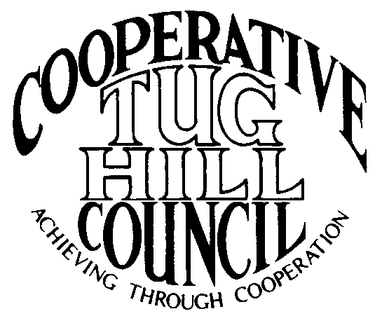 | Executive Committee  ROGER TIBBETTS, Chair  DOUGLAS DIETRICH, Vice Chair  CARLA BAUER, Secretary  IAN KLINGBAIL, Director  STEPHEN BERNAT, Director  PAULETTE WALKER, Director  FRAN YERDON, Director  Contact: Angie Kimball, Circuit Rider  PO Box 34, Redfield NY, 13437  Email: angie@tughill.org  Cell 315-480-6857  Home 315-599-8825

CTHC Executive Committee Meeting Minutes 8/23/2022

The meeting was held at the Redfield Fire Station due to primary election day and was called to order at 7:03 p.m. by Chairman R. Tibbetts. Also present for the meeting were D. Dietrich, Vice Chairman; C. Bauer, Secretary (via Zoom); F. Yerdon, Director; I. Klingbail, Director; S. Bernat, Director; P. Walker, Director; Matt Johnson, Tug Hill and A. Kimball, Circuit Rider.

Minutes: The minutes of the March 23, 2022 Executive Committee meeting were reviewed by the Committee. A motion was made by F. Yerdon (Osceola) and seconded by D. Dietrich (Martinsburg) to accept the minutes. All were in favor (see attached minutes).

Reports: A) Financial Report – Chairman R. Tibbetts (Rodman) presented the financial report as of June 30, 2022. Year-to Date Carry Over - $40,230.48; Receipts to date - $12,604.66; Distributions to Date - $7,647.07; Net Funds Available - $45,188.07. A motion was made by D. Dietrich (Martinsburg) and seconded by I. Klingbail (Lewis) to accept the report as presented. All were in favor (see attached report). The proposed dues structure going forward and the circuit rider report to date were also presented and reviewed by the Committee (see attached reports).
B) Reports of Towns – A. Kimball (CR) presented the report of the Towns and reviewed the pertinent information for each (See attached report).

Tug Hill Commission Topics: A) Upcoming Meetings - M. Johnson (THC) discussed several upcoming events including a history event about Swancott’s Mills (9/17 at West Leyden Elementary), the next Commission meeting (9/19 in Trenton), the East Branch of Fish Creek Working Group meeting (10/6 at Tavern 230 in Turin), and the Commission’s Annual dinner (10/20 at Zero Dock St. in Carthage, with a speaker from Fort Drum and invitations out next week).
B) THC Staff Updates – The Commission has hired a new Planner Matthew Smith who is working now and are interviewing to fill a Project Specialist position.
C) Information from the Last THC Retreat – Commissioners and staff at the Commission met recently for their annual retreat at the new Osceola Ski Center. They heard from Jack Santamour, who is a forester from Land Vest who will be managing the former Mulpus properties for the new owners Blue Source. He spoke about their plans to mainly manage the lands for carbon credits and that they are working on an inventory of the properties now. Additionally Dr. Scott Steiger from SUNY Oswego spoke about a lake effect snow and lightning study that they with some partners will be conducting on Tug Hill this winter. They are studying the lightning on Tug Hill during lake effect snow events and trying to determine why it strikes more over land than over the lake as it did in the past. They are hypothesizing the possibility of the wind towers having an effect on the lightning striking more frequently inland. They are looking for volunteers to host lightning sensors and may need help with retrieval of the equipment on the weather balloons which will launch during storms.
D) Any Other Tug Hill Updates – The Planning Dept. is working with Leyden on solar, Worth on zoning and subdivision updates, Montague on solar, Worth on a comp plan soon, Martinsburg on a comp plan update soon, and some possible changes to the Cooperative ZBA.

Old Business: A) Letter to TH Commissioners about Sages – A. Kimball (CR) reported that a draft letter about the Tug Hill Commissioners considering another round of Sages has gone out – no news.
C) Any Other Old Business – There was a question about solar PILOTs. R. Tibbetts (Rodman) talked about the issues and the back and forth between the Assessors and NYSERDA/NYS Tax and Finance about the new assessing model. There is a pending lawsuit and there is uncertainty currently if the model will be revised and about how to assess for the 2023 tax rolls on these projects.

New Business: A) Fall Meeting – The Committee approved to hold the Fall meeting and dinner at the Hideaway on either September 22nd or 29^{th.} A. Kimball (CR) will make the arrangements. She will talk to Dr. Scott Steiger to see if he would be interested in speaking about the study they will be doing this winter.
B) Budget – The proposed 2023 budget was presented by R. Tibbetts (Rodman) and reviewed by the committee (see attached budget). A motion was made by F. Yerdon (Osceola) and seconded by S. Bernat (Harrisburg) to approve the proposed budget and present it to the full council for approval. All were in favor.
C) Any Other New Business- F. Yerdon (Osceola) reported on their progress through the minimum maintenance road local laws. They have spent the money to make the first certified mailing ($680) and have a landowner threatening to sue if they proceed. That leaves them with the option to go forward and possibly get sued or change the proposed classifications to remove the road in questions and have to do the certified mailing again. He is unsure if they will continue the process or not.

With no more business before the committee a motion was made by R. Tibbetts (Rodman) and seconded by F. Yerdon (Osceola) to adjourn the meeting at 8:07 pm. All were in favor.

