Member Communities  Towns of Adams Boylston Florence Harrisburg Lewis Leyden Lorraine Martinsburg Montague Osceola Pinckney Redfield Rodman Turin West Turin Williamstown Worth Villages of Adams Constableville Lyons Falls Port Leyden Turin  Website: tughillcouncil.com | 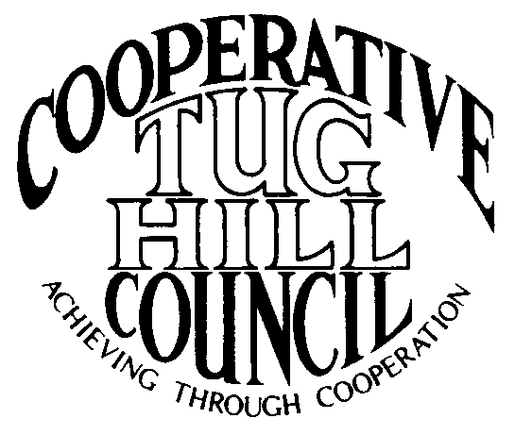 | Executive Committee  ROGER TIBBETTS, Chair  DOUGLAS DIETRICH, Vice Chair  CARLA BAUER, Secretary  IAN KLINGBAIL, Director  STEPHEN BERNAT, Director  PAULETTE WALKER, Director  FRAN YERDON, Director  Contact: Angie Kimball, Circuit Rider  PO Box 34, Redfield NY, 13437  Email: angie@tughill.org  Cell 315-480-6857  Home 315-599-8825

CTHC Spring Dinner Meeting Minutes 05/19/2022

The meeting was called to order following dinner at 7:00 p.m. by Chairman R. Tibbetts. Roll Call of Towns showed 12 towns and two villages in attendance for the meeting with representatives from Constableville, Harrisburg, Lewis, Leyden, Martinsburg, Montague, Osceola, Redfield, Rodman, Town and Village of Turin, West Turin, Williamstown and Worth present. Also present as guests were one member of the Tug Hill staff, and nine other guests for a total attendance of 33 people. Introductions of attendees followed roll call and Kelley Martin, new Associate Circuit Rider was introduced and welcomed. A break was then taken for dinner and the meeting was reconvened at 8:03 p.m.

Minutes: The minutes from September 30, 2021, were reviewed (see attached). A motion was made by B. Williams (Montague) and seconded by V. Witzigman (Osceola) to accept the minutes as presented. All were in favor.

Reports: Financial Report – A copy of the Financial Report as of May 19, 2022, was presented by Chairman R. Tibbetts (Rodman) for review by members (see attached). Year-to-Date Carryover: $40,230.48; Receipts to Date: $12,602.88; Distributions to Date: $4,742.29; Current Net Funds Available: $48,091.07. Following review, a motion was made by G. Buckingham (V/Turin) and seconded by V. Witzigman (Osceola) to accept the report as presented. All were in favor.

Election of Officers: Slate of Officers: Roger Tibbetts, Chairman
Doug Dietrich, Vice Chairman
Carla Bauer, Secretary
Stephen Bernat, Director
Ian Klingbail, Director
Paulette Walker, Director
Fran Yerdon, Director
The Slate of Officers was presented as above. There were no nominations from the floor after three requests. A motion was made by T. Thisse (Martinsburg) and seconded by G. Buckingham (V-Turin) to close the pols and have the Secretary cast one ballot for the slate of officers as presented. All were in favor.

Old Business: Any old business - None
New Business: Proposed Work Goals for 2022- The proposed work goals for 2022 were presented, there were no changes from the 2021 goals (see attached). A motion was made by B. Williams (Montague) and seconded by E. Hayes (West Turin) to approve the goals as presented. All were in favor.
Special Areas-update and approval of Pinckney’s map- The map was presented for review. It was locally adopted in October of 2020 and is the final map of the original 16 towns to be updated. A resolution (see attached) was made by S. Ward (Constableville) and seconded by A. Tubolino (Worth) for the SEQR form (see attached) to be approved and signed by the Chairman and for the map to be accepted as presented and added to the regional map. All were in favor.
Any other new business - None

Tug Hill Commission Topics: Due to an outbreak of illness placing most of the Tug Hill staff in quarantine, the updates on the agenda items listed below were provided in writing and reviewed by A. Kimball (Circuit Rider) (see attached). There were also copies of a new map that the Commission’s planning staff has been working on, showing the zoning lot sizes through out the Core Forest provided. More information on this project is still to come.
a) New Staff
b) LGC 2022 and 2023
c) Minimum Maintenance roads, official road maps
d) Laird Petrie contract
e) Community Recognition awards
f) Tug Hill Commission 50th Anniversary in 2023

Speakers: Tim Hunt, Lewis County – Tug Hill Roads planning- Tim Hunt Lewis County’s Highway Superintendent spoke to the Council on the topic of Road Planning. Ryan Piche, the Lewis County Manager was scheduled to speak as well, but he had a conflict arise in his schedule. Tim spoke about the Flat Rock Rd. situation in Martinsburg which had brought up the issue of the County trying to help the towns in dealing with development pressure on some of their seasonal roads. He said the County would not be taking over any town roads, contrary to some early thoughts on the issue.
Tim reported that Lewis County has 878 miles of town roads – 503 miles of which are improved (or paved) roads and 375 miles of which were unimproved (not paved). He gave some examples on each end of the spectrum (Lowville -38 miles of roads, 81% are paved and they get ~$188,000 in CHIPs funding; Pinckney has 36 miles of roads, .64 miles of which are paved, and they receive ~$177,000). The concern with any change of ownership of these roads is potential CHIPs impacts for the towns. CHIPs funding brings $4,128,000 into the municipalities in the County.
He then talked about what the future might bring, possibly increased traffic which can cause increased need for maintenance – where is the money going to come from? There is also increasing development pressure that can threaten the status of these roads. The County proposes working with the municipalities if they are interested and look at creating in their land use planning development areas vs. protection areas.
B. Williams (Montague) spoke about their issues and road damage from ATV runs in particular and stated he would like to discuss options and help with correcting these issues.
J. Leviker (V-Turin) spoke about the increased recreation in the county leading to increased housing being bought and constructed, as well as seasonal residences being converted to full-time residents. He also spoke about a comp plan they are working on to take some of these factors into account.

Supervisor’s Topics: T. Thisse (Martinsburg) spoke about the new section of Real Property Tax Law (Section 575b) which deals with assessing models for renewable energy projects. Some of the municipalities have been talking to the County attorney about having to take some action possibly, but the new article has currently been stayed from taking effect by the first statewide court case. He encouraged the towns to be aware of the subject and be ready to stand up depending on what happens. The Town of Denmark’s assessments on the wind project there was lowered by about $1million using the new model, for example. R. Tibbetts (Rodman) spoke about the NYS Assessors Association which tried to have input on the new method with NYSERDA, but their concerns went largely unaddressed.

With no other business before the Council, a motion was made at 8:50 pm by C. Bauer (Redfield) and seconded by R. Tibbetts (Rodman) to adjourn the meeting. All were in favor.

