Member Communities  Towns of Adams Boylston Florence Harrisburg Lewis Leyden Lorraine Martinsburg Montague Osceola Pinckney Redfield Rodman Turin West Turin Williamstown Worth Villages of Adams Constableville Lyons Falls Port Leyden Turin  Website: tughillcouncil.com | 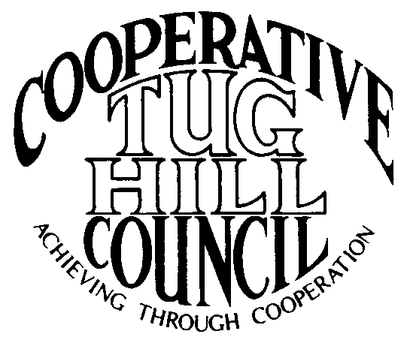 | Executive Committee  ROGER TIBBETTS, Chair  DOUGLAS DIETRICH, Vice Chair  CARLA BAUER, Secretary  IAN KLINGBAIL, Director  STEPHEN BERNAT, Director  PAULETTE WALKER, Director  FRAN YERDON, Director  Contact: Angie Kimball, Circuit Rider  PO Box 34, Redfield NY, 13437  Email: angie@tughill.org  Cell 315-480-6857  Home 315-599-8825

CTHC Executive Committee Meeting Minutes 3/23/2022

The meeting was held at the Martinsburg Municipal Building and was called to order at 7:00 p.m. by Chairman R. Tibbetts. Also present for the meeting were D. Dietrich, Vice Chairman; C. Bauer, Secretary (via Zoom); F. Yerdon, Director; I. Klingbail, Director; S. Bernat, Director; P. Walker, Director; and A. Kimball, Circuit Rider. The Board conducted an interview with Kelley Martin for the Associate Circuit Rider position until 7:45 p.m. (K. Martin resume and notes from interview attached).

Minutes: The minutes of the December 2, 2021, Executive Committee meeting were reviewed by the Committee. A motion was made by F. Yerdon (Osceola) and seconded by I. Klingbail (Lewis) to accept the minutes. All were in favor (see attached minutes).

Reports: A) Financial Report – Chairman R. Tibbetts (Rodman) presented the financial report as of March 15, 2022. Year-to Date Carry Over - $40,230.48; Receipts to date - $5,401.16; Distributions to Date - $1,993.91; Net Funds Available - $43,637.73. A motion was made by P. Walker (Boylston) and seconded by I. Klingbail (Lewis) to accept the report as presented. All were in favor (see attached report). The proposed dues structure going forward was also presented and reviewed by the Committee (see attached reports).
B) Reports of Towns – A. Kimball (CR) presented the report of the Towns and reviewed the pertinent information for each. She also discussed some regional projects which are being worked on with the municipalities and what the latest hot topics were (See attached report.)

Old Business: A) Discuss Associate CR Position/Interview: The Committee discussed Ms. Martin and outlined her assets for the position. (This portion of the minutes, conducted in closed session, have been redacted due to dealing with the employment of a particular person. The summary of the session is attached in hard copy to these minutes, not subject to Freedom of Information requests). A motion was made by F. Yerdon (Osceola) and seconded by D. Dietrich (Martinsburg) to offer a contract to Kelley Martin for the Associate Circuit Rider position. All were in favor.

B) Letter to TH Commissioners about Sages – A. Kimball (CR) reported that a draft letter about the Tug Hill Commissioners considering another round of Sages has gone out to the other circuit riders for review by the other COGs.
C) Any Other Old Business - None

New Business: A) Spring Meeting – The Committee approved to hold the Spring meeting and dinner at the Steak and Brew on May 19th. A. Kimball (CR) will make the arrangements. Tim Hunt and Ryan Piche from Lewis County would like the opportunity to speak at the meeting about road planning and solutions and the Committee agreed with that.
B) Interest in Running for Executive Committee in 2022 – All current members of the Executive Committee agreed to run for the Committee again for this year.
C) Proposed Goals – The Committee reviewed the 2021 goals and agreed to utilize the same goals for the 2022 proposed goals to present to the full Council (see attached).
D) Any Other New Business- None

With no more business before the committee a motion was made by R. Tibbetts (Rodman) and seconded by P. Walker (Boylston) to adjourn the meeting at 8:23 pm. All were in favor.

