Member Communities  Towns of Adams Boylston Florence Harrisburg Lewis Leyden Lorraine Martinsburg Montague Osceola Pinckney Redfield Rodman Turin West Turin Williamstown Worth Villages of Constableville Lyons Falls Port Leyden Turin  Website: tughillcouncil.com | 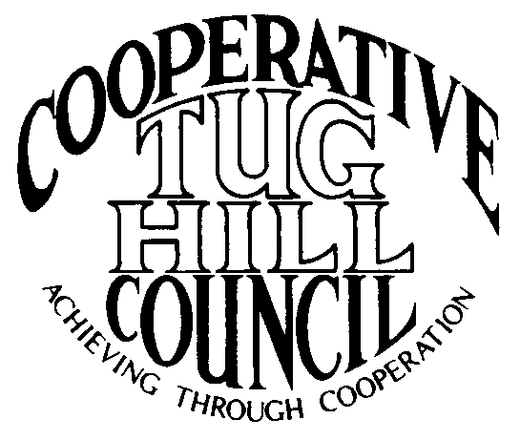 | Executive Committee  ROGER TIBBETTS, Chair  DOUGLAS DIETRICH, Vice Chair  CARLA BAUER, Secretary  IAN KLINGBAIL, Director  STEPHEN BERNAT, Director  PAULETTE WALKER, Director  FRAN YERDON, Director  Contact: Angie Kimball, Circuit Rider  PO Box 34, Redfield NY, 13437  Email: angie@tughill.org  Cell 315-480-6857  Home 315-599-8825

CTHC Fall Dinner Meeting Minutes 09/30/2021

The meeting was called to order following dinner at 7:45 pm by Chairman R. Tibbetts. Roll Call of Towns showed 13 towns and one village in attendance for the meeting with representatives from Adams, Boylston, Constableville, Harrisburg, Lewis, Leyden, Lorraine, Martinsburg, Montague, Osceola, Rodman, Turin, West Turin and Worth present. Also present as guests were three of the Tug Hill Commissioners, one member of the Tug Hill staff, and 10 other guests for a total attendance of 32 people. Introductions of attendees followed roll call.

Minutes: The minutes, with an explanation of the lack of spring meeting due to the Covid-19 pandemic, a letter to the municipalities from the Chairman and the discussing the business conducted electronically were reviewed (see attached). A motion was made by P. Walker (Boylston) and seconded by D. Dietrich (Martinsburg) to accept the minutes as presented. All were in favor.

Reports: Financial Report – A copy of the Financial Report as of September 30, 2021 was presented by Chairman R. Tibbetts (Rodman) for review by members (see attached). Year-to-Date Carryover: $38,594.24; Receipts to Date: $12,606.16; Distributions to Date: $7,795.38; Current Net Funds Available: $43,405.02. Following review, a motion was made by I. Klingbail (Lewis) and seconded by G. Churchill (Osceola) to accept the report as presented. All were in favor.

2022 Budget: The proposed 2022 budget was presented by Chairman R. Tibbetts (Rodman) (see attached). The budget showed increases in the Phone line of $50 and the Website line of $50 and a decrease of $100 in the Office/Equipment/Postage line. The total budget will remain at $15,100 with a decrease of the expected revenue from interest of $50 and the transfer from reserves increasing by $50. A motion was made by S. Bernat (Harrisburg) and seconded by N. Paradis (Worth) to accept the budget as presented. All were in favor.

Speakers: Carla Fowler and Alaina Mallette (THC) – The scheduled discussion on “Broadband Surveys and Investments in the Region” was to be delivered by Carla and Alaina remotely, but due to technical difficulties was not able to be viewed. (The presentation is available at https://tughill.org/broadband/ and this information and link to the presentation was sent out to all the municipalities the day after the meeting.)

Tug Hill Commission Topics:
Job Openings – K. Malinowski (THC) reported that they are carrying several staff vacancies at the moment and they have finally gotten the approval from the state to fill three of the vacancies. They will be looking to fill the Director of Community Projects position from which Jean Waterbury recently retired, plus entry level planner and project specialist positions. They are advertising the positions now and hope to have the new staff on by the end of the year.
Minimum Maintenance Roads Update – K. Malinowski (THC) also talked about minimum maintenance roads legislation. The bills which have been proposed for many years have never made it over the finish line. We reached out to Mark Schachner, a land use attorney to have him review the existing proposed law and the West Turin case to see if he had any new ideas. He felt that the West Turin case didn’t invalidate the existing laws as the decision was based on the very specific conditions of the case. His idea was a new strategy to create an exception within Highway Law to allow the town to not plow snow on roads listed in a properly approved minimum maintenance road law and get it approved for one or two towns first and then once the first exception is made, getting the other towns through that process. They have done some background work on making the case for a couple of towns (Montague, West Turin) and will soon be presenting the idea to our state reps to see if they will propose and support this legislation.
Other Tug Hill Updates – K. Malinowski (THC) also reported that their annual dinner will be October 14th at the Tailwater Lodge in Altmar. Reservations are still open at this point. The Fiddlers from the Hall of Fame will play and the Venerable Folks of Tug Hill display will be available for people to look at. They will also present the first Tug Hill Community Recognition Award.
-Laird Petrie has retired from the Comptroller’s office and the Commission has contracted with him to provide technical assistance to all the Tug Hill communities.
-The circuit riders are getting lots of questions about the American Rescue Plan Act (ARPA) -covid-19 funding. There is a webinar with Association of Towns scheduled for next month to try to answer questions. There are also lots of PILOT questions due to all the new solar projects and the new valuation process for these projects. They have set up a webinar with an attorney from the Hudson Valley for November to talk about that subject.

Old Business: Associate CR Kay Chapman’s Retirement Presentation – Retired Associate Circuit Rider Kay Chapman was at the meeting and a retirement gift and certificate of appreciation for her many years of service was presented to her (copy of certificate and speech attached).
Any other old business - None

New Business:
Village of Adams Proposed Membership – The Village of Adams expressed interest in joining the CTHC. A. Kimball (CR) went to one of their meetings to explain about the Council and what services we can provide. The Village approved locally to join the CTHC and now are being proposed for approval to join the Council. A motion was made by P. Walker (Boylston) and seconded by G. Churchill (Osceola) to approve the Village of Adams join the CTHC. All were in favor. A. Kimball (CR) will draw up new IMAs adding the village and get them out to the municipalities for approval.
Introduction of Karleigh Stuckey, Associate CR – K. Stuckey started as an Associate Circuit Rider in the fall of 2019, but since the full council hasn’t met since then, this is the first opportunity to introduce her to the folks from the towns and villages that she doesn’t cover. She was introduced and said a few words to the crowd.
Any other new business - None

Supervisor’s Topics: None

With no other business before the Council, a motion was made at 8:30 pm by P. Chatterton (V-Adams) and seconded by R. Tibbetts (Rodman) to adjourn the meeting. All were in favor.

