Member Communities  Towns of Adams Boylston Florence Harrisburg Lewis Leyden Lorraine Martinsburg Montague Osceola Pinckney Redfield Rodman Turin West Turin Williamstown Worth Villages of Constableville Lyons Falls Port Leyden Turin  Website: tughillcouncil.com | 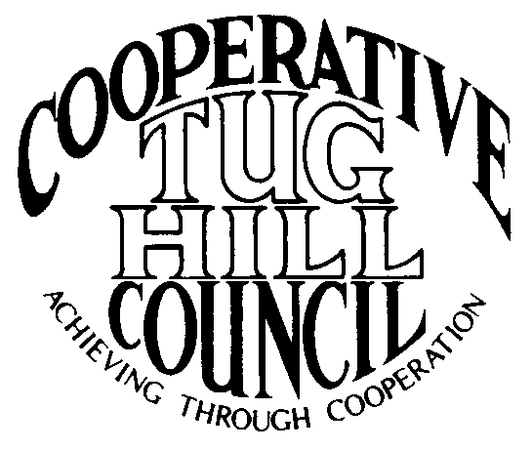 | Executive Committee  ROGER TIBBETTS, Chair  DOUGLAS DIETRICH, Vice Chair  CARLA BAUER, Secretary  IAN KLINGBAIL, Director  STEPHEN BERNAT, Director  PAULETTE WALKER, Director  FRAN YERDON, Director  Contact: Angie Kimball, Circuit Rider  PO Box 34, Redfield NY, 13437  Email: angie@tughill.org  Cell 315-480-6857  Home 315-599-8825

CTHC Spring Meeting “Minutes” 2021

In early 2020 a global health pandemic called COVID-19 hit New York State. Due to the restrictions in place concerning gathering limits, social distancing and mask wearing to help stop the spread of this virus the towns and villages of the CTHC did not gather to meet in person for the spring meeting and dinner as required by the CTHC Bylaws.

The following is the correspondence which was sent to all member municipalities explaining the situation and taking the place of the meeting:

Dear CTHC member or guest;
The CTHC Executive Committee met April 15th to discuss the viability of holding a spring meeting this year, among other matters. Currently, New York State is operating under an indoor dining limit under Executive Order 202.97. Included in that Executive Order is a requirement that for indoor gatherings, the facility may operate at no more than 75% of their maximum occupancy up to a total of 100 people and with provisions that appropriate social distancing, face coverings and cleaning protocols are observed. Masks must be worn unless seated to eat or drink and groups at tables must all be in the same party. Negative pre-tests or vaccination proof are also required for larger gatherings.
Normal attendance at one of our bi-annual meetings is generally approximately 50 people and would require a very large space to accommodate seating for people to be able to remove their masks and eat while maintaining 6 feet of distance between non-related individuals. The Executive Committee did discuss location options, but they felt that finding an appropriate space in light of the restrictions would be difficult, so at this point they have approved to cancel the spring meeting for this year in the interest of everyone's health and safety.
The CTHC bylaws require an annual meeting be held prior to May 30th each year to “evaluate performance, establish goals and objectives, elect officers, and review bylaws", so these items are generally addressed at the spring meeting each year. Due to the extraordinary circumstances surrounding the COVID-19 pandemic, meeting prior to May 30th in accordance with the bylaws is likely to be difficult if not impossible as outlined above.
The main orders of business that need to be taken care of are the approval of goals and objectives and the election of officers. The Executive Committee has approved to try and accomplish these items electronically via email/phone. They are asking each municipality to respond back to Angie with a vote on the following items:
- Slate of Officers as presented: Roger Tibbetts, Chairman
Doug Dietrich, Vice Chairman
Carla Bauer, Secretary
Steve Bernat, Director
Ian Klingbail, Director
Paulette Walker, Director
Fran Yerdon, Director
If anyone has any other nominations, please send them to Angie by May 15th or please indicate that you vote for the slate as presented. If there are nominations from the floor, a follow-up email will be sent out, so voting can be completed before May 30th.
- The proposed goals for 2021 are attached, they have just been rolled over from the 2020 goals. When you contact Angie with your vote on the officers, please also indicate if you are in favor of the goals as presented by the Executive Committee or opposed.

One final bit of news, the Village of Adams has locally approved to join the CTHC and we welcome them to the Council. The Executive Committee has approved to waive their dues for the first year as allowed in the bylaws and as we have done for our most recent members when they joined. The official vote to approve the Village of Adams joining should be done in person, so we will conduct that vote at the fall meeting and if approved we will amend the Intermunicipal Agreement after that. We extend our welcome to the Village of Adams and look forward to meeting their reps at the fall meeting. The Village will bring our total number of municipalities to 22.
Thank you for your cooperation during these continuing strange times. The Executive Committee is anticipating that a fall meeting should be feasible, so we will hopefully see you in September. You can respond to this email for your municipality’s votes on this matter or contact Angie at the phone numbers below.

By order of the CTHC Executive Committee
Angie Kimball
CTHC Circuit Rider

Following the correspondence, responses were received from 18 of the 21 CTHC municipalities. There were no additional nominations for officers from the municipalities and the vote for the proposed slate of officers was approved with a vote of Aye - 18; Nay - 0.

Additionally, no additional goals were proposed to be added to the proposed draft sent by the Executive Committee (see attached), so the 2021 goals were approved as presented with a vote of Aye - 18; Nay - 0.

There was no other business presented that needed to be addressed with additional correspondence to the membership.

