Member Communities  Towns of Adams Boylston Florence Harrisburg Lewis Leyden Lorraine Martinsburg Montague Osceola Pinckney Redfield Rodman Turin West Turin Williamstown Worth Villages of Constableville Lyons Falls Port Leyden Turin  Website: tughillcouncil.com | 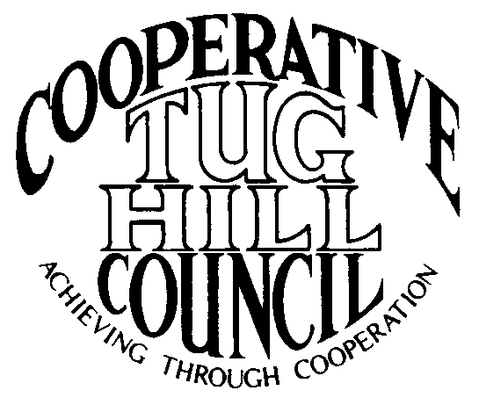 | Executive Committee  ROGER TIBBETTS, Chair  DOUGLAS DIETRICH, Vice Chair  CARLA BAUER, Secretary  IAN KLINGBAIL, Director  STEPHEN BERNAT, Director  PAULETTE WALKER, Director  FRAN YERDON, Director  Contact: Angie Kimball, Circuit Rider  PO Box 34, Redfield NY, 13437  Email: angie@tughill.org  Cell 315-480-6857  Home 315-599-8825

CTHC Executive Committee Meeting Minutes 8/24/2021

The meeting was held at the Martinsburg Municipal Building and was called to order at 7:20 p.m. by Chairman R. Tibbetts. Also present for the meeting were D. Dietrich, Vice Chairman; F. Yerdon, Director; I. Klingbail, Director; S. Bernat, Director; P. Walker, Director; K. Malinowski from the Tug Hill Commission and A. Kimball, Circuit Rider.

Minutes: The minutes of the April 15, 2021, Executive Committee meeting were reviewed by the Committee. A motion was made by I. Klingbail (Lewis) and seconded by S. Bernat (Harrisburg) to accept the minutes. All were in favor (see attached minutes).

Reports: A) Financial Report – Chairman R. Tibbetts (Rodman) reported that Terry Dack our bookkeeper is retiring. The new person is named Lee Ann Tedford and she will be working in Adams as well. He then presented the financial report as of July 31, 2021. Year-to Date Carry Over - $38,594.24; Receipts to date - $12,605.31; Distributions to Date - $5,163.85; Net Funds Available - $46,035.70. A motion was made by D. Dietrich (Martinsburg) and seconded by F. Yerdon (Osceola) to accept the report as presented. All were in favor (see attached report). The comparison of the Circuit Rider expenses and the proposed due’s structure going forward were also presented and reviewed by the Committee (see attached reports).
B) Reports of Towns – A. Kimball (CR) presented the report of the Towns and reviewed the pertinent information for each. She also discussed some regional projects which are being worked on with the municipalities and what the latest hot topics were (See attached report.)

Tug Hill Commission Topics: A) Annual Meeting: K. Malinowski (THC) reported that the annual meeting is expected to go on as planned on October 14th, in person at the Tailwater Lodge in Altmar. It will be a plated dinner rather than a buffet and they will be awarding the first Community Recognition award at the meeting.
B) Local Government Conference: They continue to discuss a LGC for 2022. There are issues with holding the conference at JCC (vaccine and mask requirements, option to cancel up to the last day). They are looking at Turning Stone Event Center as a possible alternative. They have done a survey of past attendees/vendors/sponsors to get feedback and will decide by 10/14 on if the event will go forward.
C) Minimum Maintenance Roads: K. Malinowski shared about a memo from Attorney Mark Schachner who the Commission paid to get some opinions on the minimum maintenance roads issue and possible new strategies (see attached). She also shared some preliminary analysis of West Turin and Montague (see attached) as possible test cases for new legislation making an exception to Highway Law, which then other towns would be able to use as well. F. Yerdon (Osceola) talked about an issue with National Grid placing new power poles in the existing right-of-way on one of their minimum maintenance roads and making it nearly impossible to widen the road if it ever became necessary, due to their poles being in the way. They have widened the road in question so that the poles will be placed farther back from the center of the road.
D) State Administrative Transition: With the new Governor in office, they are working through things, like who the contact person will be etc. There has been a one page “transition memo” required so far and they will be sending a welcome letter and some information on the Commission to her.
E) Other Tug Hill updates: M. Johnson (THC) sent an update on the planning projects they are working on with the CTHC municipalities: Worth-major zoning re-write; Turin-minor zoning work; Lewis - zoning and subdivision work starting soon; Osceola – Planning Board training and he has a Comp Plan webinar scheduled for October.

Old Business: A) Fall Meeting – A. Kimball (CR) gave the committee pricing and spacing options for Three Willows (Lyons Falls), Tailwater (Altmar) and Kevin’s Tug Hill Hideaway (West Leyden). Steak and Brew didn’t feel they could accommodate a group our size currently. The Committee reviewed the options and decided to book Kevin’s Tug Hill Hideaway for 9/30 for the meeting and dinner. A. Kimball (CR) will get prices from the Hideaway and send them to the committee for review and let the other venues know what has been decided.
B) Any Other Old Business - None

New Business: A) Proposed Budget for 2022 – R. Tibbetts (Rodman) presented the proposed 2022 budget for review. The total budget remains the same with some movement of funding between categories to better fit expenses. A motion was made by I. Klingbail (Lewis) and seconded by P. Walker (Boylston) to accept the budget as presented for review by the Council at the fall meeting. All were in favor (see attached).
B) Letter to TH Commissioners about Sages – There was a discussion about sending a letter to the Commissioners about doing another round of Sages. The thought is to have a five-COG sign one letter sent. A. Kimball (CR) will start drafting a letter and then coordinate with the other Tug Hill Circuit Riders on this project.
C) Any Other New Business- None

With no more business before the committee a motion was made by F. Yerdon (Osceola) and seconded by I. Klingbail (Lewis) to adjourn the meeting at 8:27 pm. All were in favor.

