Member Communities  Towns of Adams Boylston Florence Harrisburg Lewis Leyden Lorraine Martinsburg Montague Osceola Pinckney Redfield Rodman Turin West Turin Williamstown Worth Villages of Constableville Lyons Falls Port Leyden Turin  Website: tughillcouncil.com | 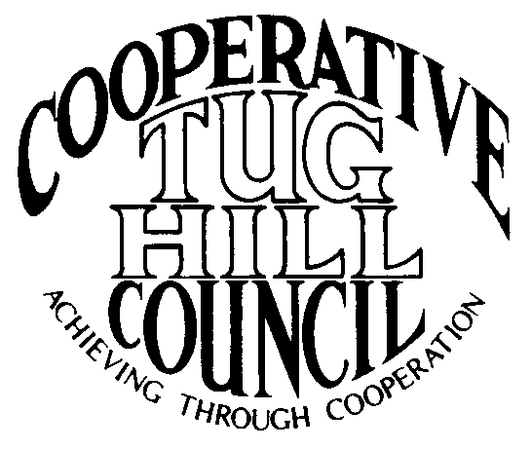 | Executive Committee  ROGER TIBBETTS, Chair  DOUGLAS DIETRICH, Vice Chair  CARLA BAUER, Secretary  IAN KLINGBAIL, Director  STEPHEN BERNAT, Director  PAULETTE WALKER, Director  FRAN YERDON, Director  Contact: Angie Kimball, Circuit Rider  PO Box 34, Redfield NY, 13437  Email: angie@tughill.org  Cell 315-480-6857  Home 315-599-8825

CTHC Executive Committee Meeting Minutes 4/15/2021

The meeting was held via Zoom and called to order at 6:32 p.m. by Chairman R. Tibbetts. Also present for the meeting were C. Bauer, Secretary; F. Yerdon, Director; I. Klingbail, Director; S. Bernat, Director; M. Johnson from the Tug Hill Commission and A. Kimball, Circuit Rider.

Minutes: The minutes of the January 28, 2021 Executive Committee meeting were reviewed by the Committee. A motion was made by C. Bauer (Redfield) and seconded by R. Tibbetts (Rodman) to accept the minutes. All were in favor (see attached minutes).

Reports: A) Financial Report – Chairman R. Tibbetts (Rodman) presented the financial report as of March 31, 2021. Year-to Date Carry Over - $38,594.24; Receipts to date - $10,201.63; Distributions to Date - $1,966.33; Net Funds Available - $46,829.54. A motion was made by S. Bernat (Harrisburg) and seconded by I. Klingbail (Lewis) to accept the report as presented. All were in favor (see attached report). The comparison of the Circuit Rider expenses and dues paid to date and the proposed dues structure going forward were also presented and reviewed by the Committee (see attached reports).
B) Reports of Towns – A. Kimball (CR) presented the report of the Towns and reviewed the pertinent information for each. She also discussed some regional projects which are being worked on with the municipalities such as the official map update project, and the Lorraine-Worth court consolidation (See attached report.)

Tug Hill Commission Topics: A) Community Recognition award: M. Johnson (THC) outlined the new award that the Commission will be giving out this year in recognition of community accomplishments. Projects can be submitted by municipalities or community groups. The decision will be made by the Commission and the COG Chairs.
B) Mini-comp plans: M. Johnson gave an update on the progress of getting the mini-comp plans adopted by the municipalities. So far, Redfield, Worth and West Turin have adopted by resolution, Pinckney is in process and the process has been mentioned in Harrisburg, Osceola and Boylston.
C) Other Tug Hill updates: None

Old Business: A) Spring Meeting Decision – The Committee discussed the possibility of a spring meeting and decided that due to safety and spacing concerns at any restaurant facility due to the continuing COVID 19 pandemic restrictions that they would not hold a spring meeting. They approved to conduct election of officers in the same manner as last year, in writing via email.
B) Village of Adams and Meeting Schedule: The Village of Adams has locally approved to join the CTHC and since we can not have a meeting to officially approve their membership until the fall meeting, A. Kimball (CR) and the Associates have begun covering their meetings on a provisional basis until the CTHC can act. In the past the dues for new members first year of membership has been waived by the Executive Committee and they approved to waive the initial years membership for the Village of Adams. A. Kimball (CR) reviewed the updated meeting coverage schedule for 2021 and a possible schedule for 2022 (see attached).
C) Any Other Old Business - None

New Business: A) COG Subscription to Zoom: A. Kimball (CR) reported that the Commission may be lowering their Zoom subscription level and discussed the possibility of the COG purchasing a subscription or possibly sharing licenses with the other COGs if the virtual meetings continue. The cost of a single license, without the transcription feature is $149/year. More details to follow as things progress.
B) 2020 “Minutes” for the COG meetings: The Board reviewed the explanation for the lack of the spring and fall meetings of 2020 and the outcome of the actions taken in writing (see attached). A motion was made by F. Yerdon (Osceola) and seconded by I. Klingbail (Lewis) to accept the “minutes” as presented. All were in favor.
C) Any Other New Business- R. Tibbetts (Rodman) reported that the Tug Hill Tomorrow Land Trust (THTLT)recently had some land in Lorraine donated to them by a doctor. Pure Water for Life (which he is on the Board of and was formed to fight the Rodman landfill) had a fund balance still and decided to donate $30,000 to THTLT to use at the new property to develop trails, parking areas etc. to make the property accessible to the public.
-F. Yerdon (Osceola) spoke about a land use issue in the town where 2 structures were placed very close to the Salmon River, in opposition to their zoning law and their special areas designations. They have had some difficulties dealing with the County codes office and the new Enforcement Officer.
-S. Bernat (Harrisburg) asked a question about solar and if the increase in value is placed on the project owner or the property owner and R. Tibbetts (Rodman) answered that it depended on the individual circumstances of the case. I. Klingbail (Lewis) also asked a question about solar development and the regulations in the new state legislation, which were answered by M. Johnson (THC).

With no more business before the committee a motion was made by F. Yerdon (Osceola) and seconded by I. Klingbail (Lewis) to adjourn the meeting at 7:15 pm. All were in favor.

