Member Communities  Towns of Adams Boylston Florence Harrisburg Lewis Leyden Lorraine Martinsburg Montague Osceola Pinckney Redfield Rodman Turin West Turin Williamstown Worth Villages of Constableville Lyons Falls Port Leyden Turin  Website: tughillcouncil.com | 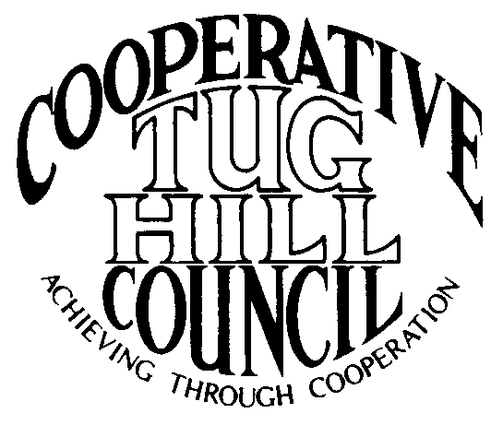 | Executive Committee  ROGER TIBBETTS, Chair  DOUGLAS DIETRICH, Vice Chair  CARLA BAUER, Secretary  IAN KLINGBAIL, Director  STEPHEN BERNAT, Director  PAULETTE WALKER, Director  FRAN YERDON, Director  Contact: Angie Kimball, Circuit Rider  PO Box 34, Redfield NY, 13437  Email: angie@tughill.org  Cell 315-480-6857  Home 315-599-8825

CTHC Spring Meeting “Minutes” 2020

In early 2020 a global health pandemic called COVID-19 hit New York State. Due to the restrictions in place concerning gathering limits, social distancing and mask wearing to help stop the spread of this virus the towns and villages of the CTHC did not gather to meet in person for the spring meeting and dinner as required by the CTHC Bylaws.

The following is the correspondence which was sent to all member municipalities explaining the situation and taking the place of the meeting:

Dear CTHC member or guest;

On April 16th Governor Cuomo extended the “NY on Pause” order keeping non-essential businesses closed and encouraging people to stay at home through May 15th. This means that the date of April 30th for the CTHC spring meeting is no longer viable and that event has been cancelled. Rather than trying to set another date amidst the current uncertainty, the CTHC Executive Committee has decided that postponing the meeting indefinitely is the wisest course at this point in time.

The CTHC bylaws require an annual meeting be held prior to May 30th each year to “evaluate performance, establish goals and objectives, elect officers, and review bylaws", so these items are generally addressed at the spring meeting each year. Due to the extraordinary circumstances surrounding the COVID-19 pandemic, meeting prior to May 30th in accordance with the bylaws is likely to be difficult if not impossible.

The main orders of business that need to be taken care of are the approval of goals and objectives and the election of officers. The Executive Committee has approved to try and accomplish these items electronically via email/phone. They are asking each municipality to respond back to Angie with a vote on the following items:

- Slate of officers as presented: Roger Tibbetts, Chairman
Doug Dietrich, Vice Chairman
Carla Bauer, Secretary
Steve Bernat, Director
Ian Klingbail, Director
Paulette Walker, Director
Fran Yerdon, Director

If anyone has any other nominations, please send them to Angie by April 30th or please indicate that you vote for the slate as presented. If there are nominations from the floor, a follow-up email will be sent out, so voting can be completed before May 30th.

- The proposed goals for 2020 are attached. When you contact Angie with your vote on the officers, please also indicate if you are in favor of the goals as presented by the Executive Committee or opposed.

Thank you for your cooperation during these strange times and if by any chance a meeting/dinner is possible by the end of May we will contact you and conduct these matters again in person at that time. You can respond to this email for your municipality’s votes on this matter or contact Angie at the phone numbers below.

By order of the CTHC Executive Committee

Angie Kimball
CTHC Circuit Rider

Following the correspondence, responses were received from 20 of the 21 CTHC municipalities. There were no additional nominations for officers from the municipalities and the vote for the proposed slate of officers was approved with a vote of Aye - 20; Nay - 0.

Additionally, no additional goals were proposed to be added to the proposed draft sent by the Executive Committee (see attached), so the 2020 goals were approved as presented with a vote of Aye - 20; Nay - 0.

There was no other business presented that needed to addressed with additional correspondence to the membership.

