Member Communities  Towns of Adams Boylston Florence Harrisburg Lewis Leyden Lorraine Martinsburg Montague Osceola Pinckney Redfield Rodman Turin West Turin Williamstown Worth Villages of Constableville Lyons Falls Port Leyden Turin  Website: tughillcouncil.com | 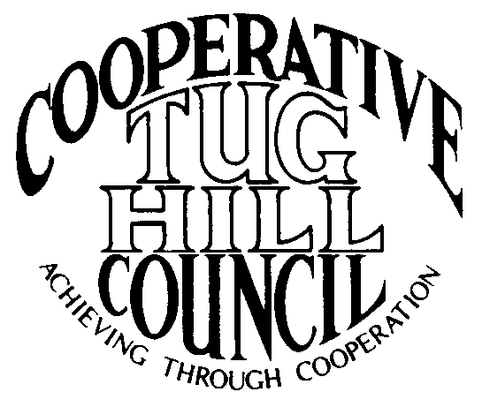 | Executive Committee  ROGER TIBBETTS, Chair  DOUGLAS DIETRICH, Vice Chair  CARLA BAUER, Secretary  IAN KLINGBAIL, Director  STEPHEN BERNAT, Director  PAULETTE WALKER, Director  FRAN YERDON, Director  Contact: Angie Kimball, Circuit Rider  PO Box 34, Redfield NY, 13437  Email: angie@tughill.org  Cell 315-480-6857  Home 315-599-8825

CTHC Fall Meeting “Minutes” 2020

In early 2020 a global health pandemic called COVID-19 hit New York State. Due to the continuing restrictions in place concerning gathering limits, social distancing and mask wearing to help stop the spread of this virus the towns and villages of the CTHC did not gather to meet in person for the fall meeting and dinner as required by the CTHC Bylaws.

The following is the correspondence which was sent to all member municipalities explaining the situation and taking the place of the meeting:

Dear CTHC member or guest;
The CTHC Executive Committee met September 22nd to discuss the viability of holding a fall meeting this year, among other matters. Currently, New York State is operating under a non-essential gathering limit of 50 people under Executive Order 202.45 for regions in Phase 4 of re-opening, such as ours. Included in that Executive Order is a requirement that for indoor gatherings, the facility may operate at no more than 50% of their maximum occupancy and with provisions that appropriate social distancing, face coverings and cleaning protocols are observed.
Normal attendance at one of our bi-annual meetings would put us very close to the 50 person limit and would require a very large space to accommodate seating for people to be able to remove their masks and eat while maintaining 6 feet of distance between non-related individuals. The Executive Committee did look into options for holding the meeting, but did not find any space that they felt would be able to safely accommodate the meeting presently, so at this point they have approved to cancel the fall meeting for this year in the interest of everyone's health and safety.
The CTHC Bylaws require one meeting in addition to the annual meeting to be held prior to October 1st "to establish the budget for the coming year" so this item is usually handled at the fall meeting. As with the essential business that had to be conducted via email/phone for the spring meeting, the Executive Committee has approved to handle the approval of the budget for 2021 in the same manner. The proposed budget for 2021 has remained unchanged from the approved budget for 2020 and is attached for your review.
Please respond back to this email or to Angie at one of the phone numbers below if your municipality is in favor or opposed to the 2021 budget as presented. Thank you for your cooperation during these unprecedented and strange times. We hope you are all staying safe and well and that we will be able to meet again in person soon.
BY ORDER OF THE CTHC EXECUTIVE COMMITTEE:"
Angie Kimball
NYS Tug Hill Commission
CTHC Circuit Rider
Following the correspondence, responses were received from 20 of the 21 CTHC municipalities. No changes were suggested from any of the municipalities to the proposed budget as sent by the Executive Committee (see attached). The proposed budget for 2021 was approved as presented with a vote of Aye – 20; Nay – 0.

There was no other business presented that needed to addressed with additional correspondence to the membership.

