Member Communities  Towns of Adams Boylston Florence Harrisburg Lewis Leyden Lorraine Martinsburg Montague Osceola Pinckney Redfield Rodman Turin West Turin Williamstown Worth Villages of Constableville Lyons Falls Port Leyden Turin  Website: tughillcouncil.com | 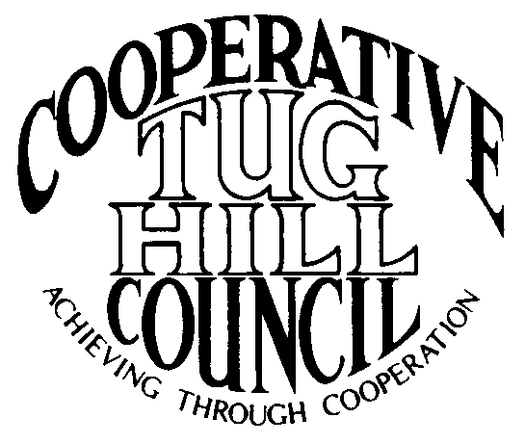 | Executive Committee  ROGER TIBBETTS, Chair  DOUGLAS DIETRICH, Vice Chair  CARLA BAUER, Secretary  IAN KLINGBAIL, Director  STEPHEN BERNAT, Director  PAULETTE WALKER, Director  VACANT, Director  Contact: Angie Kimball, Circuit Rider  PO Box 34, Redfield NY, 13437  Email: angie@tughill.org  Cell 315-480-6857  Home 315-599-8825

CTHC Fall Dinner Meeting Minutes 09/19/2019

The meeting was called to order following dinner at 7:43 pm by Chairman R. Tibbetts. Roll Call of Towns showed 13 towns and one village in attendance for the meeting with representatives from Boylston, Constableville, Florence, Harrisburg, Lewis, Leyden, Martinsburg, Montague, Osceola, Pinckney, Redfield, Rodman, West Turin and Worth present. Also present as guests were two of the Tug Hill Commissioners, three members of the Tug Hill staff, and 12 other guests for a total attendance of 45 people. Introductions of attendees followed roll call.

Minutes: The minutes of the April 25, 2019 spring meeting were reviewed (see attached). A motion was made by D. Dietrich (Martinsburg) and seconded by F. Yerdon (Osceola) to accept the minutes as presented. All were in favor.

Reports: Financial Report – A copy of the Financial Report as of September 24, 2018 was presented by Chairman R. Tibbetts (Rodman) for review by members (see attached). Year-to-Date Carryover: $40,911.12; Receipts to Date: $11,453.22; Distributions to Date: $10,187.85; Current Net Funds Available: $42,176.49. Following review, a motion was made by J. Nichols (Worth) and seconded by P. Walker (Boylston) to accept the report as presented. All were in favor.

2020 Budget: The proposed 2020 budget was presented by Chairman R. Tibbetts (Rodman) (see attached). The budget showed increases in the Coordinators line of $500 and the Meetings line of $300 and decreases of $200 in the Office/Equipment/Postage line, $50 in the telephone line, $100 in the Contingency line and $50 in the Website line. The increase in the Associate line will help cover the cost of covering our five new municipalities. The other increase in the meetings line will cover the cost of additional attendees due to the addition of our new municipalities. The total budget will increase to $15,100 with the additional income generated by increasing the transfer from reserves by $350. A motion was made by D. Dietrich (Martinsburg) and seconded by T. Yerdon (Redfield) to accept the budget as presented. All were in favor.

Speaker: Mark Gebo, Attorney – Mr. Gebo spoke about PILOTs for renewable energy systems, mainly wind projects. See his presentation (attached) for details.

Tug Hill Commission Topics:
Tug Hill Residents and Landowners Survey – K. Malinowski (THC) passed out the CTHC specific results from the Residents and Landowners survey (see attached report). The original survey was done in 2009 and this survey was conducted following the same guidelines. The survey was conducted with a sample of both full-time and seasonal residents in the same proportions as the population at large. Several pertinent sections were reviewed.
Draft THC Strategic Plan – K. Malinowski (THC) also presented a draft of the next 5-year strategic plan for the Commission. She asked the attendees to review the plan and get any comments in to her by October 14th. The plan will be submitted to the state by the end of the year after it is approved by the Commissioners.
Planner Hiring Update – K. Malinowski (THC) also reported that P. Street (THC) will be retiring by 12/31/19 or sometime near then. The hiring process for the new entry-level planner is moving forward. The new person, Alaina Mallette should be starting next Thursday if everything goes according to plan. She is a local person, from the Watertown area originally.
Minimum Maintenance Roads Update – The bill passed the Senate again this year even with the change in the majority. The bill once again stalled in the Assembly Transportation Committee, but with the change of the Chairman to Assemblyman Magnerelli, the door is hopefully open. She met with Magnerelli a couple weeks ago and the meeting seemed to be promising and she has some information to get back to him. They will keep working on it.

Tug Hill Tomorrow Land Trust – Linda Garrett from the Land Trust spoke about a Tug Hill region Farmland Protection Plan they have received a grant for and are working on. They will be doing some town visits to explain the process and how the plan when completed could help them get awarded grants for purchase/get easements for property. They have recently been awarded four grants to protect farms, two in the CTHC area, one in Martinsburg and one in the Rodman/Adams area.

Old Business: Associate CR Kay Chapman’s Retirement – The Executive Committee is searching for a replacement for K. Chapman currently. There is an interview with one of the candidates next week. Stay tuned for more information.
Director Vacancy – A. Kimball (CR) reported that she had spoken to Fran Yerdon from Osceola about temporarily filling the Director vacancy until the next election and he agreed to do it if the Council approved. A motion was made by C. Bauer (Redfield) and seconded by G. Churchill (Osceola) to appoint Fran Yerdon to the Director vacancy for the remainder of the term. All were in favor.
Any other old business - None

New Business: Any new business - None

Supervisor’s Topics: None

With no other business before the Council, a motion was made at 9:03 pm by P. Walker (Boylston) and seconded by R. Tibbetts (Rodman) to adjourn the meeting. All were in favor.

