Member Communities  Towns of Adams Boylston Florence Harrisburg Lewis Leyden Lorraine Martinsburg Montague Osceola Pinckney Redfield Rodman Turin West Turin Williamstown Worth Villages of Constableville Lyons Falls Port Leyden Turin  Website: tughillcouncil.com | 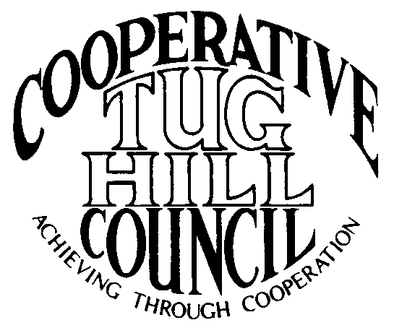 | Executive Committee  ROGER TIBBETTS, Chair  DOUGLAS DIETRICH, Vice Chair  CARLA BAUER, Secretary  IAN KLINGBAIL, Director  STEPHEN BERNAT, Director  PAULETTE WALKER, Director  FRAN YERDON, Director  Contact: Angie Kimball, Circuit Rider  PO Box 34, Redfield NY, 13437  Email: angie@tughill.org  Cell 315-480-6857  Home 315-599-8825

CTHC Executive Committee Meeting Minutes 3/24/2020

The meeting, which was held via conference call due to the COVID-19 pandemic was called to order at 7:00 p.m. by Chairman R. Tibbetts. Also present for the meeting were D. Dietrich, Vice Chair; C. Bauer, Secretary; F. Yerdon, Director; P. Walker, Director; S. Bernat, Director; I. Klingbail, Director; M. Johnson and K. Malinowski from the Tug Hill Commission and A. Kimball, Circuit Rider.

Minutes: The minutes of the December 5, 2019 Executive Committee meetings were reviewed by the Committee. A motion was made by F. Yerdon (Osceola) and seconded by D. Dietrich (Martinsburg) to accept the minutes. All were in favor (see attached minutes).

Reports: A) Financial Report – Chairman R. Tibbetts (Rodman) presented the financial report as of March 12, 2020. Year-to Date Carry Over - $35,698.40; Receipts to date - $8.51; Distributions to Date - $2, 485.507; Net Funds Available - $33,221.84. A motion was made by C. Bauer (Redfield) and seconded by I. Klingbail (Lewis) to accept the report as presented. All were in favor (see attached report). The comparison of the Circuit Rider expenses to date and the proposed dues structure going forward were also presented and reviewed by the Committee. A list of the year-end budget transfers to balance the budget was presented and reviewed (see attached reports).
B) Reports of Towns – A. Kimball (CR) presented the report of the Towns and reviewed the pertinent information for each. (See attached report.)

Tug Hill Commission Topics: A) New Community Award – K. Malinowski (THC) explained the new Community Award that the Commission is looking at putting into effect. She will send out the particulars once the Commissioners approved the program. If all goes according to plan, nomination for the award would open in June with the award given out at the annual dinner in the fall (see attached).
B) Accelerated Renewables Proposal – The Governor has put in an Accelerated Renewables Proposal in as a 30-day amendment to the budget. If approved, it will mean big changes and replace the current Article 10 process with an Empire State Development led process for anything over 10 MW. There was also be changes to the Article 7 process. The stated goal is to move projects more quickly through the approval process. We don’t know yet exactly what will happen, but the plan greatly decreases local input. The Governor still expects to have the budget approved by April 1st and we’ll have to see what happens throughout the budget process. There are no one-house budgets out – everything is being done behind closed doors.
C) Solar Paper – The Commission’s new Planning for Solar Projects paper is out for towns and villages to use. There are currently lots of solar projects popping up in Jefferson and Lewis Counties, and fewer in Oswego and Oneida Counties. One of the bigger issues is the impact on agriculture. The Commission is getting lots of requests from the municipalities for help with these matters. The paper is available on the Tug Hill website.
D) Zoom ability – The Commission has purchased a subscription to the business level of Zoom. They will offer it to the towns and villages to use to hold their meetings virtually while this pandemic is going on. It will be tested out Thursday night in Copenhagen and we’ll see how it works. Staff will help with setting up meetings and using the service. D. Dietrich commented on the last Martinsburg meeting where the Council was spaced out, but they had 25 public attend, so it could become a huge problem trying to keep in person meetings small. The Commission staff has been working to get some fact sheets out on meetings, municipal employees etc. and the information on how to access the information will be in Angie’s announcements for the month.

Old Business: A) Spring meeting – The date is currently set for 4/30 at the Steak and Brew with Bob Quinn as the speaker. All members of the Executive Committee said that they would run for their positions again for 2020. A. Kimball (CR) will send invitations out by 4/1 and they will talk about the possibility of a date change or possible cancellation depending on what happens with the pandemic. She will also check with the Steak and Brew for a possible fall back date. A. Kimball (CR) will look for a retirement gift for Kay Chapman and suggestions were to look for something nautical as she will be moving full-time to their cottage by the Lake.
B) Any Other Old Business - None

New Business: A) Dues Letters – The dues letters have been sent out to the municipalities, so money should be coming in soon.
B) COG Chairs meeting Summary – A summary of the information given by CTHC at the COG Chairs meeting was given. R. Tibbetts (Rodman) reported that it was a nice meeting and he mentioned a couple of issues that were brought up in the other COGs (a new Pilot for Brookfield Energy in Orwell and RV issues cropping up in several places).
C) Reimbursement Policy Amendments – A draft of the proposed amendments to the Associate’s Reimbursement policy was presented and reviewed. A motion was made by F. Yerdon (Osceola) and seconded by S. Bernat (Harrisburg) to approve the amendments (see attached draft). All were in favor.
D) Discuss possibility of CD for reserve funds – R. Tibbetts had sent out a sheet he got with the rates for various length CDs which he got before the pandemic began. The rates have since dropped he expects. The interest from a CD would be better than the money market account. After discussion, the matter was tabled until things stabilize from the pandemic and financial upheaval it is causing.
E) Proposed Work Goals for 2020 – The proposed goals were reviewed and discussed by the Committee. They were approved to present to the full council at the spring meeting.
F) Any Other New Business- F. Yerdon (Osceola) talked about a letter he got from Stoney Creek in the Adirondacks which was talking about property rights in the park. There is currently legislation proposed in both state houses which would remove lots of property rights from landowners. It talks about minimum lot sizes for subdivisions and requirements for conservation easements and open space. It also removes waterfront rights without compensation. He wanted everyone to be aware in case something similar should crop up here.
-I. Klingbail (Lewis) spoke about the COVID-19 virus and some information on the length of time the virus can last on surfaces. He advised everyone to use care in these times.

R. Tibbetts (Rodman) thanked everyone for joining the meeting and mentioned that this might be an option for meetings going forward, especially in winter. With no more business before the committee a motion was made by F. Yerdon (Osceola) and seconded by P. Walker (Boylston) to adjourn the meeting at 8:01 pm. All were in favor.

