Member Communities  Towns of Adams Boylston Florence Harrisburg Lewis Leyden Lorraine Martinsburg Montague Osceola Pinckney Redfield Rodman Turin West Turin Williamstown Worth Villages of Constableville Lyons Falls Port Leyden Turin  Website: tughillcouncil.com | 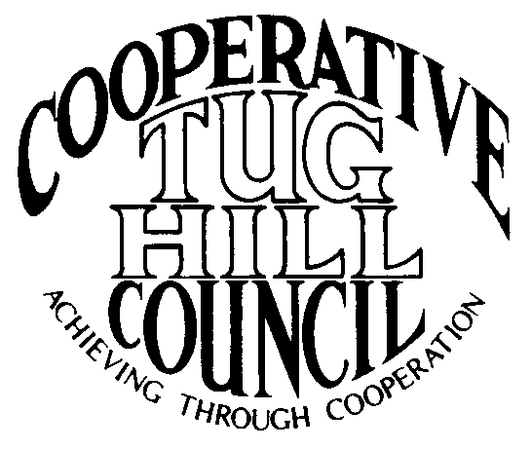 | Executive Committee  ROGER TIBBETTS, Chair  DOUGLAS DIETRICH, Vice Chair  CARLA BAUER, Secretary  IAN KLINGBAIL, Director  STEPHEN BERNAT, Director  PAULETTE WALKER, Director  FRAN YERDON, Director  Contact: Angie Kimball, Circuit Rider  PO Box 34, Redfield NY, 13437  Email: angie@tughill.org  Cell 315-480-6857  Home 315-599-8825

CTHC Executive Committee Meeting Minutes 1/28/2021

The meeting was held via Zoom and called to order at 7:11 p.m. by Chairman R. Tibbetts. Also present for the meeting were D. Dietrich, Vice Chair; C. Bauer, Secretary; F. Yerdon, Director; P. Walker, Director; S. Bernat, Director; M. Johnson from the Tug Hill Commission and A. Kimball, Circuit Rider.

Minutes: The minutes of the September 22, 2020 Executive Committee meeting were reviewed by the Committee. A motion was made by D. Dietrich (Martinsburg) and seconded by F. Yerdon (Osceola) to accept the minutes. All were in favor (see attached minutes).

Reports: A) Financial Report – Chairman R. Tibbetts (Rodman) presented the financial report as of January 27, 2021. Year-to Date Carry Over - $38,594.24; Receipts to date - $0.00; Distributions to Date - $330.93; Net Funds Available - $38,263.31. A motion was made by F. Yerdon (Osceola) and seconded by D. Dietrich (Martinsburg) to accept the report as presented. All were in favor (see attached report). The comparison of the Circuit Rider expenses to date and the proposed dues structure going forward were also presented and reviewed by the Committee (see attached reports).
B) Reports of Towns – A. Kimball (CR) presented the report of the Towns and reviewed the pertinent information for each. She also discussed some regional projects which are being worked on with the municipalities (See attached report.)

Tug Hill Commission Topics: A) RPTL 480a paper: M. Johnson (THC) and A. Kimball (CR) spoke about the latest paper the Commission has put out explaining the 480a program and impact on municipalities. A copy of the paper was sent to all the committee (see attached).
B) Broadband Project: M. Johnson (THC) reported that the existing bill has been re-proposed in the Assembly, but not yet in the Senate. He and some others at THC are working on some edits to the bill to streamline the language and make it follow Highway Law more closely. The edits also address the concern from the Assembly Transportation committee which have been hanging the bill up for years and some issues brought up by the recent Weikel decision in West Turin. He also talked about the importance of towns adopting seasonal use zoning to help buttress the minimum maintenance road laws.
C) Planning and Zoning Projects: M. Johnson (THC) spoke about the mini comp plan adoption process. They have also been working with West Turin on solar and seasonal use zoning. They have begun work with Harrisburg on solar zoning. There is also talk that Worth may update their very old zoning law and Williamstown may be looking at their first zoning law.
D) Other business: M. Johnson (THC) also reported that the Commission is in the Governor’s budget proposal and talked about some grant funding which is expected to be funded in the 2021 budget. He also spoke about the 2021 THC Annual meeting which has been tentatively scheduled for October 14th at the Tailwater Lodge in Altmar. He spoke about the new Community Recognition Award that the Commission hopes to unveil at the annual meeting and what the award entails. He reported that three of the Commission staff have been loaned out to the vaccination sites around the state part-time, so the rest of the staff has been working to cover the absences.

Old Business: A) Kay’s retirement gift – The Committee decided to send the gift to her and let her know that the next time we can get together, we will invite her to come and bring the gift, so we can do an official presentation.
B) CD for Reserve Funds – R. Tibbetts (Rodman) reported on the funds as established during the financial report.
C) Any Other Old Business - None

New Business: A) Village of Adams – R. Tibbetts (Rodman) reported that he had heard from the Village and they are considering joining the Council. A. Kimball (CR) has spoken to the Mayor and will be attending their next Board meeting to speak to the Board about the benefits of joining. The Village would be the final municipality in our area which is unaffiliated and if they join, they will bring the total of the CTHC municipalities to 22.
B) Associates contract’s 2021 – The contracts were the same as last year’s contracts and the Committee reviewed them and approved the drafts as presented (see attached).
C) Spring Meeting – interest in Executive Committee offices – All of the current Committee members agreed to run for their positions in 2021. Angie will check with Ian to make sure he intends to continue as he was not on the meeting.
D) 2021 Proposed Goals – The goals from 2020 were rolled over and the Committee reviewed the goals. They approved the draft goals to be presented to the full Council for 2021 (see attached).
E) Terry Dack Retirement – Terry is our accountant and she initially intended to be done by May. She has decided to stay until fall as she has had a hard time finding a replacement and getting training done. R. Tibbetts (Rodman) reports that he believes that she has someone in mind to replace her, but he doesn’t know who it is yet. The current salary we pay is $600 and the position hasn’t had a raise in a long time as Terry has been happy with that as it doesn’t take her long to do our books. Stay tuned for more information.
F) Any Other New Business- R. Tibbetts (Rodman) reported that he had been re-appointed as Rodman’s rep and verified that the rest of the Committee members had also been re-appointed by their Boards if necessary.
-The Committee also decided to hold off on deciding on a spring meeting until the next Executive Committee meeting to see how things have progressed regarding COVID rules.

With no more business before the committee a motion was made by S. Bernat (Harrisburg) and seconded by F. Yerdon (Osceola) to adjourn the meeting at 7:40 pm. All were in favor.

