Member Communities  Towns of Adams Boylston Florence Harrisburg Lewis Leyden Lorraine Martinsburg Montague Osceola Pinckney Redfield Rodman Turin West Turin Williamstown Worth Villages of Constableville Lyons Falls Port Leyden Turin  Website: tughillcouncil.com | 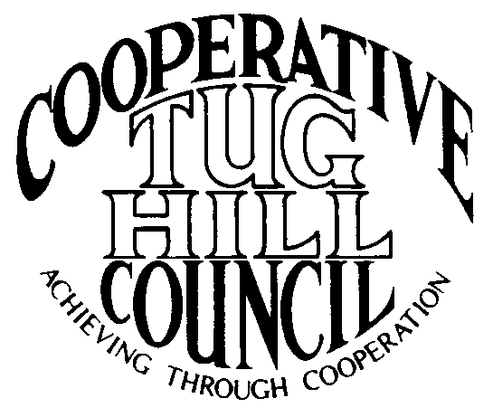 | Executive Committee  ROGER TIBBETTS, Chair  DOUGLAS DIETRICH, Vice Chair  CARLA BAUER, Secretary  IAN KLINGBAIL, Director  STEPHEN BERNAT, Director  PAULETTE WALKER, Director  FRAN YERDON, Director  Contact: Angie Kimball, Circuit Rider  PO Box 34, Redfield NY, 13437  Email: angie@tughill.org  Cell 315-480-6857  Home 315-599-8825

CTHC Executive Committee Meeting Minutes 12/5/2019

The meeting was called to order at 7:02 p.m. by Chairman R. Tibbetts. Also present for the meeting were D. Dietrich, Vice Chair; C. Bauer, Secretary; F. Yerdon, Director; P. Walker, Director; M. Johnson and P. Street from the Tug Hill Commission and A. Kimball, Circuit Rider.

Minutes: The minutes of the September 3, 2019 Executive Committee meetings were reviewed by the Committee. A motion was made by F. Yerdon (Osceola) and seconded by D. Dietrich (Martinsburg) to accept the minutes. All were in favor (see attached minutes). The minutes of the September 26, 2019 Executive Committee meeting were reviewed by the Committee. A motion was made by D. Dietrich (Martinsburg) and seconded by F. Yerdon (Osceola) to accept the minutes. All were in favor (see attached minutes).

Reports: A) Financial Report – Chairman R. Tibbetts (Rodman) presented the financial report as of December 4, 2019. Year-to Date Carry Over - $40,911.12; Receipts to date - $11,576.00; Distributions to Date - $15, 474.59; Net Funds Available - $37,012.53. A motion was made by F. Yerdon (Osceola) and seconded by P. Walker (Boylston) to accept the report as presented. All were in favor (see attached report). The comparison of the Circuit Rider expenses to date was also presented and reviewed by the Committee. Associate B. Steria is going to go over the face amount of the contract once the voucher for December arrives. A motion was made by D. Dietrich (Martinsburg) and seconded by C. Bauer (Redfield) to increase the face amount of the B. Steria contract to cover the final voucher for 2019. All were in favor (see attached comparison report).
B) Reports of Towns – A. Kimball (CR) presented the report of the Towns and reviewed the pertinent information for each. (See attached report.)
C) Any other reports - None

Tug Hill Commission Topics: A) COG Chairs Meeting Possible Dates – The proposed dates for the COG Chairs meeting are either January 22nd or January 29, with the meeting to be held in Lorraine. Chairman Tibbetts reported that he was OK with either date.
B) Minimum Maintenance Roads Strategy – The three options that have been discussed for possible bill changes were discussed. They include putting the bill forth as a regional bill, which Assemblyman Magnerelli mentioned at a meeting, however this lacks support from some of our partners (Assoc. of Towns, State Highway Super’s Assoc.). The second option is to add an opt-in by County requirement, which Senator Griffo favors, but again lacks support from the Assoc. of Towns as it takes the control out of local control and puts it at the County level. The final proposed option is to add a permissive referendum requirement to the adoption procedure in the legislation. This may be enough to gain support to get the moving through the Assembly Transportation Committee and would likely not be an impediment for our towns. It would require a “grandfather” clause for the towns with laws already on the books. The Committee would like K. Malinowski (THC) to draft a letter to Senator Griffo that they could review and approve to send with the permissive referendum option highlighted.
C) Commission Budget for Next Year – The Commission budget request for next year includes an increase in their Special Revenue Account from $50,000 to $200,000, which would allow them to carry funding over from year to year and give greater flexibility in finding new funding sources for projects. They are also asking for permission to hire another staff member at a grade 14 pay-scale. The person would hopefully be a multi-disciplinary person with skills in more than one area.

Old Business: A) Kay’s Retirement – A. Kimball (CR) asked the Committee what they would like to do for Assoc. Circuit Rider Kay Chapman’s retirement. They would like to purchase her a gift to commemorate her years of service. A. Kimball will find something appropriate at an approximate cost of $100 to be presented at the spring meeting.
B) Associate’s Contracts for 2020 – The proposed contracts for the Associate Circuit Rider’s were reviewed by the Committee. The contracts were the same as last year except for raising the contract maximum face value from $4,200 to $4,500 (see attached draft contact).
C) Any Other Old Business - None

New Business: A) Election Changes /Newly Elected Letters – The changes in local officials from the last election were presented to the Committee for review (see attached). The letters for the newly elected officials introducing the CTHC and giving our contact information and brochure should be mailed next week.
B) Spring Meeting – Possible Dates/Locations/Speakers – The Committee proposed holding the 2020 spring meeting at the Steak and Brew on 4/30 with 4/23 as a fall back date. The proposed speakers were Bob Quinn from Tug Hill Tomorrow Land Trust or possibly someone from the Conservation Fund to talk about the Kendall Tract project/purchase.
C) Any Other New Business- None

With no more business before the committee a motion was made by F. Yerdon (Osceola) and seconded by P. Walker (Boylston) to adjourn the meeting at 8:02 pm. All were in favor.

