Member Communities  Towns of Adams Boylston Florence Harrisburg Lewis Leyden Lorraine Martinsburg Montague Osceola Pinckney Redfield Rodman Turin West Turin Williamstown Worth Villages of Constableville Lyons Falls Port Leyden Turin  Website: tughillcouncil.com | 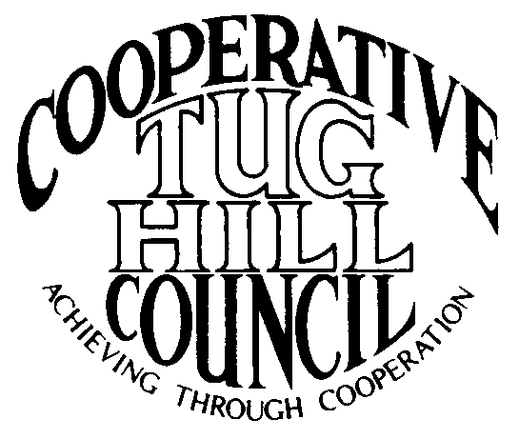 | Executive Committee  ROGER TIBBETTS, Chair  DOUGLAS DIETRICH, Vice Chair  CARLA BAUER, Secretary  IAN KLINGBAIL, Director  STEPHEN BERNAT, Director  ROSALIE WHITE, Director  PAULETTE WALKER, Director  Contact: Angie Kimball, Circuit Rider  PO Box 34, Redfield NY, 13437  Email: angie@tughill.org  Cell 315-480-6857  Home 315-599-8825

CTHC Spring Dinner Meeting Minutes 04/25/2019

The meeting was called to order at 7:35 pm by Chairman R. Tibbetts (Rodman). Roll Call of Towns/Villages showed 14 towns and 2 villages in attendance for the meeting with representatives from Adams, Boylston, Constableville, Harrisburg, Lewis, Leyden, Lorraine, Lyons Falls, Martinsburg, Montague, Osceola, Pinckney, Redfield, Rodman, Turin and West Turin present. Also present as guests were one of the Tug Hill Commissioners, two members of the Tug Hill staff, and fourteen other guests for a total attendance of 47 people. Introductions followed roll call.

Minutes: The minutes of the September 27, 2018 fall meeting were reviewed (see attached). A motion was made by D. Dietrich (Martinsburg) and seconded by P. Walker (Boylston) to accept the minutes as presented. All were in favor.

Reports: Financial Report – A copy of the Financial Report as of April 16, 2019 was presented by Chairman R. Tibbetts (Rodman) for review by members (see attached). Year-to-Date Carryover: $40,911.12; Receipts to Date: $10,814.79; Distributions to Date: $3,794.94; Current Net Funds Available: $47,930.97. Following review, a motion was made by P. Walker (Boylston) and seconded by C. Bauer (Redfield) to accept the report as presented. All were in favor.

Election of Officers: Chairman Tibbetts (Rodman) presented the proposed slate of officers for 2019 as follows: Roger Tibbetts, Chairman; Doug Dietrich, Vice Chairman; Carla Bauer, Secretary; Stephen Bernat, Director; Ian Klingbail, Director and Paulette Walker, Director; with one vacancy for Director on the slate. Chairman Tibbetts then opened the floor for nominations for any office or for the vacant Director position– there were none offered. G. Stinson (Rodman) moved that the polls be closed and that the Secretary cast one ballot for the slate of officers proposed by the Chairman (as above), seconded by D. Kellogg (Adams). All were in favor.

Speaker: The scheduled speaker for the evening, Attorney Mark Gebo, was unable to attend the meeting due to being hospitalized. He sent his regrets.

Tug Hill Commission Topics:
Minimum Maintenance Roads – K. Malinowski (THC) reported that they have been working on the legislation and have new bill numbers for the session. Things have changed in Albany following the last election, including a new Chairman for the Assembly Transportation Committee, Assemblyman Magnerelli. They have been working with statewide partners including the Association of Towns, the Adirondack Association of Towns and Villages, the NYS Town Highway Superintendent’s Association, the NYS County Highway Superintendent’s Association and the NYS Snowmobile Association. They are meeting with members of both the Senate and Assembly Rural Resources Committees and some key majority members. P. Street (THC) has also done a presentation at the Rockefeller Institute in Albany about the newest paper they have written, which is a checklist of items municipalities can take to protect roads, to bring additional light to the subject. E. Hayes (West Turin) reported that the prior Minimum Maintenance Road court case they were involved in was decided in their favor mainly on the timeliness of the filing. The same individual has now filled another lawsuit against the Town based on the validity of the law, so stay tuned.
Strategic Plan Update – K. Malinowski (THC) reported that they had solicited input at the Local Government Conference and that they are now reaching out to the COGs to get input for the Commission’s next 5-year Strategic Plan. They will be sending out a short online survey soon to their constituents. Anyone with ideas, please contact her. The current plan expires 12/31/19. She also mentioned the White Paper which they do every 5 years following the survey of local government officials. The paper has been delivered to the Governor and our State representatives. Thanks to everyone for responding.
Residents and Landowners Survey – K. Malinowski (THC) spoke about a Residents and Landowners survey which was done 10 years ago by JCC at the Commission’s behest. They would like to repeat the study again this year, starting this spring/summer. The cost to have JCC do the survey again is $21,000 and they are asking the COGs if they want to contribute to the study. No action was taken at this time.
Phil’s Retirement – K. Malinowski (THC) reported that P. Street (THC) expects to retire by 12/31/19. They are actively seeking to fill the vacancy now. M. Johnson (THC) will move up to the Director position and they hope to fill an entry-level planner position. They hope to have some overlap with Phil, Matt and the new person to help with the transition. Many people said congratulations to Phil and sent him good wishes.

Old Business: Any old business - None

New Business: Proposed Work Goals for 2019 – The proposed work goals for 2019 were presented and reviewed (see attached). A motion was made by L. Wojnowski (T/Turin) and seconded by V. Moore (Lorraine) to accept the work goals for 2019 as presented. All were in favor.
Special Areas: update and approval of Boylston’s map – The SEQR form for this action was filed out and a negative declaration was entered for the action (see attached). The “Resolution for Local Reserve Plan Amendment and Filing” was read and a motion was made by F. Yerdon (Osceola) and seconded by P. Walker (Boylston) to accept the resolution as presented (see attached) and incorporate the updated Special Areas map for Boylston into the regional map. All were in favor.
Kay’s Retirement – Associate Circuit Rider Kay Chapman has announced that she will be retiring and not accepting the Circuit Rider contract for 2020. Coordinator A. Kimball spoke about the qualifications being available on the CTHC website and asked that anyone aware of an interested person should have them contact her.
Any other new business - None

Supervisor’s Topics: G. Stinson (Rodman) spoke about the 16th annual SNIRT run, which had 4,880 people registered, of which about 950 were passengers (so about 3,800 machines). He stated it went pretty well, there were a few tickets issued, a couple of minor accidents and one DWI. He stated he thought the event was becoming more family oriented and that there was minimal damage to some roads. J. Genter (Constableville) reported that there was more than minimal damage in West Turin. There was severe damage to 3 roads which are currently closed. E. Hayes (W. Turin) said that the repairs are expected to be very costly and that there is a county-level meeting next week on the subject.

With no other business before the Council, a motion was made at 8:10 pm by V. Moore (Lorraine) and seconded by A. Stacy (Boylston) to adjourn the meeting. All were in favor.

