Member Communities  Towns of Adams Boylston Florence Harrisburg Lewis Leyden Lorraine Martinsburg Montague Osceola Pinckney Redfield Rodman Turin West Turin Williamstown Worth Villages of Constableville Lyons Falls Port Leyden Turin  Website: tughillcouncil.com | 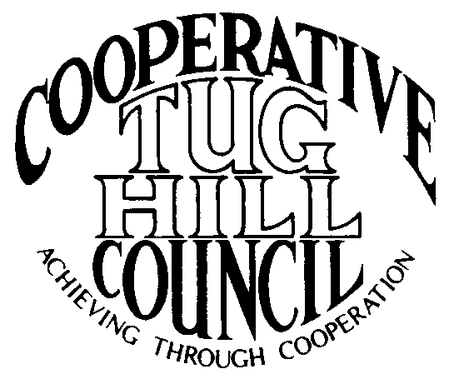 | Executive Committee  ROGER TIBBETTS, Chair  DOUGLAS DIETRICH, Vice Chair  CARLA BAUER, Secretary  IAN KLINGBAIL, Director  STEPHEN BERNAT, Director  ROSALIE WHITE, Director  PAULETTE WALKER, Director  Contact: Angie Kimball, Circuit Rider  PO Box 34, Redfield NY, 13437  Email: angie@tughill.org  Cell 315-480-6857  Home 315-599-8825

CTHC Fall Dinner Meeting Minutes 09/27/2018

The meeting was called to order at 7:04 pm by Chairman R. Tibbetts. Roll Call of Towns showed 14 towns and three villages in attendance for the meeting with representatives from Adams, Boylston, Constableville, Harrisburg, Lewis, Leyden, Lorraine, Lyons Falls, Martinsburg, Montague, Osceola, Pinckney, Port Leyden, Redfield, Rodman, Town of Turin and West Turin present. Also present as guests were one of the Tug Hill Commissioners, four members of the Tug Hill staff, and 13 other guests for a total attendance of 49 people. Introductions followed roll call and the meeting recessed at that point at 7:15 pm for dinner. The meeting reconvened at 7:57 pm and the agenda continued.

Minutes: The minutes of the April 26, 2018 spring meeting were reviewed (see attached). A motion was made by F. Yerdon (Osceola) and seconded by D. Kellogg (Adams) to accept the minutes as presented. All were in favor.

Reports: Financial Report – A copy of the Financial Report as of September 24, 2018 was presented by Chairman R. Tibbetts (Rodman) for review by members (see attached). Year-to-Date Carryover: $43,553.79; Receipts to Date: $9,644.27; Distributions to Date: $8,652.51; Current Net Funds Available: $44,545.55. Following review a motion was made by V. Moore (Lorraine) and seconded by D. Dietrich (Martinsburg) to accept the report as presented. All were in favor.

2018 Budget: The proposed 2019 budget was presented by Chairman R. Tibbetts (Rodman) (see attached). The budget showed an increase in the Associate Coordinator line of $2,200, a decrease in the office/equipment/postage line of $50, and increase in the website line of $50. The increase in the Associate line will help cover the cost of covering our five new municipalities. The other increase in the website line will cover an increase in the hosting cost of the website. The total budget will increase to $14,700 and all five of our new municipalities will be paying dues in 2019. A motion was made by D. Dietrich (Martinsburg) and seconded by G. Stinson (Rodman) to accept the budget as presented. All were in favor.

Speaker: Joseph Russell, Attorney with Barclay Damon, LLP – Mr. Russell who is the municipal attorney for several of our municipalities spoke about road issues. He spoke first about the minimum maintenance road issue. He reviewed the West Turin case, wherein the Supreme Court found the case in favor of the plaintiff. West Turin appealed to the State Court of Appeals who sidestepped and ruled in favor of West Turin on procedural grounds rather than making a determination on the actual law. In short, the issues argued by the plaintiff were 1) that the town has the lack of authority to enact such a law and 2) that towns are pre-empted from legislating due to the section of Highway Law which lists the duties of the Highway Superintendent. The defense points were 1) the state doesn’t have to give towns the authority to pre-empt laws due to their Home Rule authority and 2) the Highway Law statute has caveats in it that the Highway Superintendent duties must be carried out within the budget appropriations.
Mr. Russell then spoke about ATVs and their travel on roads. In many places they are permitted on town roads and this is forbidden in the Vehicle and Traffic Law unless an exception applies, such as a local law or ordinance being approved to open sections of roads to provide access to off-road ATV trails. Municipalities must find it “otherwise impossible” to access the trails unless the road is used and they need a record to support this contention to be defensible. T. Thisse (Martinsburg) asked “what about if a law is 6-7 years old?” to which Mr. Russell replied the law would still be subject to challenge and there is no statute of limitations to challenge the law. There were no other questions for Mr. Russell on the subject.

Tug Hill Commission Topics:
Mini Comp Plans- P. Street (THC) spoke about the fact that many of our towns don’t have official comprehensive plans, which are necessary for zoning, so he started looking at the joint planning materials that the CTHC towns have done over the years. At the spring meeting he discussed coming up with a resolution for each town to pass listing all of the joint planning work they have done (see attached list). This summer, we had an intern, John King (who was at the meeting) who packaged all of the joint planning materials in a mini comp plan for each municipality except for Leyden and Lorraine, who have individual comp plans and Adams and the four villages who have newly joined and weren’t a part of the planning done in the past. The plans were then distributed to each town that was present. M. Johnson (THC) explained that these were the beginnings of a comp plan for the towns to review. Things could be added or removed if the towns desired. They are a great start for anyone wanting to do a more specific individual plan. They include demographic information, the old planning stuff like PATH and the Resource Management Plans, inventories, goals and objectives, land use laws and maps. They drew it together into these plans which he hopes will jump start the comprehensive planning effort for the towns.
Local Leader Survey Results – P. Street (THC) handed out a summary of the survey results (see attached). The Commission is required to do a survey every five years of their local officials asking how they are doing. This time they had a 64% response rate which was great and they received at least one survey back from every Tug Hill municipality. The results will be turned into a white paper which the Commission must present to the Governor and the Legislature and that will be coming out on early 2019.

Annual Dinner – P. Street handed out copies of the invitation to the Commission’s Annual Dinner (see attached). It will be held 11/8 at the Grape and Grog in Camden. There is a new book coming out and everyone who comes to the meeting will get a free copy.

Old Business: Welcome New Members – A. Kimball (CR) welcomed our new members attending from our new municipalities including A. Klossner and J. Genter from Constableville; H. Collins from Port Leyden; D. Dolhof from Lyons Falls and D. Kellogg and M. Stone from Adams.
IMA Renewal – A. Kimball (CR) reported that all of the municipalities have approved the new Inter-Municipal Agreement (IMA) and she is just waiting for copies of the IMA with the signatures back from some of the municipalities to be able to get the copy of the IMA with everyone’s signature back to the Clerk’s to be filed. She read a list of the municipalities whose signatures she was still missing.
Any other old business - None

New Business: Any new business - None

Supervisor’s Topics: None

With no other business before the Council, a motion was made at 8:31 pm by F. Yerdon (Osceola) and seconded by T. Thisse (Martinsburg) to adjourn the meeting. All were in favor.

