Member Communities  Towns of Adams Boylston Florence Harrisburg Lewis Leyden Lorraine Martinsburg Montague Osceola Pinckney Redfield Rodman Turin West Turin Williamstown Worth Villages of Constableville Lyons Falls Port Leyden Turin  Website: tughillcouncil.com | 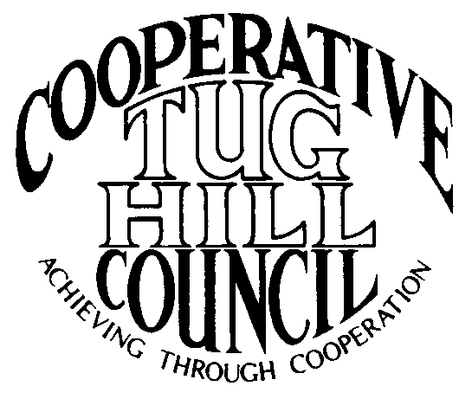 | Executive Committee  ROGER TIBBETTS, Chair  DOUGLAS DIETRICH, Vice Chair  CARLA BAUER, Secretary  IAN KLINGBAIL, Director  STEPHEN BERNAT, Director  ROSALIE WHITE, Director  PAULETTE WALKER, Director  Contact: Angie Kimball, Circuit Rider  PO Box 34, Redfield NY, 13437  Email: angie@tughill.org  Cell 315-480-6857  Home 315-599-8825

CTHC Executive Committee Meeting Minutes 8/28/2018

The meeting was called to order at 7:31 p.m. by Chairman R. Tibbetts. Also present for the meeting were D. Dietrich, Vice Chair; S. Bernat, Director; P. Walker, Director; R. White, Director; A. Kimball, Circuit Rider and P. Street from the Tug Hill Commission.

Minutes: The minutes of the June 26, 2018 Executive Committee meeting were reviewed by the Committee. A motion was made by D. Dietrich (Martinsburg) and seconded by P. Walker (Boylston) to accept the minutes. All were in favor. (See attached minutes.)

Reports: A) Financial Report – A copy of the CTHC financial report and financial projection both as of August 27, 2018 were presented by R. Tibbetts (Rodman) and reviewed by the members. Year-to-Date Carryover: $43,553.79; Receipts-to-Date: $9,638.46; Distributions-to-Date: $8,402.57; Current Net Funds Available: $44,789.68. Following review and discussion of reports a motion was made by S. Bernat (Harrisburg), seconded by R. White (Leyden) to accept the financial reports as presented. All were in favor. (See attached reports.)
B) Reports of Towns – A. Kimball (CR) presented the report of the Towns and reviewed the pertinent information for each. (See attached report.)
C) Tug Hill Updates and Project Reports:
1) Mini-Comp Plans – P. Street (THC) stated that the Commission had an intern who worked on some mini-comp plans for each CTHC town, except for the ones with existing comp plans, based on their cooperative planning work through CTHC over the years. He discussed how the Committee would like these rolled out to the towns, and the Committee felt that 2 copies for each town should be presented to each town at the fall meeting and an explanation given of the process.
2) Land Owner Survey – P. Street (THC) spoke about a Tug Hill Landowner and Resident study that the Commission funded 10 years ago that they did in conjunction with the Local Leaders Survey. It was a survey of about 1,000 landowners, split among 800 residents and 200 non-resident landowners. They would like to re-do the survey so they can look at trends since the last survey. The cost to have JCC re-do the survey with it pared down to 50 questions from 75 will be about $25,000. The Commission has about $10,000 to contribute and they will be looking for sources for the rest of the money and will most likely ask the COGs to contribute.
3) Other Tug Hill topics – P. Street (THC) concluded by mentioning that the 3 Senate appointments of Commissioners (R. Maciejko, T. Boxberger, M. Yerdon) had been renewed. The Assembly appointments are also current (L. Chereshnoski, G. Ritter, B. Scriber) and J. Bogdanowicz’s Governor’s appointment is current. There are currently 2 Governor’s appointment vacancies, so please send the word out to anyone who might be interested in applying to be a Commissioner. Also, there was a recent article in the Conservationist about the Commission’s 45th anniversary which mentions work on both the East Branch of Fish Creek project and the Kendall Tract project, both in the CTHC area, so check it out.
D) Any other reports – None

Old Business: A) Fall meeting – The Committee reviewed the draft invitation and suggested some edits prior to mailing the invitations (see attached).
B) Website updates – The initial contact information for each municipality is done on the website. A. Kimball (CR) will be finishing up any areas which need to be verified or double checked.
C) Other Old Business – None

New Business: A) Proposed Budget for 2019 – The proposed budget for 2019 was presented by R. Tibbetts (Rodman) for review by the Committee (see attached). The breakdown of the Associates costs was also presented for review (see attached). The current budget shows an increase from 2018, due to the additional costs of covering our 5 new municipalities and also of covering A. Kimball’s (CR) mileage. This increase can be covered currently without increasing dues per Chairman Tibbetts (Rodman). After review and discussion, a motion was made by D. Dietrich (Martinsburg) and seconded by P. Walker (Boylston) to approve the budget as presented for 2019 for presentation to the full Council at the fall meeting. All were in favor.
B) Any Other New Business- A. Kimball (CR) brought up the issue of an official records manager who should be filing the CTHC records. Currently the records are at her house and they should be with our official records repository, which would be the Town of Rodman, most likely as they are our fiscal agent and that is where the financial records are stored. Rodman, however, is having some issues with their own records storage due to water damage and as they have never acted in this capacity, A. Kimball (CR) suggested appointing a temporary repository to hold the records as she sorts them out until things are discussed with the full Council and Rodman. P. Walker (Boylston), who is the Records Management Officer (RMO) for her town, volunteered to have the records stored in their secure records room and act as temporary RMO pending a permanent solution. A motion was made by D. Dietrich (Martinsburg) and seconded by S. Bernat (Harrisburg) to appoint Boylston as the temporary records repository for CTHC records, with P. Walker acting as RMO. All were in favor.

With no more business before the committee a motion was made by R. White (Leyden) and seconded by P. Walker (Boylston) to adjourn the meeting at 8:48 pm. All were in favor.

