Member Communities  Towns of Boylston Florence Harrisburg Lewis Leyden Lorraine Martinsburg Montague Osceola Pinckney Redfield Rodman Turin West Turin Williamstown Worth Nonmember Villages of Constableville Lyons Falls Port Leyden Turin  Website: tughillcouncil.com | 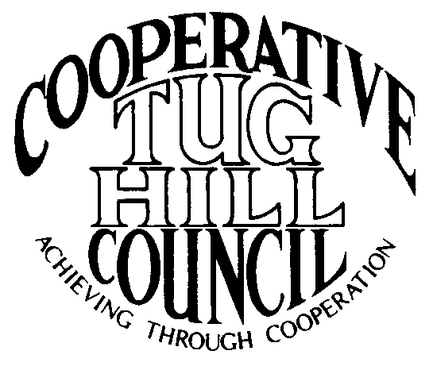 | Executive Committee  ROGER TIBBETTS, Chair  DOUGLAS DIETRICH, Vice Chair  MERIANNE SHELMIDINE, Secretary  IAN KLINGBAIL, Director  CARLA BAUER, Director  STEPHEN BERNAT, Director  ROSALIE WHITE, Director  Contact: Angie Kimball, Circuit Rider  PO Box 34, Redfield NY, 13437  Email: angela@tughill.org  Cell 315-480-6857  Home 315-599-8825

CTHC Executive Committee Meeting Minutes 11/21/2013

The meeting was called to order at 7:00 p.m. by Chairman R. Tibbetts. Present for the meeting were D. Dietrich, Vice Chairman; M. Shelmidine, Secretary; S. Bernat, Director; C. Bauer, Director; R. White, Director; A. Kimball, Circuit Rider; J. Bartow and P. Street, Tug Hill Commission. There were no introductions.

Minutes: The minutes of the July 29, 2013 Executive Committee meeting were reviewed by the Committee. A motion was made by R. Tibbetts and seconded by M. Shelmidine to accept the minutes as presented. All in favor. (See attached.)

Reports: A) Financial Report – A copy of the CTHC financial report and financial projection as of November 18, 2013 were presented by R. Tibbetts and reviewed by the members. Year-to-Date Carryover: $36,746.35; Receipts-to-Date: $9,773.64; Distributions-to-Date: $6,169.10; Current Net Funds Available: $40,350.89. Following review and discussion of reports a motion was made by C. Bauer, seconded by D. Dietrich to accept the financial reports as presented. All in favor. (See attached.)
B) Reports of Towns – A. Kimball, Circuit Rider, presented the November 2013 report of the Towns and reviewed the pertinent information for all towns (see November notes, attached)
C) Tug Hill Updates and Project Reports – P. Street presented information regarding the Audubon Society’s Bird Habitat area which has been significantly increased from the area used initially in the Special Areas project. He has some concerns with changing the maps to meet the new area. Comments were given by the Committee in regards to this matter, mainly against the new bird area. There have been some issues with confusion regarding regulatory matters etc. with the habitat areas. A motion was made by D. Dietrich and seconded by S. Bernat to remove the Audubon Society’s Bird Habitat Area from the Special Areas project. All in favor.
D) Any other reports – There were no other reports.

Old Business: Invitation to villages to join the Council - No action was taken at this time.

New Business: A) RPL 480A Exemptions Discussion: There was a discussion about the 480A program regarding how Assessors assess forest land. J. Harvill at the Commission is mapping the 480A properties in all four Counties and hopes to have the m done by early 2014. This may help the Towns to predict which properties may file for the exemption. The Commission is also working on language to send to our State Legislator’s regarding codifying the 1% shift rule (where the State makes the Towns whole if their property tax rolls shift by more than 1%) that the State currently follows but is not mandated in law at present. The State group that J. Bartow has been attending which is looking at this issue is looking at some other incentive options that wouldn’t include a property tax exemption, like perhaps an income tax benefit. R. Tibbetts is also working on paper for the Assessor’s journal on this issue and how badly the figures are skewed at present.
B) Training for Associates: R. Tibbetts reported that he has been granting permission for the Associates to go to training. He feels this is important, especially with B. Steria being new. The Committee had no issues with the Chairman approving training per his judgment.
C) Feedback From Legislator’s Meeting: J. Bartow reported that the meeting that the Commission sponsored with the State Legislative delegation went well. There was good attendance and a lively discussion. D. Dietrich reported that even though you may not learn a lot of new information at the meeting – it is a good discussion. Also learned how dysfunctional State government is and how difficult it is for our Legislators to get anything passed.
D) Newly Elected Update: A. Kimball presented a list to the members of the newly elected officials in our area (see attached). A notice of an upcoming training for Newly Elected Officials in Boonville and Parish was also passed out.
E) Industrial Forest Lands-Recent Developments: There have been many changes recently. Marcy Timberlands/TIR is selling some properties (The Conservation Fund is buying the properties for eventual sale to the State), and Mulpus is also up for sale. J. Bartow met with the Nature Conservancy in October and there will be a meeting of the PILOT parties soon. There is some rumor that South Lewis School may not sign the agreement. In 2017 there are 21 camps that will need to be removed from the Mulpus property that were a part of the East Branch of Fish Creek agreement. Recently J. Bartow, K. Malinowski and A. Kimball met with a new group called the Tug Hill Core Landowners who are concerned about this and other issues. J. Bartow feels that the East Branch of Fish Creek Working Group should be re-activated. Woodwise is currently talking to the DEC regarding a Working Forest conservation easement on 1500 acres in W. Turin. The DEC wants them to consider a bigger deal, or a fee sale to them of the property. The Council may want to talk with the Towns and get a common voice as many of these parcels cross Town boundaries.
F) Any other new business - J. Bartow reported on the preliminary results of the Local Leaders Survey. The numbers may be down slightly, overall approval rating was very high. They will be tallying the results this month to be sent out to the Governor and Legislators in January.
- D. Dietrich brought up that the members of the Executive Committee used to receive a stipend for each meeting they attend. Several years ago, the Committee members gave this up due to financial problems, and as the Council just recently gave the Associate Circuit Riders a raise he was wondering about the money. R. Tibbetts reported that the change occurred when the Circuit Rider position became a Commission employee, they no longer got grant money from the Commission and there were some temporary budget issues. The process was never started again. The newer members stated that they took the job not expecting any payment. C. Bauer suggested that perhaps in place of the stipend the Council could pay for the guests of the Executive Committee members at the annual meetings. A motion was made by D. Dietrich and seconded by M. Shelmidine for the Council to pay for the guest’s of Executive Committee member’s dinner at the two annual meetings. All in favor.

-M. Shelmidine reported that she would be away for a few months and staying in Colorado. She stated that Lorraine doesn’t intend to replace her as their CTHC rep. She expects to return no later than June.

With no more business before the Committee a motion was made by D. Dietrich and seconded by C. Bauer to adjourn the meeting at 9:42 pm. All in favor.

