Member Communities  Towns of Boylston Florence Harrisburg Lewis Leyden Lorraine Martinsburg Montague Osceola Pinckney Redfield Rodman Turin West Turin Williamstown Worth Nonmember Villages of Constableville Lyons Falls Port Leyden Turin  Website: tughillcouncil.com | 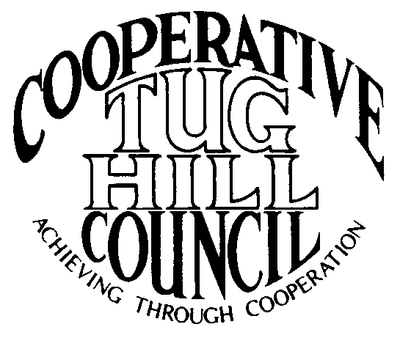 | Executive Committee  ROGER TIBBETTS, Chair  DOUGLAS DIETRICH, Vice Chair  CARLA BAUER, Secretary  IAN KLINGBAIL, Director  STEPHEN BERNAT, Director  ROSALIE WHITE, Director  PAULETTE SKINNER, Director  Contact: Angie Kimball, Circuit Rider  PO Box 34, Redfield NY, 13437  Email: angela@tughill.org  Cell 315-480-6857  Home 315-599-8825

CTHC Executive Committee Meeting Minutes 6/30/2015

The meeting was called to order at 7:06 p.m. by Chairman R. Tibbetts. Also present for the meeting were D. Dietrich, Vice Chairman; C. Bauer, Secretary; S. Bernat, Director; R. White, Director; I. Klingbail, Director; P. Skinner, Director; A. Kimball, Circuit Rider; and John Bartow, and Phil Street from the Tug Hill Commission. There were no introductions.

Minutes: The minutes of the March 5, 2015 Executive Committee meeting were reviewed by the Committee. A motion was made by D. Dietrich and seconded by C. Bauer to accept the minutes as presented. All were in favor. (See attached minutes.)

Reports: A) Financial Report – A copy of the CTHC financial report and financial projection as of June 26, 2015 were presented by R. Tibbetts and reviewed by the members. Year-to-Date Carryover: $42,027.36; Receipts-to-Date: $7,825.89; Distributions-to-Date: $3,116.83; Current Net Funds Available: $46,736.42. Following review and discussion of reports a motion was made by C. Bauer, seconded by R. White to accept the financial reports as presented. All were in favor. (See attached reports.)
B) Reports of Towns – A. Kimball presented the report of the Towns and reviewed the pertinent information for each. (See attached report.) She also discussed the progress with the proposed legislation with the Town of Lewis to change the residency requirement for their Town Justice position. The proposed bill which has passed both houses of the Legislature allows a resident from Lewis, Osceola, West Turin or Leyden to run for the Justice position in Lewis. The bill currently awaits the Governor’s approval. The Committee agreed to send a letter in support of the bill to the Governor’s office.
C) Tug Hill Updates and Project Reports:
1) Tug Hill Broadband – J. Bartow presented a survey they would like the CTHC to send out to residents in Turin, Rodman and Harrisburg regarding internet availability and usage; to allow a possible grant proposal for funding from the Governor’s Broadband Initiative funding. The project wouldn’t be part of the CFA’s but the new funding stream may be available by September, although no one knows for sure. They are talking to last mile providers and looking at the wireless network system used currently by the Akwesassnee Reservation. DANC and THC have chosen the three towns to survey based on closeness to existing fiber optic capability and the population density. S. Bernat reported that Harrisburg has a wireless type of internet access and that is nearly unusable at peak times due to slow speeds. The Committee reviewed the proposed survey and suggested changes to a couple of questions (see attached). Additionally, the cost of mailing the surveys was discussed and a suggestion was made by D. Dietrich to discuss the possibility of utilizing the Lewis County Chamber of Commerce’s bulk mailing permit to help reduce costs. Chairman Tibbetts will try and speak with them about the project, and see if they might want to contribute toward the project as well. In regards to the amount the Committee was authorized to spend towards the project, A. Kimball reviewed the minutes from the spring meeting and there were two separate resolutions approved; one allowing $1,000 to be spent on signs for the Broadband project and another allowing the Executive Committee to address the situation as they see fit. The Committee felt comfortable spending up to $1,000 for postage and other costs for the survey project and using the remainder for signs or whatever else is needed.
2) Special Area update - P. Street updated the Committee on the progress on the Special Areas project – Osceola is the next Town to be starting the update. The only two towns that have not at least started the process are Turin and Boylston. Harrisburg’s map is at the Planning Board and hopefully they will be moving soon. Leyden needs some changes done to their map and some road issues were discussed. Pinckney remains stalled on the map, but are working on a long-range road maintenance plan and THC is helping them with that.
3) Road Mapping update - P. Street also reported that the only town that has not approved their Highway map yet is Boylston, and we are working to make sure that everyone has their framed copy of their map.
4) J. Bartow Retirement – J. Bartow announced that he is retiring from State service 7/31/15. His last day in the office will be 7/15 as he has some vacation to use up. He is going to work for the Empire State Forest Products Association. The Commissioners are looking for a new executive Director and have appointed Katie Malinowski as Acting Executive Director during the search process. Chairman Tibbetts thanked John for his time and efforts on behalf of our communities and wished him good luck with his future endeavors.
D) Any other reports – None

Old Business: A) Invitation to villages to join the Council – A. Kimball reported that she had spoken to the Associate Circuit Riders and that they were amenable to possibly covering extra meetings if the Villages were to accept our invitation to join. She reported that she felt that adequate coverage could be given to the Villages should they decide to join. The Committee decided to send a letter to the four villages to see if they would like to join the CTHC.

New Business: A) Fall Meeting and Dinner – The fall meeting was discussed. The Committee decided to hold the dinner on 9/17 at the Steak and Brew in Turin. A raise for the Associates was discussed, and a motion was made by D. Dietrich and seconded by C. Bauer to raise the salary of the Associate Circuit Riders to $18 per hour for 2016. All were in favor. The Committee discussed having Liz Swearington, the Lewis County Manager as speaker to discuss efficiencies through shared services with the County. I. Klingbail will speak to her.
B) Election of Officers Question – D. Dietrich had a concern about taking nominations from the floor for officers, and presenting a slate of officers. His concern is that if there is a nomination for an office from the floor, each office would have to be done one by one and we would need written ballots. Additionally, each town would get one vote, per the bylaws. He just wanted everyone to be aware that an issue could occur.
C) Angie Vacation – A. Kimball announced that she would be on vacation from 7/5 until 7/19 so that the Committee would be aware. She will let all of the towns know and let them know that they can call on the Associate Circuit Riders with any questions that arise during her absence.
D) Performance Evaluation of Angie – with Phil – At this point A. Kimball and J. Bartow left the meeting so that P. Street could discuss A. Kimball’s job evaluation with the Executive Committee.

With no more business before the Committee a motion was made by and seconded by to adjourn the meeting at pm. All were in favor.

