Member Communities  Towns of Boylston Florence Harrisburg Lewis Leyden Lorraine Martinsburg Montague Osceola Pinckney Redfield Rodman Turin West Turin Williamstown Worth Nonmember Villages of Constableville Lyons Falls Port Leyden Turin  Website: tughillcouncil.com | 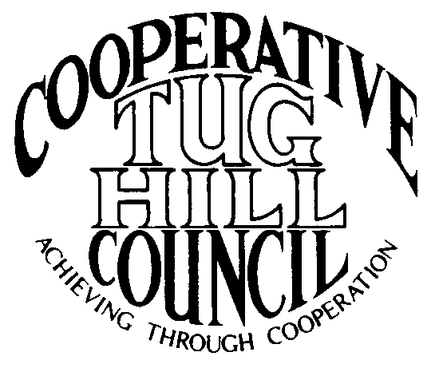 | Executive Committee  ROGER TIBBETTS, Chair  DOUGLAS DIETRICH, Vice Chair  MERIANNE SHELMIDINE, Secretary  IAN KLINGBAIL, Director  CARLA BAUER, Director  STEPHEN BERNAT, Director  ROSALIE WHITE, Director  Contact: Angie Kimball, Circuit Rider  PO Box 34, Redfield NY, 13437  Email: angela@tughill.org  Cell 315-480-6857  Home 315-599-8825

CTHC Executive Committee Meeting Minutes 07/29/2013

The meeting was called to order at 7:07 p.m. by Chairman R. Tibbetts. Present for the meeting were D. Dietrich, Vice Chairman; M. Shelmidine, Secretary; C. Bauer, Director; Stephen Bernat, Director; A. Kimball, Circuit Rider; J. Bartow, Tug Hill Commission and P. Street, Tug Hill Commission. There were no introductions.

Minutes: The minutes of the May 31, 2013 and June 18, 2013 Executive Committee meetings were reviewed by the Committee. A motion was made by D. Dietrich and seconded by M. Shelmidine to accept the minutes as presented. All in favor.

Reports: A) Financial Report – A copy of the CTHC financial reports and financial projections for June 30, 2013 and July 19, 2013 were presented by R. Tibbetts and reviewed by the members. Year-to-Date Carryover as of July 19, 2013: $36,746.35; Receipts-to-Date: $9,692.15; Distributions-to-Date: $3,530.56; Current Net Funds Available: $42,907.94. Following review and discussion of reports a motion was made by C. Bauer, seconded by M. Shelmidine to accept the financial reports as presented. All in favor.
B) Reports of Towns – A. Kimball, Circuit Rider, presented the July 2013 report of the Towns and reviewed the pertinent information for all towns (see July notes, attached)
C) Tug Hill Updates and Project Reports – J. Bartow presented a tentative new brochure. The members reviewed the design and sent back some editing. The Road Mapping project was reviewed by P. Street. Boylston and Worth have been started and work continues on several other maps. They are researching some qualified abandonments and easement issues in WMU’s. P. Street also updated the progress on the Special Areas Mapping project (see sheet). J. Bartow reported on the Conservation Fund appraisals of two properties in Redfield and Williamstown that they are acquiring for later State purchase. J. Bartow also reported on the progress of the Nature Conservancy PILOT, an upcoming tour of Mulpus property in Osceola and Lewis, the upcoming 5 year survey and report and the possible dates for the next Legislator’s meeting which they hope to hold in Constableville on October 28, 29 or 30.
D) Any other reports – There were no other reports.

Old Business: The Committee decided to hold off on sending the invitation to the villages to join the membership of the CTHC until we have a consensus on the new brochure. There was no other old business.

New Business: A) Fall Dinner - The agenda for the Fall Dinner and Meeting was discussed. D. Dietrich verified that J. Mahoney Lewis County’s new Trail Coordinator would be the guest speaker. A. Kimball verified that the reservation was made for the Steak and Brew for Sept. 26th and reviewed the details of menu suggestions and costs. Invitations will be created and going out soon, hopefully before the August Board meetings.
B) Any other new business – D. Dietrich mentioned the Town of Martinsburg’s Open House for their new municipal building will be 7/30 from 4pm to 8 pm and all are welcome to attend.
- Chairman Tibbetts briefly discussed the Tug Hill Aquifer Study which is ongoing.

Adjournment: With no other business before the Committee, a motion was made by R. Tibbetts and seconded by C. Bauer to adjourn the meeting at 8:19 pm. All in favor.

