Member Communities  Towns of Boylston Florence Harrisburg Lewis Leyden Lorraine Martinsburg Montague Osceola Pinckney Redfield Rodman Turin West Turin Williamstown Worth Nonmember Villages of Constableville Lyons Falls Port Leyden Turin  Website: tughillcouncil.com | 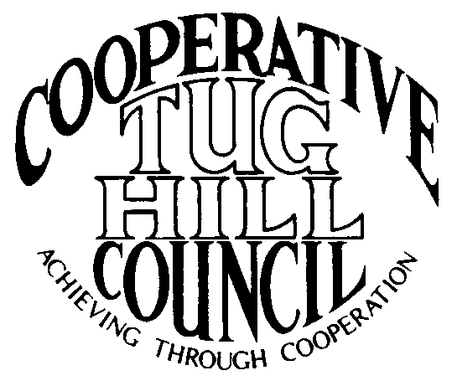 | Executive Committee  ROGER TIBBETTS, Chair  DOUGLAS DIETRICH, Vice Chair  MERIANNE SHELMIDINE, Secretary  IAN KLINGBAIL, Director  CARLA BAUER, Director  STEPHEN BERNAT, Director  Contact: Angie Kimball, Circuit Rider  PO Box 34, Redfield NY, 13437  Email: angela@tughill.org  Cell 315-480-6857  Home 315-599-8825
CTHC Executive Committee Meeting Minutes 02/28/2013

The meeting was called to order at 7:03 p.m. by R. Tibbetts, Chairman. Present for the meeting were D. Dietrich, Vice Chairman; M. Shelmidine, Secretary; I. Klingbail, Director; C. Bauer, Director; S. Bernat, Director; R. White, Proposed Director; A. Kimball, Circuit Rider; J. Wooding, Associate Circuit Rider; K. Chapman, Associate Circuit Rider; J. Bartow, Tug Hill Commission; and P. Street, Tug Hill Commission.

Introduction of Rosalie White, Town of Leyden Supervisor, who is proposed to fill the Executive Committee vacancy.

Minutes: Minutes of the December 6, 2012 Executive Committee meeting were reviewed by the Committee. A motion was made by D. Dietrich and seconded by C. Bauer to accept the minutes as presented. All in favor.

Reports: A) Financial Report - A copy of the CTHC financial report as of 12/31/2012 was presented by R. Tibbetts and reviewed by the members. Year-to-Date Carryover: $34,969.88; Receipts to Date: $9,679.42; Distributions to Date: $7,902.95; Current Net Funds Available: $36,746.35. Following review and discussion of the reports, a motion was made by C. Bauer and seconded by D. Dietrich to accept the financial reports as presented. All in favor.
B) Reports of Towns - A. Kimball Circuit Rider reported on Boylston, Florence, Lewis, Osceola, Redfield and Williamstown. (See February Meeting notes, attached).
C) Reports of Associates - K. Chapman, Associate Circuit Rider reported on Lorraine, Montague, Pinckney, Rodman and Worth. J. Wooding, Associate Circuit Rider reported on Harrisburg, Leyden, Martinsburg, Turin and West Turin. (See February Meeting notes, attached).
D) Tug Hill Updates and Project Reports – 1) Road Mapping – P. Street reported on the Road Mapping Project. Several Towns started with Low Volume and Minimum Maintenance maps first which should really be steps two and three of the process. Currently are working get a complete and correct map of each Towns road system, which should be step one. M. Dietrich from the Tug Hill Commission is working on the maps currently for the Towns whose data has been collected. Martinsburg adopted their new map in February and are moving on with the process.
2) Special Areas – P. Street reported that meetings have been held with Montague and Rodman, with meetings set up in Pinckney and Lorraine for March and a couple other Towns pending setting a meeting date (see attached sheet.) West Turin is still the only Town that is complete, but the project is moving forward.
3) Core Forest Analysis – J. Bartow gave a presentation on the Core Forest and some concerns raised during the PILOT discussions at the meetings with the Towns and the Nature Conservancy. Also, reported on possible large forest tracts filing 480a in Redfield and Worth. After discussion it was decided that these topics will be brought before the whole Council at the Spring Meeting.

Old Business: A discussion of the possibility of Village membership was discussed again. There is an issue with coverage of the meetings. All four Villages would be in J. Wooding’s area. The possibility of a Village Associate was discussed. J. Wooding also reported that she is considering retirement and a search for a replacement may need to be undertaken prior to next winter. Will be discussed with full Council and possibly send invitations to Villages to join at the Fall dinner. More information to follow but no action currently taken.

New Business: Attorney’s Fees - M. Shelmidine brought up a discussion of the legal fees Towns are paying and inquired about a Tug Hill Commission lawyer. Tug Hill advised that they do not have a lawyer on staff. They will do much of the legwork on new laws, information requests etc., but they would still need to go through the Town’s attorneys for final review. This keeps there from being any conflicts and decreases liability to all concerned. The Commission does have a brochure that outlines all the services they can help with that can be distributed to the Towns. No action was taken on this topic at present.
Spring Dinner – R. Tibbetts presented an Agenda and reviewed same. Discussion of slate of proposed Officers, which includes current Board and the addition of Rosalie White to the Director’s vacancy and any nominations from the floor. After discussion it was decided to have the Tug Hill Commission present information on several topics and dispense with a Guest Speaker. The other items on the agenda included discussion of a second Legislators meeting in October 2013, which the Executive Board is in favor of and would like to have in Constableville. Discussion of a survey to Supervisors in advance to know what they would like to hear about, and so draft legislation could be available to hand to Legislators if anything is necessary. Dinner will be April 25 at the Central Hotel in Glenfield, cocktails 5:30, dinner at 6:30 sharp. Reservations will be due before 4/18 so D. Dietrich can turn them in.
Update of CTHC Brochure – A. Kimball will get to work on getting this document updated and C. Bauer and M. Shelmidine have volunteered to assist in this project.

With no other business before the Committee, a motion was made by D. Dietrich and seconded by C. Bauer to adjourn at 9:25 p.m.

A. Kimball
Circuit Rider

