Member Communities  Towns of Boylston Florence Harrisburg Lewis Leyden Lorraine Martinsburg Montague Osceola Pinckney Redfield Rodman Turin West Turin Williamstown Worth Nonmember Villages of Constableville Lyons Falls Port Leyden Turin  Website: tughillcouncil.com | 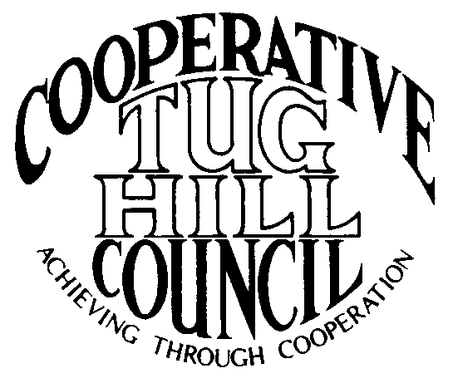 | Executive Committee  ROGER TIBBETTS, Chair  DOUGLAS DIETRICH, Vice Chair  CARLA BAUER, Secretary  IAN KLINGBAIL, Director  STEPHEN BERNAT, Director  ROSALIE WHITE, Director  PAULETTE SKINNER, Director  Contact: Angie Kimball, Circuit Rider  PO Box 34, Redfield NY, 13437  Email: angela@tughill.org  Cell 315-480-6857  Home 315-599-8825

CTHC Executive Committee Meeting Minutes 2/25/2016

The meeting was called to order at 7:03 p.m. by Chairman R. Tibbetts. Also present for the meeting were D. Dietrich, Vice Chairman; C. Bauer, Secretary; S. Bernat, Director; R. White, Director; P. Skinner, Director; I. Klingbail, Director; A. Kimball, Circuit Rider; and Phil Street from the Tug Hill Commission. There were no introductions.

Minutes: The minutes of the December 3, 2015 Executive Committee meeting were reviewed by the Committee. A motion was made by D. Dietrich and seconded by C. Bauer to accept the minutes as presented. All were in favor. (See attached minutes.)

Reports: A) Financial Report – A copy of the CTHC financial report and financial projection as of February 24, 2016 were presented by R. Tibbetts and reviewed by the members. Year-to-Date Carryover: $42,692.58; Receipts-to-Date: $605.49; Distributions-to-Date: $669.63; Current Net Funds Available: $42,628.44. Following review and discussion of reports a motion was made by I. Klingbail, seconded by P. Skinner to accept the financial reports as presented. All were in favor. (See attached reports.)
B) Reports of Towns – A. Kimball presented the report of the Towns and reviewed the pertinent information for each. (See attached report.) She also discussed the progress with the Justice Court consolidation study in Lorraine and the completion of a court consolidation paper for THC; that she had met with Kay and gotten the signed Associate contracts; that the dues letters should be going out soon and that she had been working on a tentative invitation to the spring meeting (see attached).
C) Tug Hill Updates and Project Reports:
1) TIR/Forestry meeting – P. Street reported that the former Harden properties now owned by TIR are for sale again. There is a meeting 2/29 in Albion to discuss the matter and talk about Community Forests. C. Bauer will be going to the meeting to represent the Executive Committee.
2) Tug Hill Aquifer – Recently proposed manure facilities have upset people. There are issues with towns being able to control the placement of these facilities due to the State Right to Farm laws. There is the possibility of some meetings being set up if the Towns want to take action.
3) THC Personnel – The Commission is working on getting A. Kimball’s pay grade raised from a 14 to an 18 to match the other Circuit Riders. They are working with the Department of Budget currently and hope to have some news soon. The Commission also needs to fill Katie’s (Malinowski) old position now that she has been promoted to the Executive Director position. The position may become a more generalized Director position rather than just the Director of Natural Resources.
4) Other Tug Hill Updates – P. Street finished by discussing a possible new wind farm that may be undertaken by Iberdrola on the west side of the “Hill”. There is a meeting on this next week so more information to follow. Also, we have Harrisburg’s Special Areas map to approve at the spring meeting and also possibly Leyden’s if we can get it done in time (see attached). He also presented a sheet on the status of the towns with minimum maintenance road laws (see attached). Boylston is the only town yet to complete their Highway map approval. After we complete all of the maps we will start working on any minimum maintenance roads updates that need to be done. He would also like to talk about “camp zoning” at the spring meeting and how it can help strengthen the minimum maintenance road laws.

D) Any other reports – None

Old Business: A) Town Information Study – All 16 have been received and A. Kimball will have some results ready for the spring meeting.
B) Work Goals 2016 – The goals from last year were presented and reviewed by the Committee. The Committee suggested any changes they wanted included to the proposed 2016 goals (see attached) and they will presented at the spring meeting for approval.
C) CTHC Website Change-over quotation – The quote for the change-over of the CTHC website from Riverside Media (see attached) was presented and compared to the previous quote received from Renewal Media (see attached). The quote from Riverside Media was for $1040 and the quote from Renewal Media was for $2000. A motion was made by D. Dietrich and seconded by I. Klingbail to accept the quotation from Riverside Media for the work on the CTHC website. All were in favor.

New Business: A) Meeting with NOCCOG about Shared Services - A. Kimball discussed the possibility of setting up a meeting with the other COGs especially NOCCOG to discuss shared services. She suggested that maybe a COG Chairs meeting would be the place to start. After the Committee discussed the matter, it was decided to see about setting up a COG Chairs meeting and there talking about a SuperCOG meeting. The Committee would prefer that the SuperCOG meeting be more COG driven if it is set up rather than being a presentation by the Commission.
B) Election of Officers – All current officers were asked if they would be running for election in their current positions on the Executive Committee, and all answered in the affirmative.
C) Speaker for the Spring Meeting – Bob Quinn from the Tug Hill Tomorrow Land Trust has been confirmed as the speaker for the spring meeting, which has been confirmed for 4/21.
D) Other New Business – D. Dietrich reported that none of the Martinsburg officials had received their invitations to the Local Government Conference by mail. P. Street will report this and try and see what went amiss. He also reported a new email address which A. Kimball will update on the contact list.

With no more business before the Committee a motion was made by C. Bauer and seconded by R. White to adjourn the meeting at 8:07 pm. All were in favor.

