Member Communities  Towns of Boylston Florence Harrisburg Lewis Leyden Lorraine Martinsburg Montague Osceola Pinckney Redfield Rodman Turin West Turin Williamstown Worth Nonmember Villages of Constableville Lyons Falls Port Leyden Turin  Website: tughillcouncil.com | 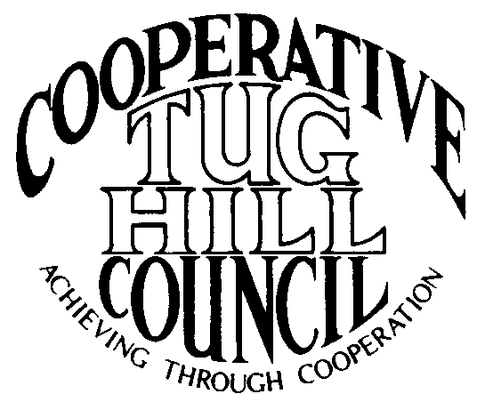 | Executive Committee  ROGER TIBBETTS, Chair  DOUGLAS DEITRICH, Vice Chair  MERIANNE SHELMIDINE, Secretary  IAN KLINGBAIL, Director  CARLA BAUER, Director  STEPHEN BERNAT, Director  Contact: Angie Kimball, Circuit Rider  PO Box 34, Redfield NY, 13437  Email: angela@tughill.org  Cell 315-480-6857  Home 315-599-8825
CTHC Executive Committee Meeting Minutes 12/6/12

The meeting was called to order at 7:00 p.m. by R. Tibbetts, Chairman. Present for the meeting were D. Dietrich, Vice Chair; M. Shelmidine, Secretary; C. Bauer, Director; S. Bernat, Director; I. Klingbail, Director; A.Kimball, Circuit Rider; J. Bartow, Tug Hill Commission; and P. Street, Tug Hill Commission.

Introduction of Angie Kimball, newly hired Circuit Rider.

Financial Reports: A copy of the CTHC financial report as of 11/30/12 was given and reviewed by members present. Year-to-Date Carryover: $34,969.88; Receipts-to-Date: $9,671.44; Distributions-to-Date: $6,850.65; Current Net Funds Available: $37,790.67.
A copy of the CTHC Financial Projection was given and reviewed by members. Tentative figures provided through 2017.
Following review and discussion a motion was made by D. Dietrich, seconded by S. Bernat to approve the Financial Reports as presented. All in favor.

Reports: J. Bartow and P. Street presented the following:
-Presented the Tug Hill Commission policy on “Councils of Government and for Circuit Rider Services” (adopted 12/3/04); and reviewed the terms of the policy;
-Reviewed the current job description and duties of the Circuit Rider position;
-Reviewed the Evaluation process and forms used for the Circuit Rider position and requested Executive Board members let P. Street know any problems or concerns with A. Kimball’s performance so these can be part of the evaluation process;
- CTHC Executive Board’s current contact list was presented for any additions or corrections, so that it may be corrected and disseminated;
- CTHC’s current Information Pamphlet was presented for review for any changes necessary for possible re-printing of same.

R. Tibbetts then presented the Associate Circuit Riders Contract and reviewed a wording change. The wording added states “Mileage shall be from the Associate Circuit Rider’s home base to an approved meeting or event and return to their home base.” All Board members were in agreement with adding this wording change to the contract.

P. Street then reported on the status of the Towns on the working projects as follows:
Special Areas: There has been no significant progress to date. There has been interest shown from Florence and possibly from Lorraine once their zoning process is finished.

Highway Mapping: Worth, Boylston and Leyden are the only Towns still pending commencement. The field work is either done or in progress in all other Towns, with 6 maps in process of drafting, 1 being considered by Town Board and 5 maps having been adopted (4 old versions, T/O Pinckney adopted new version). P. Street expects by the end of winter 2013 all of the maps will be complete except Worth, Boylston and Leyden and he expects those Towns to be completed by end of summer 2013.

New Business: -Spring meeting to be held 04/25/13 at the Central Hotel in Glenfield. Topic and speaker to be determined at a later date.
-Next Executive Committee meeting – end of February with location to be determined at a later date.

A motion was made to adjourn at 8:38 p.m. by D. Dietrich, seconded by C. Bauer. All in favor.

A Kimball, Circuit Rider

