Member Communities  Towns of Boylston Florence Harrisburg Lewis Leyden Lorraine Martinsburg Montague Osceola Pinckney Redfield Rodman Turin West Turin Williamstown Worth Nonmember Villages of Constableville Lyons Falls Port Leyden Turin  Website: tughillcouncil.com | 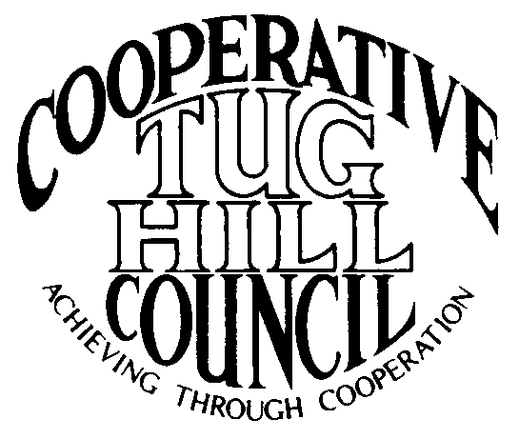 | Executive Committee  ROGER TIBBETTS, Chair  DOUGLAS DIETRICH, Vice Chair  CARLA BAUER, Secretary  IAN KLINGBAIL, Director  STEPHEN BERNAT, Director  ROSALIE WHITE, Director  PAULETTE SKINNER, Director  Contact: Angie Kimball, Circuit Rider  PO Box 34, Redfield NY, 13437  Email: angela@tughill.org  Cell 315-480-6857  Home 315-599-8825

CTHC Executive Committee Meeting Minutes 12/3/2015

The meeting was called to order at 7:06 p.m. by Chairman R. Tibbetts. Also present for the meeting were D. Dietrich, Vice Chairman; S. Bernat, Director; R. White, Director; P. Skinner, Director; A. Kimball, Circuit Rider; and Katie Malinowski from the Tug Hill Commission. There were no introductions.

Minutes: The minutes of the June 30, 2015 Executive Committee meeting were reviewed by the Committee. A motion was made by D. Dietrich and seconded by S. Bernat to accept the minutes as presented. All were in favor. (See attached minutes.)

Reports: A) Financial Report – A copy of the CTHC financial report and financial projection as of November 30, 2015 were presented by R. Tibbetts and reviewed by the members. Year-to-Date Carryover: $42,027.36; Receipts-to-Date: $9,059.46; Distributions-to-Date: $7,399.97; Current Net Funds Available: $43,686.85. Following review and discussion of reports a motion was made by D. Dietrich, seconded by S. Bernat to accept the financial reports as presented. All were in favor. (See attached reports.)
B) Reports of Towns – A. Kimball presented the report of the Towns and reviewed the pertinent information for each. (See attached report.) She also discussed the progress with the Justice Court consolidation study in Lorraine and reviewed some projects that are just getting started, such as project with Lewis, the Audubon Society and Climate Smart Communities, and some work with the Town of Turin and the Turin Fire Department which may be coming up to help with some issues in ambulance service.
C) Tug Hill Updates and Project Reports:
1) Executive Director Search – K. Malinowski outlined the search process to date – the process started in August and the deadlines to accept resumes was extended twice until the final deadline of 10/15. They received ten resumes total and the Commissioners have reviewed all of the resumes. J. Bogdanowicz (THC Chairman) has called and spoken to all of the COG chairs and he has been working closely with Albany. He hopes they will have a selection made by the end of the year. It was unknown by her if they were going to interview the candidates or just make a decision. R. Tibbetts commented that he had spoken to J. Bogdanowicz and that he couldn’t imagine not interviewing. He felt that it rubbed somewhat wrong that the COGs hadn’t been involved at all in the process. D. Dietrich commented that the process was totally different this time.
2) Tug Hill Broadband – K. Malinowski reported that there has not been a Request For Proposal (RFP) put out yet for any of the Broadband Initiative money. They continue to talk with DANC, who is looking at some new technology working with Mohawk Networks on some new wireless technology. “Last Mile” costs are still an issue that DANC doesn’t want to tackle.
3) 480a update – The changes proposed last year without the budget part attached ended up being scrapped. The DEC is doing stakeholders meetings again with the newest 480b proposal, which would be part of the budget. This sounds more promising than last year. K. Malinowski passed out a copy of the newest proposal (see attached). She also gave the Committee members copies of the newest white paper the Commission has come out with which is on Protected Lands on Tug Hill (see attached).
D) Any other reports – None

Old Business: A) Town Information Study – We have received the surveys back from 15 of our 16 towns. Everyone has responded except Pinckney. A. Kimball will send one more copy to them and try and get it filled out and will tabulate the results to have them available for the spring meeting regardless.

New Business: A) Election Results – A. Kimball passed out a sheet with the results from the Nov. 2015 elections for the Committee to review (see attached).
B) 2016 Work Goals – A. Kimball gave the Committee members copies of the 2015 Goals so that they could review them before the next Committee meeting and bring any suggested changes to the next meeting, to be presented after that at the spring meeting (see attached).
C) Spring Meeting - Possible locations were discussed and the Committee decided to tentatively schedule for 4/28 at the Tug Hill Hideaway. Bob Quinn from Tug Hill Tomorrow Land Trust is a possible speaker. R. Tibbetts is the contact for the speaker. A. Kimball will check availability of the venue and work on setting up the details.
D) Other New Business – A quote from Renewal Media was presented for the switching over of the existing CTHC to a Wordpress based site that A. Kimball can keep updated from home. It was somewhat higher than anticipated and the Committee would like to have some other prices to compare before taking it to the full Council. A. Kimball will get some more quotes on the project.

With no more business before the Committee a motion was made by D. Dietrich and seconded by S. Bernat to adjourn the meeting at 7:52 pm. All were in favor.

