Member Communities  Towns of Boylston Florence Harrisburg Lewis Leyden Lorraine Martinsburg Montague Osceola Pinckney Redfield Rodman Turin West Turin Williamstown Worth Nonmember Villages of Constableville Lyons Falls Port Leyden Turin  Website: tughillcouncil.com | 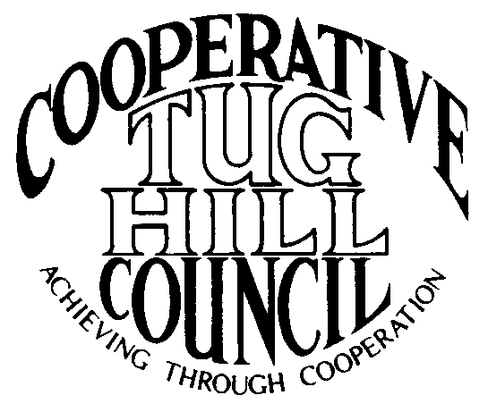 | Executive Committee  ROGER TIBBETTS, Chair  DOUGLAS DIETRICH, Vice Chair  MERIANNE SHELMIDINE, Secretary  IAN KLINGBAIL, Director  CARLA BAUER, Director  STEPHEN BERNAT, Director  ROSALIE WHITE, Director  Contact: Angie Kimball, Circuit Rider  PO Box 34, Redfield NY, 13437  Email: angela@tughill.org  Cell 315-480-6857  Home 315-599-8825

CTHC Executive Committee Meeting Minutes 12/12/2014

The meeting was called to order at 7:15 p.m. by Chairman R. Tibbetts. Also present for the meeting were D. Dietrich, Vice Chairman; S. Bernat, Director; I. Klingbail, Director; A. Kimball, Circuit Rider; and John Bartow, and Phil Street from the Tug Hill Commission. There were no introductions.

Minutes: The minutes of the July 31, 2014 Executive Committee meeting were reviewed by the Committee. A motion was made by D. Dietrich and seconded by S. Bernat to accept the minutes as presented. All in favor. (See attached minutes.)

Reports: A) Financial Report – A copy of the CTHC financial report and financial projection as of December 9, 2014 were presented by R. Tibbetts and reviewed by the members. Chairman Tibbetts reported that the finances look good and we could probably entertain a raise for the Associates eventually. The dues projection was also reviewed and D. Dietrich commented that we need to keep the dues at their current level as long as we can to help with the Towns as they are dealing with tax cap issues. Year-to-Date Carryover: $39,390.09; Receipts-to-Date: $9,754.56; Distributions-to-Date: $6,155.78; Current Net Funds Available: $42,988.87. Following review and discussion of reports a motion was made by I. Klingbail, seconded by S. Bernat to accept the financial reports as presented. All in favor. (See attached report.)
B) Reports of Towns – A. Kimball presented the report of the Towns and reviewed the pertinent information for each.
C) Tug Hill Updates and Project Reports – J. Bartow gave a report and summary of the Commission’s five year Strategic Plan (see attached summary). Additionally, the progress of the Highway Mapping project was discussed. The only two towns that have not currently approved their Official Highway map are Boylston and Leyden (see attached update sheet). The Special Areas project was also discussed and slow progress continues to be made. The Inter-municipal Agreement for the Combined Justice Court was discussed and a meeting may be set up with the three towns. There was also a discussion about the possibility of a shared service Inter-municipal agreement between some of the Lewis County towns in regards to the Dog Control Officer position if there is any interest. Several of the towns have lost their Dog Control Officer for this year.
D) Any other reports – There were no other reports.

Old Business: Invitation to villages to join the Council – The matter will be discussed again in the future, once the schedule has settled down.
Town Information Survey - A. Kimball gave an update on this project to date. Surveys are back from 5 towns, with reminders sent out to all the other towns.

New Business: A) Work Goals for 2015: The latest set of goals that have been found were from 2008 (see attached). These were reviewed by the Committee and updated for review by the Full Council at the Spring meeting. A motion to approve the Work Goals for 2015 as amended was made by S. Bernat and seconded by D. Dietrich. All were in favor (see updated goals for 2015, attached).
B) Executive Committee Guidelines Change: The Executive Committee Guidelines were reviewed and some changes were proposed. In the Objectives section a one word change was proposed. The Membership section was discussed and a change was proposed to the guidelines regarding terms of office for Executive Committee members, to make Guidelines match the Bylaws and the established practice (see attached Guidelines for the discussed changes). The proposed changes will be submitted to the Executive Committee members prior to the next meeting for approval before being recommended to the Full Council at the spring meeting.
C) CTHC Representative Job Description: A. Kimball reported that she had a request from Vince Moore (Supervisor, Lorraine) for a job description for the CTHC Representative position, due to having to fill the vacancy left by Merianne Shelmidine’s resignation. The Committee discussed the description and decided on wording to be added to the Bylaws that will explain the position (see attached proposed Bylaw change). The proposed change will be sent to all Towns prior to the spring meeting so that the amendment can be voted on by the full Council. A copy of the description will be sent to V. Moore at this time so that the Town of Lorraine can fill the vacancy created by M. Shelmidine’s resignation.
D) Any other new business – A. Kimball reported on the Word Press class that she took. She hopes to be able to take over the CTHC website eventually and be able to handle the changes and editing of the site herself.
- The next Tug Hill Commission meeting will be at 10 am Monday 12/15. A. Kimball will not be able to attend, but she has written up a report for the Commissioners. Chairman R. Tibbetts was invited to attend the meeting and deliver the Council’s report if he so desired.

With no more business before the Committee a motion was made by R. Tibbetts and seconded by S. Bernat to adjourn the meeting at 8:43 pm. All in favor.

