Member Communities  Towns of Boylston Florence Harrisburg Lewis Leyden Lorraine Martinsburg Montague Osceola Pinckney Redfield Rodman Turin West Turin Williamstown Worth Nonmember Villages of Constableville Lyons Falls Port Leyden Turin  Website: tughillcouncil.com | 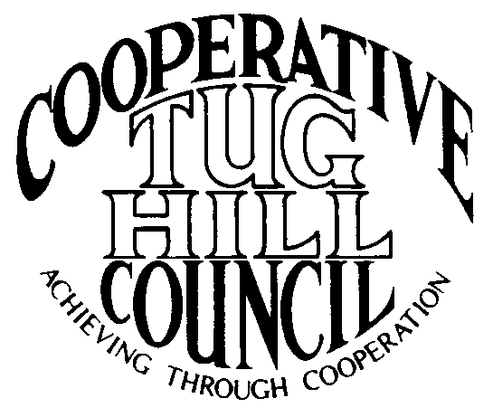 | Executive Committee  ROGER TIBBETTS, Chair  DOUGLAS DIETRICH, Vice Chair  CARLA BAUER, Secretary  IAN KLINGBAIL, Director  STEPHEN BERNAT, Director  ROSALIE WHITE, Director  PAULETTE SKINNER, Director  Contact: Angie Kimball, Circuit Rider  PO Box 34, Redfield NY, 13437  Email: angela@tughill.org  Cell 315-480-6857  Home 315-599-8825

CTHC Spring Dinner Meeting Minutes 04/30/2015

The meeting was called to order at 7:00 pm by Chairman R. Tibbetts. Roll Call of Towns showed 15 towns in attendance for the meeting with representatives from Boylston, Florence, Harrisburg, Lewis, Leyden, Lorraine, Martinsburg, Osceola, Pinckney, Redfield, Rodman, Turin, West Turin, Williamstown and Worth present. Also present as guests were three of the Tug Hill Commissioners, six members of the Tug Hill staff, and fifteen other guests for a total attendance of 49 people. Following introductions a pause was taken for dinner. The meeting recommenced at 7:50 pm.

Minutes: The minutes of the September 18, 2014 spring meeting were reviewed (see attached). A motion was made by T. Thisse (Martinsburg) and seconded by B. Snyder (Harrisburg) to accept the minutes as presented. All were in favor.

Reports: Financial Report – A copy of the Financial Report as of April 24, 2015 was presented by Chairman R. Tibbetts (Rodman) for review by members (see attached). Year-to-Date Carryover: $42,027.36; Receipts to Date: $15.47; Distributions to Date: $1,775.54; Current Net Funds Available: $40,267.29. Following review a motion was made by G. Stinson (Rodman) and seconded by J. Hamblin (Williamstown) to accept the report as presented. All in favor.

Election of Officers: The slate of officers included: Roger Tibbetts, Chairman; Doug Dietrich, Vice Chairman; Carla Bauer, Secretary; Stephen Bernat, Director; Ian Klingbail, Director; Rosalie White, Director and Paulette Skinner, Director. After extending the request three times, there were no nominations from the floor. At that time the polls were closed and a motion was made by R. Tibbetts (Rodman) and seconded by R. Maciejko (THC/Turin) that the Secretary cast one ballot for the slate of officers presented. All were in favor.

Presentation - Tug Hill Commission Topics:
Special Areas – The completed and Town approved maps for the Towns of Williamstown and Redfield were presented to the Council. A Resolution for Local Reserve Plan Amendment and Filing and the necessary Short Environmental Assessment Form were presented to the Council and upon a motion by J. Hamblin (Williamstown) and a second by V. Moore (Lorraine) the resolution was approved as presented (see attachment). Additionally, an update on the status of the other town’s progress was presented by P. Street (THC). Boylston and Turin remain the only towns who haven’t started the process yet. (Progress report attached)
Highway Mapping – An update of the Highway Mapping project was presented to the Council by P. Street (THC). Currently all of the CTHC towns have some form of the map either completed and approved or in progress. Work is continuing to complete this project hopefully soon. Some of the towns are working on minimum maintenance roads. (Progress report attached)
Legislators Meeting – J. Bartow (THC) reported that the Legislators meeting for this fall is scheduled for 10/1 tentatively for the Redfield Fire Hall. Anyone with topics they would like to discuss at the meeting was asked to get them to the Executive Committee to be passed on. Mr. Bartow (THC) also reported that the information on the State’s Consolidated Funding Applications came out today. Deadline to apply for this funding is 7/31/15. He also briefly discussed the Governor’s Broadband Initiative. The Commission staff has been meeting with the Development Authority of the North Country (DANC) as well as the North Country Regional Economic Development Council (REDC) in regards to the subject. They hope to get coverage for three or four CTHC towns. He mentioned the possibility of the Council purchasing some signs in support of the projects, and possibly a survey of the interested people. The Commission will do a proposal with possible costs for the signs, and get it to the Executive Committee as any proposal will have to be submitted by the end of July. A motion was made by J. Nichols (Worth) and seconded by T. Yerdon (Redfield) to allow the Executive Committee to spend funds not to exceed $1,000 and at their discretion for signs in support of a broadband project in CTHC towns. All were in favor. The final business that Mr. Bartow related was that the Commission’s Annual meeting and dinner will be held 5/28 at the Adams Country Club. Invitations will be going out soon. The Commission will be recognizing the next round of Tug Hill Sages at the meeting.
Tug Hill Traverse - K. Malinowski (THC) discussed the Tug Hill Traverse project, which is a proposed long-distance hiking trail across Tug Hill. Bob McNamara and Zach Wakeman have done some work mapping out a feasible trail and presented the information to the Nature Conservancy, in hopes of garnering some funding for a feasibility study. Maps of the proposed trail were available for review. More information will be available as the project moves along.

Old Business: Discussion of Village Membership – This discussion currently continues on hold as we examine our potential for covering the meetings.
Town Information Study – An update of the status of the Town Information survey was given. Currently 9 of our 16 Towns have returned their surveys. The Towns who have not sent their surveys in were asked to do so, in hopes of having the information compiled by the fall meeting.

New Business: Proposed Bylaw Change – The proposed Bylaw change was read and after discussion, a motion was made by V. Moore (Lorraine) and seconded by D. Dietrich (Martinsburg) to accept the alteration of “Section 3. Composition of the CTHC” (see attached). All were in favor.
Executive Committee Guidelines Change – The proposed Executive Committee Guidelines change was read and after discussion, a motion was made by T. Yerdon (Redfield) and seconded by F. Yerdon (Osceola) to accept the alteration of the “Objectives” and “Membership” sections of the Executive Committee Guidelines (see attached). All were in favor.
Work Goals for 2015 – The proposed work goals for 2015 were present by Chairman Tibbetts (see attached). After a review of the goals and a discussion, a motion was made by G. Stinson (Rodman) and seconded by J. Nichols (Worth) to accept the 2015 Work Goals as presented. All were in favor.

Speaker: Rob Davies, NYS DEC Director of Lands and Forests – Mr. Davies spoke about the history of the Real Property Tax Law Section 480a program and the actions leading up to the current proposed changes to the program. He also outlined issues with the current program and goals for the proposed new program. (See attached notes). Following the presentation, Mr. Davies took many questions from the audience on the new proposals and noted the concerns of the Towns (see attached notes for more information).

Supervisor’s Topics: G. Stinson (Rodman) gave a report on the 12th Annual SNIRT run. They had about 3,400 people registered and everything went well. There were no accidents and very few tickets issued.
F. Yerdon (Osceola) asked if the money available for the Broadband Initiative from the State was something that the Council could apply for. J. Bartow answered that the Commission is looking at a project and the Council could endorse the project and perhaps help with the money necessary as matching funds, but DANC or the Towns would be the main grant applicant. A motion was made by F. Yerdon (Osceola) and seconded by T. Thisse (Martinsburg) to allow the Executive Committee to address this situation as they deem fit, as the grants will be due before the fall meeting. All were in favor.

With no other business before the Council, a motion was made at 9:00 pm by R. Tibbetts (Rodman) and seconded by M. Yerdon (THC/Redfield) to adjourn the meeting. All were in favor.

