Member Communities  Towns of Boylston Florence Harrisburg Lewis Leyden Lorraine Martinsburg Montague Osceola Pinckney Redfield Rodman Turin West Turin Williamstown Worth Nonmember Villages of Constableville Lyons Falls Port Leyden Turin  Website: tughillcouncil.com | 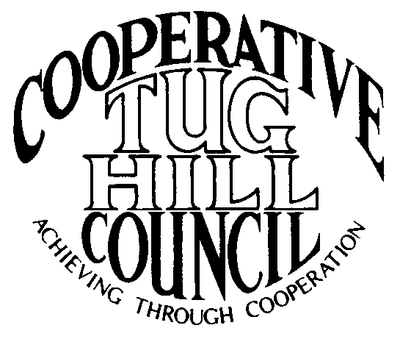 | Executive Committee  ROGER TIBBETTS, Chair  DOUGLAS DIETRICH, Vice Chair  CARLA BAUER, Secretary  IAN KLINGBAIL, Director  STEPHEN BERNAT, Director  ROSALIE WHITE, Director  PAULETTE SKINNER, Director  Contact: Angie Kimball, Circuit Rider  PO Box 34, Redfield NY, 13437  Email: angela@tughill.org  Cell 315-480-6857  Home 315-599-8825

CTHC Spring Dinner Meeting Minutes 04/21/2016

The meeting was called to order at 7:02 pm by Chairman R. Tibbetts. Roll Call of Towns showed 15 towns in attendance for the meeting with representatives from Boylston, Florence, Harrisburg, Lewis, Leyden, Lorraine, Martinsburg, Montague, Osceola, Pinckney, Redfield, Rodman, Turin, West Turin and Worth present. Also present as guests were two of the Tug Hill Commissioners, two members of the Tug Hill staff, and ten other guests for a total attendance of 38 people. Following introductions a pause was taken for dinner. The meeting recommenced at 7:49 pm.

Minutes: The minutes of the September 17, 2015 fall meeting were reviewed (see attached). A motion was made by P. Skinner (Boylston) and seconded by S. Harmych (Pinckney) to accept the minutes as presented. All were in favor.

Reports: Financial Report – A copy of the Financial Report as of April 20, 2016 was presented by Chairman R. Tibbetts (Rodman) for review by members (see attached). Year-to-Date Carryover: $42,692.58; Receipts to Date: $5,416.05; Distributions to Date: $1,462.27; Current Net Funds Available: $46,646.36. Following review, a motion was made by D. Dietrich (Martinsburg) and seconded by V. Moore (Lorraine) to accept the report as presented. All in favor.

Election of Officers: The slate of officers included: Roger Tibbetts, Chairman; Doug Dietrich, Vice Chairman; Carla Bauer, Secretary; Stephen Bernat, Director; Ian Klingbail, Director; Rosalie White, Director and Paulette Skinner, Director. After extending the request three times, there were no nominations from the floor. At that time the polls were closed and a motion was made by T. Yerdon (Redfield) and seconded by L. Wojnowski (Turin) that the Secretary cast one ballot for the slate of officers presented. All were in favor.

Special Area Maps – The completed and Town approved maps for the Towns of Harrisburg and Leyden were presented to the Council. A Resolution for Local Reserve Plan Amendment and Filing and the necessary Short Environmental Assessment Form were presented to the Council and upon a motion by D. Dietrich (Martinsburg) and a second by E. Hayes (W. Turin) the resolution to accept the Special Areas maps was approved as presented (see attachment).

Tug Hill Commission Topics: Camp Zoning and Minimum Maintenance Roads – The Town of West Turin’s Minimum Maintenance Road law has been overturned in Supreme Court. A copy of the decision was provided by the Commission (see attached). They reported that since the decision they have looked at the Minimum Maintenance Road bill which they have been trying to get approved by the State Legislature for years. The bill always passes the Senate and gets stuck in the Assembly’s Transportation Committee. After reviewing the Transportation Committee’s membership it was found that Assemblyman Brindisi, one of our Tug Hill Legislators was on the committee. K. Malinowski and P. Street (THC) met the Assemblyman and shared the information they had and the court decision. He has become a co-sponsor of the bill and he has sent the information that THC provided to the Committee’s council for review. A map of the towns state-wide that have approved a minimum maintenance road law was presented and there are approximately 50 towns scattered all over the state. A resolution in support of the minimum maintenance road legislation was presented and a motion to approve the resolution was made by F. Yerdon (Osceola) and seconded by E. Hayes (W. Turin). All were in favor.
E. Hayes (W. Turin) reported that his Board had met with Mark Gebo, their attorney, and have decided to file an appeal of the court decision. He reported that the road in question has been a snowmobile trail for years and there are issues with being able to widen the road to plow it as in places there is state land on both sides of the road, and the cost is prohibitive. He also reported that they have already gotten another request in to maintain another of their minimum maintenance roads.
P. Street (THC) spoke about the “camp zoning” that Pinckney has added to their zoning law (see attached). This deals with the use of the lands along the roads rather than the roads themselves. Pinckney has also passed a driveway installation law (see attached), which doesn’t allow for a curb cut on a minimum maintenance road. These tactics are trying to use zoning to buttress the minimum maintenance road laws. Some towns have also added seasonal dwelling permits only on minimum maintenance roads to their zoning law. Towns are trying many avenues to get at the problem, and he offered to come to any town and talk about some of these possible solutions.
F. Yerdon (Osceola) also mentioned that Kevin McArdle, who was the attorney for the complainant in the W. Turin case is also the municipal attorney for some of our towns, including Osceola, and he will be looking at Mr. McArdle’s use as their municipal attorney.
COG Chairs meeting – K. Malinowski (THC) reported that a COG Chairs meeting has been set up for 4/26, which she hopes will be quite productive.

Old Business: Village Membership – A. Kimball (Circuit Rider) reported that all of the Villages had been invited to the fall meeting and we had no response from any of them at that point. She will be going to make a personal appearance before each board to tell them about the Council and what we have to offer, and see what happens after that. She is on the schedule to attend the meeting at the Village of Port Leyden in May.
Town Information Study – All sixteen towns responded to the information study that the Council has been undertaking. A. Kimball (Circuit Rider) presented the results to the attendees (see attached). More specific information will be available upon request if any of the towns need it.

New Business: Work Goals for 2016 – The proposed work goals for 2016 were presented by Chairman Tibbetts (see attached). After a review of the goals and a discussion, a motion was made by V. Moore (Lorraine) and seconded by J. Nichols (Worth) to accept the 2016 Work Goals as presented. All were in favor.

Speakers: Bob Quinn and Linda Garrett, Tug Hill Tomorrow Land Trust – Bob Quinn spoke of the history of the Land Trust and its concern for protecting Tug Hill. Their Board of Directors consists of all local people and they rely on private donations to do their work. He spoke about conservation easements and that they can enforce terms of these easements into the future, and that they do not take the property off the tax rolls. He then mentioned several projects that the Land Trust is working on in the area. They passed out informational brochures with contact information to the attendees.

Supervisor’s Topics: E. Hayes (W. Turin) spoke of the minimum maintenance road case and that it will affect other towns eventually if the appeal or passage of a new state law isn’t successful. The costs will be very high for their town and he stated that if anyone was interested in helping with the costs it would be appreciated. Chairman Tibbetts (Rodman) mentioned that the CTHC has donated money to towns in the past to help with issues of this nature and that he would bring it up to the Executive Committee.
T. Yerdon (Redfield) asked if there was any news about the proposed changes to 480a. K. Malinowski reported that there was a lot of talk in January and the DEC thought that the new 480b would be in the budget; however there was a staff change in the Governor’s office and they lost the main supporter of the measure, so it was not in the Governor’s budget. The DEC has thoughts that it may become a department bill, but then it would once again have no funding which would not be good for the towns. They will continue to follow the subject and keep the wishes of our towns on the minds of the powers that be.

With no other business before the Council, a motion was made at 8:44 pm by R. Tibbetts (Rodman) and seconded by M. Yerdon (THC/Redfield) to adjourn the meeting. All were in favor.

