Martinsburg History
Martinsburg Town Hall was built in 1812, with the land given by General Walter Martin and the cost of the building also came from him. It was used at the time as the county court house since Martinsburg was the county seat. The first county court was held here on January 7, 1812.
The county seat was removed to Lowville in 1864 and the title to the building reverted back to the Martin family. General Martin had since died so his sons became heirs of the building. One son gave his share back to the town and the remaining sons’ interest was purchased.
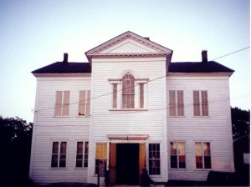
As was Walter Martin’s wishes, the hall continued to be used. It then was turned into a permanent academy know as Martin Institute. A charter for this was obtained in 1870 and the school survived until 1888, when it was sold by mortgage foreclosure for $285 and was to be leased to the town as a town hall. In 1891, Martinsburg acquired full title to the building and it has served as the town hall ever since.
Martinsburg town hall is the first public building in all of Lewis County. It is also the oldest. One very interesting event that took place in this building happened in 1839 when the first and only execution in Lewis County was completed in this hall. Lawrence McCarty was put to death by hanging for murder of his father-in-law and the only remaining evidence is the weight used in the hanging.
On March 21, 2001, the Martinsburg Town Hall was placed on the state and national register of Historic places.

