Member Communities  Towns of Boylston Florence Harrisburg Lewis Leyden Lorraine Martinsburg Montague Osceola Pinckney Redfield Rodman Turin West Turin Williamstown Worth Nonmember Villages of Constableville Lyons Falls Port Leyden Turin  Website: tughillcouncil.com | 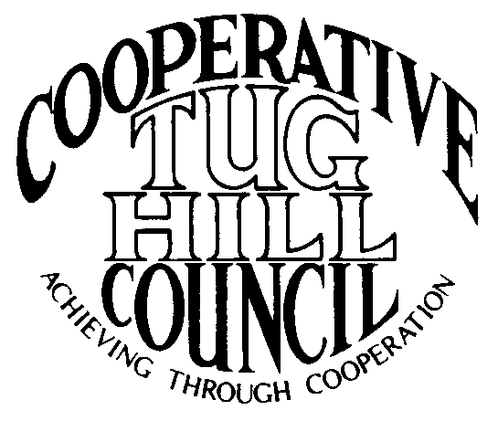 | Executive Committee  ROGER TIBBETTS, Chair  DOUGLAS DIETRICH, Vice Chair  CARLA BAUER, Secretary  IAN KLINGBAIL, Director  STEPHEN BERNAT, Director  ROSALIE WHITE, Director  PAULETTE SKINNER, Director  Contact: Angie Kimball, Circuit Rider  PO Box 34, Redfield NY, 13437  Email: angela@tughill.org  Cell 315-480-6857  Home 315-599-8825

CTHC Fall Dinner Meeting Minutes 09/22/2016

The meeting was called to order at 7:00 pm by Chairman R. Tibbetts. Roll Call of Towns showed 14 towns in attendance for the meeting with representatives from Boylston, Harrisburg, Lewis, Leyden, Lorraine, Martinsburg, Montague, Osceola, Pinckney, Redfield, Rodman, Turin, West Turin and Worth present. Also present as guests were two of the Tug Hill Commissioners, three members of the Tug Hill staff, and ten other guests for a total attendance of 38 people. Introductions followed roll call.

Minutes: The minutes of the April 21, 2016 spring meeting were reviewed (see attached). A motion was made by D. Dietrich (Martinsburg) and seconded by R. White (Leyden) to accept the minutes as presented. All were in favor.

Reports: Financial Report – A copy of the Financial Report as of September 14, 2016 was presented by Chairman R. Tibbetts (Rodman) for review by members (see attached). Year-to-Date Carryover: $42,692.58; Receipts to Date: $10,245.83; Distributions to Date: $5,647.14; Current Net Funds Available: $47,291.27. Following review a motion was made by P. Skinner (Boylston) and seconded by T. Thisse (Martinsburg) to accept the report as presented. All were in favor.

Budget: Chairman Tibbetts presented the proposed 2017 budget. He reported a proposed decrease of the amount to be transferred from reserves for the revenue category and a decrease to the Associate Coordinators line in the expenditures category, resulting in a total decrease in the budget of $1,150 (see attached). Chairman Tibbetts reported that the rate of pay for the Associates would remain the same and the mileage rate paid would be equal to the state rate for 2017. A motion was made to approve the 2017 budget by V. Moore (Lorraine) and seconded by G. Stinson (Rodman). All were in favor.

Tug Hill Commission Topics:
Minimum Maintenance Roads – K. Malinowski (THC) reported that the Low Volume Roads Bill did not get out of the Assembly transportation committee again this year. There is not likely to be a fall session of the Legislature. She reported that she and P. Street (THC) have been speaking to many stakeholders, including the Adirondack Mountain Club, the DEC, the Farm Bureau, the Nature Conservancy, the Cornell Local Roads program and the Adirondack Council to try and bring awareness of the issue to their attention. They are working to see if the bill language can be changed slightly, without changing the intent, to help address some of the concerns of these groups and help build support to get the bill out of committee. Our Legislators, who are the bill sponsors, are OK with the possibility of changes and they will review and resubmit the bill when it is finished. She also presented a statewide Minimum Maintenance Road map which may help people envision the areas that are affected.
Super COG Meeting – The invitations to the Super COG meeting have gone out. The meeting will be held 10/27 at the Boonville Town and Village Hall. There is no charge for the meeting and there will be snacks/refreshments provided.
THC Annual Meeting - The Commission’s Annual Meeting has been scheduled for November 10th at the Tailwater Lodge in Altmar. The Venerable Folks of Tug Hill exhibit will be on display and the speaker for the evening will be Ken Lynch, former Region 7 director for DEC and currently Executive Deputy Commissioner at DEC. The RPTL 480 a/b proposed revisions are still in play and are being presented with the reimbursement of the exemptions to the towns included.
Local Government Conference: The Conference is currently held at the end of March, which can be difficult due to the weather, as well as the end of the State financial year. The only other possible date to be able to use JCC is sometime in the first two weeks of June. They are getting the idea out now to get opinions from the local officials, so please send in your thoughts.

Old Business: None

New Business: Updated CTHC Website – A. Kimball (Circuit Rider) discussed the work that has been done on the CTHC website. The website was recently converted to a Word press design, allowing her to update and edit from her home computer. She has been working on editing the site and invited everyone to check out the new site and send her any comments.
Super COG meeting – Chairman R. Tibbetts commented on the Super COG meeting returning to its roots and that it will be more informal and without the big presentation, which should make it a better learning experience.

Speakers: Marguerite Wells, Number 3 wind and Bill Moore, S. Jefferson County wind – Ms. Wells, from Invenergy, spoke first about the Number Three wind project which is proposed in Lowville and Harrisburg. They are undergoing the Public Service Commission’s Article 10 process. They anticipate approximately 40 turbines and if all goes as planned they anticipate being on-line by 2019. Following Ms. Wells, Mr. Moore spoke briefly about the possible project in southern Jefferson County. This project is in the very early stages as they are still looking for a solution to the transmission of the power. They need a way to connect the North Country to the CNY part of the grid, and it is very difficult to get changes to the power grid. There is room for 150 to 200 turbines, but they would need town support and he was unsure of the local feeling about the project.

Supervisor’s Topics: T. Thisse (Martinsburg) spoke about the minimum maintenance road legislation work and expressed his appreciation to THC for their work to get the legislation passed.
T. Yerdon (Redfield) reported about a “ransomware” attack that one of their computer’s had undergone. They ended up having to destroy the computer. She discussed computer back-up systems, the costs and the lack of tech support most town have at their disposal.
E. Hayes (West Turin) discussed the tax cap and how low it was going to get.

With no other business before the Council, a motion was made at 8:25 pm by P. Skinner (Boylston) and seconded by T. Yerdon (Redfield) to adjourn the meeting. All were in favor.

