Member Communities  Towns of Adams Boylston Florence Harrisburg Lewis Leyden Lorraine Martinsburg Montague Osceola Pinckney Redfield Rodman Turin West Turin Williamstown Worth Villages of Constableville Lyons Falls Port Leyden Turin  Website: tughillcouncil.com | 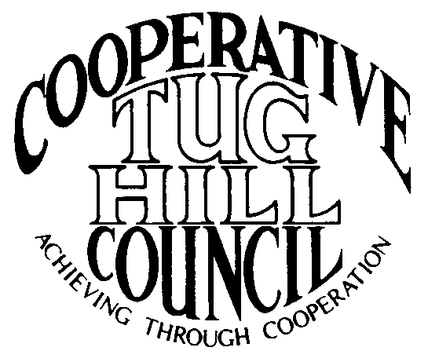 | Executive Committee  ROGER TIBBETTS, Chair  DOUGLAS DIETRICH, Vice Chair  CARLA BAUER, Secretary  IAN KLINGBAIL, Director  STEPHEN BERNAT, Director  ROSALIE WHITE, Director  PAULETTE WALKER, Director  Contact: Angie Kimball, Circuit Rider  PO Box 34, Redfield NY, 13437  Email: angie@tughill.org  Cell 315-480-6857  Home 315-599-8825

CTHC Executive Committee Meeting Minutes 3/1/2018

The meeting was called to order at 7:00 p.m. by Chairman R. Tibbetts. Also present for the meeting were D. Dietrich, Vice Chair; C. Bauer, Secretary; S. Bernat, Director; P. Walker, Director; I. Klingbail, Director; Rosalie White, Director; A. Kimball, Circuit Rider and K. Malinowski and P. Street from the Tug Hill Commission.

Minutes: The minutes of the December 21, 2017 Executive Committee meeting were reviewed by the Committee. A motion was made by D. Dietrich (Martinsburg) and seconded by R. White (Leyden) to accept the minutes as presented. All were in favor. (See attached minutes.)

Reports: A) Financial Report – A copy of the CTHC financial reports from January through March 2018, the Circuit Rider comparison and financial projection as of March 1, 2018 were presented by R. Tibbetts (Rodman) and reviewed by the members. Year-to-Date Carryover: $43,553.79; Receipts-to-Date: $10.51; Distributions-to-Date: $1,524.56; Current Net Funds Available: $42,039.74. Following review and discussion of reports a motion was made by S. Bernat (Harrisburg), seconded by P. Walker (Boylston) to accept the financial reports as presented. All were in favor. (See attached reports.)
B) Reports of Towns – A. Kimball presented the report of the Towns and reviewed the pertinent information for each. (See attached report.)
C) Tug Hill Updates and Project Reports:
1) Model Associates Contract – P. Street (THC) reported that the Commission has been working on a model Associate’s contract to offer the COGs as samples that are more contractor-like. A sample was provided (see attached) for the members to review. I. Klingbail (Lewis) stated that this has been a hot topic at his employment specifically that you can’t work as an independent contractor if you are doing the same work that you would as an employee. The definitions of employees vs. contractors were reviewed from the NYS Dept. of Labor. No action was taken at this point.
2) State Land Tax Proposal – K. Malinowski (THC) reviewed the proposal in the Governor’s budget which would change how the State pays taxes on state land to make it a more uniform process. She presented a sheet with some projections on the possible impacts on our Tug Hill towns (see attached). She doesn’t know if the proposal will go anywhere, as it is getting some opposition, but they will keep and eye on things.
3) 480B Proposal – K. Malinowski (THC) also reported on the proposed 480b changes included in the Empire Forestry for the Future Initiative (EFFI) also included in the Governor’s budget proposal (see attached). Also included in the EFFI proposal is a timber harvest notification requirement, a state procurement preference for NY grown and manufactured wood products and a community forest grant program. There seems to be some confusion with people mixing this program and the State Land Tax proposal together. She again is not sure how this bill will do, so they are monitoring the situation. She recommended getting comments in to legislators if anyone had comments on either proposal.
4) Minimum Maintenance Roads – K. Malinowski (THC) brought a copy of the map that was presented at Map Day in Albany last spring and also brought more copies of the white paper on Minimum Maintenance Roads for the members. They have been doing outreach and have several statewide organizations on board with helping with the legislation. The NYS Snowmobile Assoc. has a lobbyist and they will be setting up meetings with Assemblyman Gantt’s staff, as we need to get the bill on the Transportation Committee’s agenda and then get it out of committee to the floor. The NYS Highway Superintendent’s Association is also taking up the issue. They have been in contact with several statewide organizations trying to get people to call their legislators to try and get some pressure going. The process will really start to ramp up after the budget is passed, so if it is not on the agenda by the end of April do we take a group to Albany again? The other possibility is to start work on County bills at that point. West Turin’s next hearing on their appeal will probably be a May or June hearing date, so stay tuned.
D) Any other reports – None

Old Business: A) IMA Updates- A. Kimball (CR) reported that all of our municipalities have approved the new IMA and she is still awaiting 2 signatures to get the final copies completed and filed with the clerks.
B) Special Areas Maps website progress- A. Kimball (CR) reported that the link to the new maps is on the CTHC webpage and the section is up and running.
C) Other Old Business – Chairman R. Tibbetts (Rodman) reported on the COG Chairs meeting and what he spoke about from our COG. The chairs thought a SuperCOG would be good to hold this year and the date is tentatively set for the end of May.
New Business: A) Spring Meeting- The meeting will be held at the Central Hotel in Glenfield. D. Dietrich (Martinsburg) will speak to the proprietor and get the details to A. Kimball (CR) for the invitations. The speaker is proposed to be Ryan Piche, Lewis County Manager and his team on economic development in Lewis County. A. Kimball (CR) will contact him and see if he would like to speak.
- Elections: Executive Committee Membership – All of the current Executive Committee stated that they would run for election again for 2018.
- 2018 Goals – The 2017 goals were reviewed and the Board discussed changes for the proposed 2018 goals to be presented to the full Council at the spring meeting (see attached)
B) Town of Adams Interest in Joining – The Town of Adams has expressed interest in joining the CTHC. A. Kimball (CR) attended their January meeting to discuss the matter and let them know what we do. They are interested in joining and their Board approved to join pending approval from the full CTHC. The matter will be added to the spring meeting agenda for a vote by the full Council.
C) Any Other New Business- An announcement just received from T. Yerdon, Redfield’s Supervisor, was read about a recent announcement of the Round III awards for the Broadband Initiative. Several of our towns are on the list of where funding will be going to increase broadband coverage.

With no more business before the committee a motion was made by D. Dietrich (Martinsburg) and seconded by I. Klingbail (Lewis) to adjourn the meeting at 8:09 pm. All were in favor.

