Member Communities  Towns of Adams Boylston Florence Harrisburg Lewis Leyden Lorraine Martinsburg Montague Osceola Pinckney Redfield Rodman Turin West Turin Williamstown Worth Villages of Constableville Lyons Falls Port Leyden Turin  Website: tughillcouncil.com | 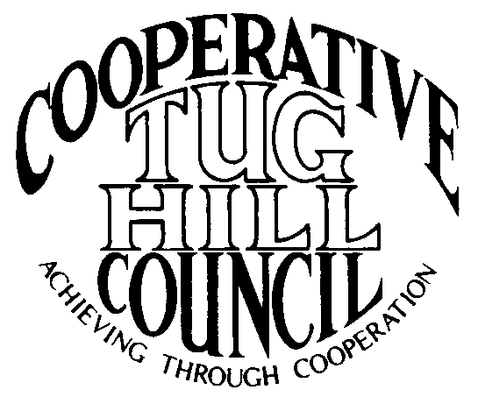 | Executive Committee  ROGER TIBBETTS, Chair  DOUGLAS DIETRICH, Vice Chair  CARLA BAUER, Secretary  IAN KLINGBAIL, Director  STEPHEN BERNAT, Director  ROSALIE WHITE, Director  PAULETTE WALKER, Director  Contact: Angie Kimball, Circuit Rider  PO Box 34, Redfield NY, 13437  Email: angie@tughill.org  Cell 315-480-6857  Home 315-599-8825

CTHC Executive Committee Meeting Minutes 6/26/2018

The meeting was called to order at 7:02 p.m. by Chairman R. Tibbetts. Also present for the meeting were D. Dietrich, Vice Chair; C. Bauer, Secretary; S. Bernat, Director; P. Walker, Director; I. Klingbail, Director; A. Kimball, Circuit Rider and K. Malinowski and P. Street from the Tug Hill Commission.

Minutes: The minutes of the March 1, 2018 Executive Committee meeting were reviewed by the Committee. A motion was made by C. Bauer (Redfield) and seconded by S. Bernat (Harrisburg) to accept the minutes with the correction of Paulette’s new last name. All were in favor. (See attached corrected minutes.)

Reports: A) Financial Report – A copy of the CTHC financial reports from April through June 25, 2018, the dues paid to date and financial projection as of June 25, 2018 were presented by R. Tibbetts (Rodman) and reviewed by the members. Year-to-Date Carryover: $43,553.79; Receipts-to-Date: $9,626.86; Distributions-to-Date: $5,812.33; Current Net Funds Available: $47,368.32. Following review and discussion of reports a motion was made by R. Tibbetts (Rodman), seconded by I. Klingbail (Lewis) to accept the financial reports as presented. All were in favor. (See attached reports.)
B) Reports of Towns – A. Kimball presented the report of the Towns and reviewed the pertinent information for each. (See attached report.)
C) Tug Hill Updates and Project Reports:
1) Montague Radar – K. Malinowski (THC) reported that the Montague Radar paper the Commission has been working on is now out. They worked with the National Weather Service to make sure that the information they had was correct. They have also talked to Todd Polk at Fort Drum about the issue and Fort Drum is discussing with the developers re-designs of the projects to get the towers out of the concern zone. There is also an air defense radar in Steuben which they have reached out to try and get the zones for, but they are waiting for information back from them.
2) Local Leaders Survey Results – K. Malinowski (THC) handed out a copy of the results from the Commission’s Local Leader’s Survey for the committee to review. They had a 64% return rate, which they were very happy with. The results will be converted into a white paper which will be shared with our state legislators, after the election this year.
3) 45th Anniversary celebration – K. Malinowski (THC) also spoke about their annual meeting this year which will be their 45th anniversary. The meeting will be held 11/8 at the Grape and Grog in Camden. They will be honoring Arnie Talgo and the new book they have been working on should be out by then.
4) Super COG meeting – K. Malinowski (THC) asked for feedback on the meeting, format, location, etc. R. Tibbetts (Rodman) commented that he thought it was a good session and that there was good participation. He doesn’t feel we need to do one of these meetings every year. D. Dietrich (Martinsburg) expressed concerns about the discussion at the meeting regarding wind projects and that he felt that Martinsburg was cast in a bad light as they have an existing wind farm. A discussion followed about the concerns and other people’s thoughts on the matter. At the end of the discussion, it was noted that some of the currently proposed projects have different issues that the Maple Ridge project didn’t have, as well as a different process to go through.
5) CTHC Mini-plans – P. Street (THC) reported that at the last Executive Committee meeting there was a discussion on comp plans and the resolutions that Redfield and Worth had approved listing their documents which are operation as their comp plans. There was a discussion at the spring meeting about the subject as well. The Commission will have an intern this summer and he would be able to make the mini-comp plans for the towns. He starts on 7/2 and is available through about 8/11. Once the plans are complete, the towns can adopt them or not as they desire.
D) Any other reports – None

Old Business: A) Associate’s contracts – A. Kimball (CR) handed out a proposed draft of the new contract for the Associate’s for review (see attached). After a discussion on the proposed contract and some minor changes, a motion was made by D. Dietrich (Martinsburg) and seconded by I. Klingbail (Lewis) to utilize this contract starting in 2019.
B) Intermunicipal Agreement (IMA) – A. Kimball (CR) handed out a draft of the new IMA which includes the Town of Adams for review. A motion was made by C. Bauer (Redfield) and seconded by P. Walker (Boylston) to approve the updated IMA and disperse it for signatures.
C) Other Old Business – None
New Business: A) Fall Meeting- The meeting will be held at the Steak and Brew in Turin if available. The date will be 9/27 with a back-up date of 9/20. Ideas for speakers included something about solar projects, broadband expansions, snowmobile issues (with D. Dietrich speaking) or Attorney Joe Russell, who R. Tibbetts (Rodman) will speak to.
B) Mad River Wind – support of towns –R. Tibbetts (Rodman) presented some ideas he had about support for Redfield and Worth (the towns involved in the Mad River wind project) (see attached). A discussion followed about if the CTHC should comment on the process or attempt to assist the towns. After discussion, the matter was tabled for the present time.
C) New meeting coverage schedule – The new meeting coverage schedule was passed out by A. Kimball (CR) (see attached) for the committee to review.
C) Any Other New Business- None

With no more business before the committee a motion was made by D. Dietrich (Martinsburg) and seconded by C. Bauer (Redfield) to adjourn the meeting at 8:20 pm. All were in favor.

