Member Communities  Towns of Boylston Florence Harrisburg Lewis Leyden Lorraine Martinsburg Montague Osceola Pinckney Redfield Rodman Turin West Turin Williamstown Worth Nonmember Villages of Constableville Lyons Falls Port Leyden Turin  Website: tughillcouncil.com | 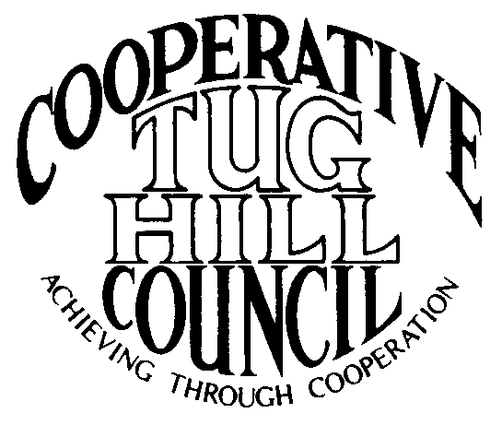 | Executive Committee  ROGER TIBBETTS, Chair  DOUGLAS DIETRICH, Vice Chair  CARLA BAUER, Secretary  IAN KLINGBAIL, Director  STEPHEN BERNAT, Director  ROSALIE WHITE, Director  PAULETTE SKINNER, Director  Contact: Angie Kimball, Circuit Rider  PO Box 34, Redfield NY, 13437  Email: angela@tughill.org  Cell 315-480-6857  Home 315-599-8825

CTHC Executive Committee Meeting Minutes 1/19/2017

The meeting was called to order at 7:04 p.m. by Chairman R. Tibbetts. Also present for the meeting were D. Dietrich, Vice Chair; S. Bernat, Director; R. White, Director; P. Skinner, Director; A. Kimball, Circuit Rider and K. Malinowski and M. Dietrich from the Tug Hill Commission.

Minutes: The minutes of the August 1, 2016 Executive Committee meeting were reviewed by the Committee. A motion was made by D. Dietrich and seconded by P. Skinner to accept the minutes as presented. All were in favor. (See attached minutes.)

Reports: A) Financial Report – A copy of the CTHC financial report and financial projection as of December 31, 2016 were presented by R. Tibbetts and reviewed by the members. Year-to-Date Carryover: $42,692.58; Receipts-to-Date: $10,269.02; Distributions-to-Date: $8,272.75; Current Net Funds Available: $44,688.85. Following review and discussion of reports a motion was made by S. Bernat, seconded by D. Dietrich to accept the financial reports as presented. All were in favor. (See attached report.)
B) Reports of Towns – A. Kimball presented the report of the Towns and reviewed the pertinent information for each. (See attached report.)
C) Tug Hill Updates and Project Reports:
1) Grant or Funding for Intern- K. Malinowski reported that the Commission would like to have another intern come in for the summer. They thought one of the possible uses of the intern could be to update the CTHC Resource Management Plan (RMP). The intern they had last year was funded by a grant from Pratt Northram, which limits the area the intern can come from, and unfortunately this grant is due by 1/31/17. They also discussed the possibility of sharing the funding for an intern. The committee agreed to bring the idea up at the spring meeting for ideas and approved to go forward with the idea.
2) Rockefeller Institute of Government presentation- K. Malinowski and A. Kimball did a presentation at the Rockefeller Institute of Government in Albany about our area and COG and how our municipalities share services, focusing on Justice Courts. The presentation went over well and there were lots of questions. It was a great opportunity for networking.
3) Local Government Conference- The conference is coming up soon. There are online and regular paper registrations available this year. There are discussions on-going about a possible date change due to the conference currently happening at the end of the State fiscal year as well as conflicts with lots of other conferences which are scheduled at that time of year making it hard to get good speakers. The dates they are looking at presently are June 7th or 14th.
4) Renewables on the Ground Roundtable- This is a state-wide group that the Commission is participating in. They are trying to figure out how to meet Governor Cuomo’s “50 by 30” goal of having 50% of NY’s energy be from renewable sources by 2030. There are environmental concerns about siting versus the decreased carbon footprint of wind and solar energy. Katie will be gathering feedback from our communities and taking it back to the Roundtable.
5) Miscellaneous- The 480a/b possible amendments were in the Governor’s “state of the state” book (including the town reimbursements), but they did not appear in the budget bills. This may end up going forward as a Department bill, but overall things look somewhat promising. There was also a new county efficiency plan proposed in the “state of the state”, which they will be keeping an eye on. The new Minimum Maintenance Road bills are out with the same wording as last time so far. She will be talking to the Adirondack Mountain Club and others again to try and garner support.

D) Any other reports – None

Old Business: A) Super COG meeting- The notes from last fall’s Super COG meeting were handed out to the committee (see attached).

New Business: A) Website-mapping section – M. Dietrich gave a presentation of some options for the special area map section of the website. He demonstrated the Commission’s map viewer, and also discussed the possibility of pdf maps and story maps. The committee looked at the current map in the website and discussed the various options. It will be brought up at the spring meeting and a similar presentation made to the full Council.
B) Website –standardization of town pages – The committee looked at the pages from a couple of towns that A. Kimball had entered the standardized information for. She would like to have a page for each town with the same information as well as whatever information the town would like. The committee approved to go forward with presenting the plan to the full Council.
C) IMA Updates – The IMA for the Cooperative Zoning Board of Appeals was mentioned. A. Kimball will be working with the involved towns to get the IMA renewed as the current one expires 5/30/17. The IMA for the CTHC also expires this year (12/31/17) and a copy of the existing IMA was given to the committee, so that they could review it prior to the spring meeting (see attached). A copy will be provided to the towns at the spring meeting so they can review it in advance of having to approve a new IMA by the end of the year.
D) Election Updates – A list of the changes in elected officials for the November elections was reviewed by A. Kimball. As this is an off election year there weren’t many changes.
E) Any Other New Business- A tentative date of 4/27 was selected for the spring meeting. The meeting will need to be at someplace with wifi or a good cell phone signal (for a hot spot) in order for the presentations on the website to be given. A. Kimball will check with the Alpine, the Steak and Brew and if necessary some fire department and have dinner catered.
-A. Kimball passed along a request from the Associate Circuit Riders for a reimbursement policy, which will make it easier for them to know what they can submit vouchers for and what they can’t. R. Tibbetts will work on drafting something.

With no more business before the committee a motion was made by S. Bernat and seconded by R. White to adjourn the meeting at 8:39 pm. All were in favor.

