Member Communities  Towns of Boylston Florence Harrisburg Lewis Leyden Lorraine Martinsburg Montague Osceola Pinckney Redfield Rodman Turin West Turin Williamstown Worth Villages of Constableville Lyons Falls Port Leyden Turin  Website: tughillcouncil.com | 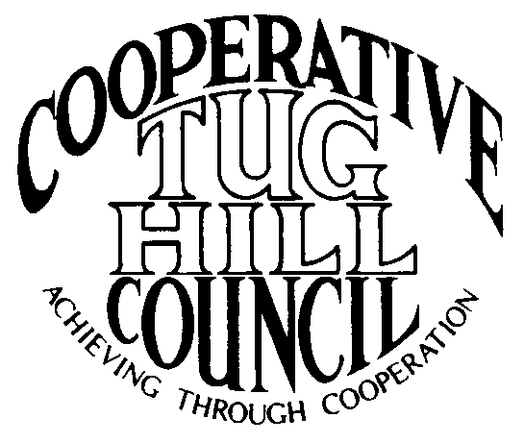 | Executive Committee  ROGER TIBBETTS, Chair  DOUGLAS DIETRICH, Vice Chair  CARLA BAUER, Secretary  IAN KLINGBAIL, Director  STEPHEN BERNAT, Director  ROSALIE WHITE, Director  PAULETTE WALKER, Director  Contact: Angie Kimball, Circuit Rider  PO Box 34, Redfield NY, 13437  Email: angie@tughill.org  Cell 315-480-6857  Home 315-599-8825

CTHC Executive Committee Meeting Minutes 12/21/2017

The meeting was called to order at 7:04 p.m. by Chairman R. Tibbetts. Also present for the meeting were D. Dietrich, Vice Chair; S. Bernat, Director; P. Walker, Director; I. Klingbail, Director; R. White, Director; A. Kimball, Circuit Rider and P. Street from the Tug Hill Commission.

Minutes: The minutes of the August 22, 2017 Executive Committee meeting were reviewed by the committee. A motion was made by D. Dietrich and seconded by S. Bernat to accept the minutes as presented. All were in favor. (See attached minutes.)

Reports: A) Financial Report – A copy of the CTHC financial report and financial projection as of November 30, 2017 were presented by R. Tibbetts and reviewed by the members. Year-to-Date Carryover: $44,688.85; Receipts-to-Date: $9,706.53; Distributions-to-Date: $9,541.35; Current Net Funds Available: $44,854.03. The dues structure for the next several years with the addition of the villages was also reviewed. Following review and discussion of reports a motion was made by I. Klingbail, seconded by P. Skinner to accept the financial reports as presented. All were in favor. (See attached reports.)
B) Reports of Towns – A. Kimball presented the report of the Towns and reviewed the pertinent information for each. (See attached report.)
C) Tug Hill Updates and Project Reports:
1) Planning Documents – P. Street discussed the amount of planning work the towns in our Council have done over the years, even if they haven’t done a “comprehensive plan” per se. He presented a sample resolution for Redfield (see attached) which shows everything they have approved over the years. He presented a chart with the basic information for each town and he would like to do one of these resolutions for each town for their approval so long as the Executive Committee is in favor. The feeling was to package the more recent materials for the towns to go with the resolution once we start working on this.
2) Intern for 2018 – The Commission is working to get interns again for the summer of 2018. Let Angie know if you have any ideas for an intern project.
3) COG Chairs and Super COG – The COG Chairs meeting is set for 1/29 at the Lorraine Town Hall, and we are tentatively looking at an end of May date for Super COG.
D) Any other reports – Adams Supervisor Dave Kellogg has spoken to R. Tibbetts about possibly joining the CTHC. A. Kimball was going to attend the December meeting, but had a death in the family, so she will go to their January meeting to give them some information about the Council and see if they would like to join.

Old Business: A) IMA Updates- A. Kimball reported that the IMA update was approved by all the members and she has 13 of the 20 signed copies in hand and she will be working on getting the remaining signatures so she can get signed copies to all the Clerks.
B) Special Areas Map Website Updates- A. Kimball reported that she is working at getting the new mapping link up on the website. The password protection on the old map has been removed and she just has to find time to work with M. Dietrich at the Commission to add the link to the map viewer.

New Business: A) Spring Meeting- The Committee discussed possible locations for the meeting and it was decided to go back to the Central Hotel in Glenfield. Possible topics were snowmobile issues or another wind project update. D. Dietrich will talk to Jackie Mahoney and if she isn’t available he may be able to get someone from the Snowmobile Assoc. or speak himself. The proposed date is April 26th.
B) Newly Elected Officials – A. Kimball presented a sheet with the newly elected officials in the CTHC municipalities (see attached) and a copy of the letter sent to the new officials (see attached) to the Committee.
C) New Meeting Coverage Schedule – A copy of the new meeting coverage schedule was given to the Committee (see attached). Currently the Associates’ will each be covering 6 meetings and A. Kimball will be covering 8, as well as visiting the other 12 at least once a year.
D) Any Other New Business - The request for sponsorship of the THC Local Government Conference was discussed. R. Tibbetts felt that with the changes in the budget it might be better to decline. D. Dietrich was not in favor of sponsoring. I. Klingbail asked if the other COGs sponsored to which A. Kimball replied “yes”. A motion was made by D. Dietrich and seconded by S. Bernat not to sponsor the Local Government Conference. All were in favor.
- P. Street reported that Redfield is hoping to pass a new zoning law soon and is likely to want to join the Cooperative ZBA, increasing the membership to 6 towns. He discussed the possibility of splitting the Board into two, three person Boards. There is also the possibility that Lorraine and Lyons Falls (if they complete their Zoning Law) would be interesting in joining a Cooperative Board.
- The proposed Associate contracts were reviewed by the Committee and a motion was made by S. Bernat and seconded by I. Klingbail to approve Chairman R. Tibbetts to sign the contracts as presented. All were in favor.

With no more business before the committee a motion was made by D. Dietrich and seconded by R. White to adjourn the meeting at 8:30 pm. All were in favor.

