Member Communities  Towns of Adams Boylston Florence Harrisburg Lewis Leyden Lorraine Martinsburg Montague Osceola Pinckney Redfield Rodman Turin West Turin Williamstown Worth Villages of Constableville Lyons Falls Port Leyden Turin  Website: tughillcouncil.com | 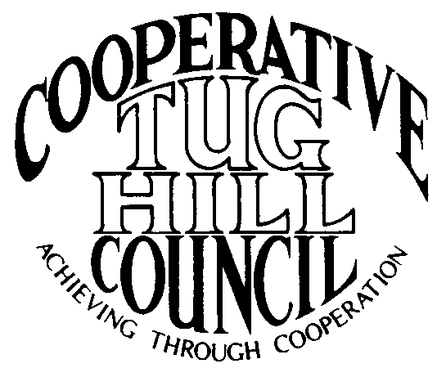 | Executive Committee  ROGER TIBBETTS, Chair  DOUGLAS DIETRICH, Vice Chair  CARLA BAUER, Secretary  IAN KLINGBAIL, Director  STEPHEN BERNAT, Director  ROSALIE WHITE, Director  PAULETTE WALKER, Director  Contact: Angie Kimball, Circuit Rider  PO Box 34, Redfield NY, 13437  Email: angie@tughill.org  Cell 315-480-6857  Home 315-599-8825

Executive Committee Meeting
March 26, 2019
Boylston Town Hall

AGENDA

7:00 p.m. – Call the meeting to order

- Attendance

- Minutes of the previous meeting – reading and approval

- Reports: a) Financial report – Roger
b) Reports of Towns – Angie
c) Tug Hill Topics and Project reports
1) Resident and Landowner Survey
2) Strategic Plan
3) Phil’s retirement
4) Minimum Maintenance Roads update
d) Any other reports

- Old Business: a) Spring meeting details finalization (location, speaker)
b) Wind Project updates
c) Any other old business

- New Business: a) Election of Officers – interest in holding office
b) Work Goals for 2019
c) Any other new business

6) Motion for adjournment

