Member Communities  Towns of Boylston Florence Harrisburg Lewis Leyden Lorraine Martinsburg Montague Osceola Pinckney Redfield Rodman Turin West Turin Williamstown Worth Nonmember Villages of Constableville Lyons Falls Port Leyden Turin  Website: tughillcouncil.com | 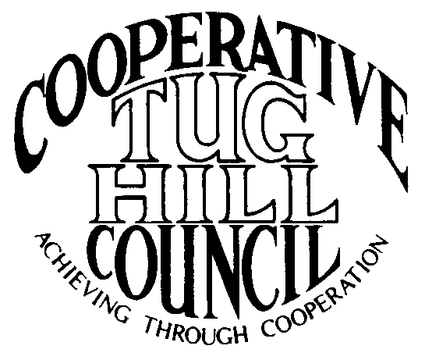 | Executive Committee  ROGER TIBBETTS, Chair  DOUGLAS DIETRICH, Vice Chair  MERIANNE SHELMIDINE, Secretary  IAN KLINGBAIL, Director  CARLA BAUER, Director  STEPHEN BERNAT, Director  ROSALIE WHITE, Director  Contact: Angie Kimball, Circuit Rider  PO Box 34, Redfield NY, 13437  Email: angela@tughill.org  Cell 315-480-6857  Home 315-599-8825

CTHC Spring Dinner Meeting Minutes 05/22/2014

The meeting was called to order at 7:00 pm by Chairman R. Tibbetts. Roll Call of Towns showed 12 towns in attendance for the meeting with representatives from Boylston, Harrisburg, Lewis, Leyden, Lorraine, Martinsburg, Montague, Osceola, Pinckney, Rodman, Redfield and West Turin present. Also present as guests were four of the Tug Hill Commissioners, two members of the Tug Hill staff, and seven other guests for a total attendance of 34 people.

Minutes: The minutes of the September 26, 2013 fall meeting were reviewed. A motion was made by D. Dietrich (Martinsburg) and seconded by T. Yerdon (Redfield) to accept the minutes as presented. All were in favor.

Reports: Financial Report – A copy of the Financial Report as of May 20, 2014 was presented by Chairman R. Tibbetts for review by members. Year-to-Date Carryover: $39,390.09; Receipts to Date: $8,419.09; Distributions to Date: $1,867.95; Current Net Funds Available: $45,941.23. Following review a motion was made by F. Yerdon (Osceola) and seconded by C. Bauer (Redfield) to accept the report as presented. All in favor.

At 7:25 the meeting was temporarily suspended for dinner. The meeting resumed at 8:00 pm.

Election of Officers: Slate presented – Roger Tibbetts, Chairman
Douglas Dietrich, Vice Chairman
Carla Bauer, Secretary
Ian Klingbail, Director
Stephen, Bernat, Director
Merianne Shelmidine, Director
Rosalie White, Director
There were no nominations from the floor. A motion was made by T. Yerdon (Redfield) for the polls to be closed and the Secretary to cast one ballot for the Slate of Officers presented, seconded by T. Thisse (Martinsburg). All in favor.

Presentation - Tug Hill Commission Topics:
Special Areas – The completed and Town approved maps for the Towns of Florence and Lorraine were presented to the Council. A Resolution for Local Reserve Plan Amendment and Filing and the necessary Short Environmental Assessment Form were presented to the Council and upon a motion by M. Yerdon (THC – Redfield) and a second by C. Bauer (Redfield) the resolution was approved as presented (see attachment). Additionally, an update on the status of the other town’s progress was presented. There are currently six maps approved and added to the regional plan (including Lorraine and Florence) with the anticipation of more maps to be approved locally by the fall meeting.
Highway Mapping – An update of the Highway Mapping project was presented to the Council. Currently all of the CTHC towns have some form of the map either completed and approved or in progress. Work is continuing to complete this project hopefully soon.
East Branch of Fish Creek - The East Branch of Fish Creek Working Group met 5/15/14 to update all the stakeholders on what has been happening and about some upcoming changes in the State’s easement lands (see attached sheets).
Cultural Heritage Program – J. Bartow (THC) discussed the Heritage project being undertaken by the Traditional Arts of Upstate New York (TAUNY). He also discussed the possibility of Loretta Lipkowski painting portraits of the Tug Hill Sages which is one of the projects being discussed.
Local Leaders Survey – Finally J. Bartow (THC) presented a tabulation report summarizing the results of the Local Leaders Survey that the Commission completes every five years. The numbers were very high for the Commission continuing its work with the communities (see attached report).

Old Business: Discussion of Village Membership – This discussion is currently on hold until we have both of our Associate’s back and things have settled down.

New Business: Guest Speaker – Bob McKenzie – Unfortunately due to the severe thunderstorm that hit this afternoon and some flooding in Leyden, Mr. McKenzie who is the Emergency Medical Services Coordinator, was unable to attend.
Fall Legislators Meeting – Will try to set the meeting up for September and possibly hold it at the Redfield Fire Hall. It is an election year and scheduling may be problematic, so the meeting could possibly be held on a Saturday morning.
Any other New Business: Gerry Ritter, the NOCCOG Circuit Rider is retiring soon. The Commission, in coordination with NOCCOG, is in the hiring process.

Supervisor’s Topics: F. Yerdon (Osceola) reported on an audit that the Town had National Grid undertake of their street lighting system and the savings that they will be receiving in the upcoming years. He would like to get this information out to all the towns.
Several Supervisors also asked about training on the new tax freeze and shared services plans put out by the Governor. There are very few details available yet, but the Commission will be glad to conduct some training, if they are requested to, as soon as some details become available.

With no other business before the Council, a motion was made at 8:35 pm by J. Bogdanowicz (THC-Montague) and seconded by R. Tibbetts (Rodman) to adjourn the meeting. All in favor.

