Member Communities  Towns of Boylston Florence Harrisburg Lewis Leyden Lorraine Martinsburg Montague Osceola Pinckney Redfield Rodman Turin West Turin Williamstown Worth Nonmember Villages of Constableville Lyons Falls Port Leyden Turin  Website: tughillcouncil.com | 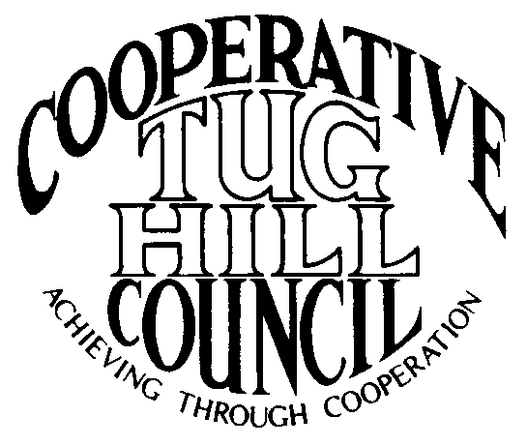 | Executive Committee  ROGER TIBBETTS, Chair  DOUGLAS DIETRICH, Vice Chair  MERIANNE SHELMIDINE, Secretary  IAN KLINGBAIL, Director  CARLA BAUER, Director  STEPHEN BERNAT, Director  ROSALIE WHITE, Director  Contact: Angie Kimball, Circuit Rider  PO Box 34, Redfield NY, 13437  Email: angela@tughill.org  Cell 315-480-6857  Home 315-599-8825

CTHC Spring Dinner Meeting Minutes 04/25/2013

The meeting was called to order at 6:40 pm by Chairman R. Tibbetts. Roll Call of Towns showed 13 towns in attendance for the meeting with representatives from Harrisburg, Lewis, Leyden, Lorraine, Martinsburg, Montague, Osceola, Pinckney, Redfield, Rodman, West Turin, Williamstown and Worth present. Also present as guests were three of the Tug Hill Commissioners, five members of the Tug Hill staff, and five other guests for a total attendance of 36 people.

Reports: Financial Report – A copy of the Financial Report as of April 24, 2013 was presented by Chairman R. Tibbetts for review by members. Year-to-Date Carryover: $36,746.35; Receipts to Date: $6,022.12; Distributions to Date: $1,521.77; Current Net Funds Available: $41,246.70. Following review a motion was made by C. Bauer (Redfield) and seconded by F. Platt (Lewis) to accept the report as presented. All in favor.

Election of Officers: Slate presented – Roger Tibbetts, Chairman
Douglas Dietrich, Vice Chairman
Merianne Shelmidine, Secretary
Ian Klingbail, Director
Stephen, Bernat, Director
Carla Bauer, Director
Rosalie White, Director
There were no nominations from the floor. A motion was made by D. Dietrich (Martinsburg) for the polls to be closed and the Secretary to cast one ballot for the Slate of Officers presented, seconded by E. Hayes (West Turin). All in favor.

Tug Hill Commission Executive Director J. Bartow then fielded a question from the floor regarding their status in the budget, which was at nearly the same level as 2012-13; and reported that the staff was due to get performance advances which would be the first since 2008. He also reported that the Local Government Conference went well and the attendance was in excess of 600. There were several sidebar meetings with local officials and Kathy Moshier and Rob Davies of the DEC that he thought went very well (more details followed during their presentation). The survey results should be out soon.

At 6:50 a short pause was taken for dinner. The meeting reconvened at 7:40 pm.

Presentation - Tug Hill Commission Topics:
Road Mapping – P. Street (Director of Planning) reported on the progress of the Road Mapping project. Presently two towns have accepted their new road maps and are looking at their low volume road maps. Two towns have their new maps and the Highway Superintendents are reviewing them. One town’s map has been reviewed by the Highway Superintendent and has gone back for corrections. Three draft maps are in the process of being generated. Three towns have passed old versions of the maps, but not new versions as yet and four towns have not had their data collected yet. They hope to have all the data collected this summer for all the CTHC towns and hope to have the draft maps out to the remaining towns by the end of the year.
Special Areas – K. Malinowski (Director of Natural Resources) reported on the progress of the Special Areas Mapping project. Currently, West Turin is the only town who has completed the process, but several other towns should have the process completed soon. Two towns have their public hearings set with two more to be set by the May meetings. There have also been preliminary meetings held or soon to be held in three other towns and three more met sometime in the past on the issue. Hopefully several more towns’ maps will be ready to be accepted by the Council by the fall meeting.
Core Forest – J. Bartow (Executive Director) discussed the meetings that were held with the DEC at the Local government Conference which brought to the attention of the DEC how badly the 480A exemption plan is hurting our small towns, as well as several other local issues. He also discussed other core forest issues like fragmentation, the new Nature Conservancy PILOT, and pending land sales by a TMO in Redfield and Williamstown. A discussion followed regarding these issues, stumpage fees, DEC being understaffed to supervise their lands and their programs. The Commission staff will continue to work on the issues as the Council directs.

Old Business: None

New Business: Retirement of Jeanne Wooding – A gift and card was given to Jeanne for her years of service from the CTHC, and also a framed Certificate of Appreciation from the Tug Hill Commission. She was thanked for her years of service and wished well on her upcoming retirement which is effective 5/31/13. The job search is underway to find Jeanne’s replacement with ads to be out soon in several local papers.
Fall Legislators Meeting – Will try to set the meeting up for late September and possibly hold it at the Constableville Fire Hall. Supervisor’s try and get topics that you want discussed in to your Circuit Riders and we will try and get the topics in to the Legislators in advance, so we can focus on both regional issues and any more localized issues that are relevant.
Discussion of Village Membership – A discussion regarding inviting the Villages of Port Leyden, Lyons Falls, Constableville and Turin to become full paying members, with coverage by Circuit Riders and by Tug Hill staff took place. Concerns include if the meetings can be adequately covered, and if there would be interest from the Villages. R. Tibbetts will work on a letter of invitation from the Council to send to the Villages; and if there is interest expressed A. Kimball will go to their meeting with updated brochures and project lists and to answer any questions (J. Bartow and A. Kimball will work to get this material updated).
Any other New Business: None

Supervisor’s Topics: SNIRT Run – K. Chapman reported they had 3000+/- riders and some damage was done, which was covered in the press. The Snowmobile club is cleaning up damage today (replanting seeds, fixing roads etc.)
F. Yerdon (Osceola) reported that the process to receive their Certificate of Need for their ambulance service is progressing. They have a public hearing coming up 5/9/13 and then they can apply for a certificate to bill so the process should hopefully be complete soon. The Town is also reviewing their land use codes and they are having an issue with people living in recreational vehicles (RV’s) full time. There cannot be a Certificate of Occupancy issued for a RV. This problem is occurring all over the area and he is wondering if this is an issue that the CTHC could look at as a whole, possibly setting up a basic starting resolution that could be adapted to each town’s codes. Perhaps a committee could be set up with P. Street to look into this issue for possible solutions and have a plan to present at the legislators meeting.

With no other business before the Council, a motion was made at 8:30 pm by R. Tibbetts (Rodman) and seconded by C. Bauer (Redfield) to adjourn the meeting. All in favor.

