Member Communities  Towns of Boylston Florence Harrisburg Lewis Leyden Lorraine Martinsburg Montague Osceola Pinckney Redfield Rodman Turin West Turin Williamstown Worth Nonmember Villages of Constableville Lyons Falls Port Leyden Turin  Website: tughillcouncil.com | 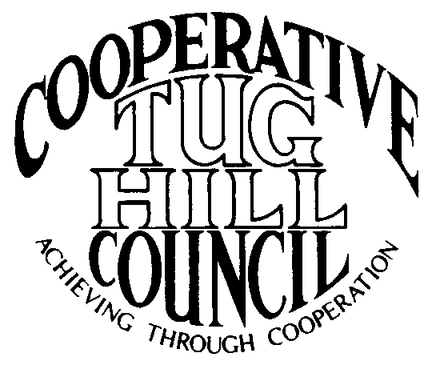 | Executive Committee  ROGER TIBBETTS, Chair  DOUGLAS DIETRICH, Vice Chair  CARLA BAUER, Secretary  IAN KLINGBAIL, Director  MERIANNE SHELMIDINE, Director  STEPHEN BERNAT, Director  ROSALIE WHITE, Director  Contact: Angie Kimball, Circuit Rider  PO Box 34, Redfield NY, 13437  Email: angela@tughill.org  Cell 315-480-6857  Home 315-599-8825

CTHC Fall Dinner Meeting Minutes 09/18/2014

The meeting was called to order at 7:00 pm by Chairman R. Tibbetts. Roll Call of Towns showed 12 towns in attendance for the meeting with representatives from Florence, Lewis, Leyden, Lorraine, Martinsburg, Osceola, Pinckney, Redfield, Rodman, Turin, West Turin and Worth present. Also present as guests were three of the Tug Hill Commissioners, two members of the Tug Hill staff, and eight other guests for a total attendance of 36 people. Following introductions a pause was taken for dinner. The meeting recommenced at 7:40 pm.

Speaker: Bob MacKenzie from Lewis County’s Emergency Management Office gave a presentation on volunteerism in the Fire and EMS fields.

Minutes: The minutes of the May 22, 2014 spring meeting were reviewed (see attached). A motion was made by D. Dietrich (Martinsburg) and seconded by C. Bauer (Redfield) to accept the minutes as presented. All were in favor.

Reports: Financial Report – A copy of the Financial Report as of August 31, 2014 was presented by Chairman R. Tibbetts (Rodman) for review by members (see attached). Year-to-Date Carryover: $39,390.09; Receipts to Date: $9,738.25; Distributions to Date: $3,853.01; Current Net Funds Available: $45,275.33. Following review a motion was made by M. Shelmidine (Lorraine) and seconded by R. White (Leyden) to accept the report as presented. All in favor.

Budget: Chairman R. Tibbetts (Rodman) presented a copy of the proposed budget for 2015. A copy of the 2014 budget was attached for comparison purposes. Chairman Tibbetts (Rodman) has proposed a budget which is unchanged from the 2014 budget (see attached). After review of the proposed budget, a motion was made by A. Millick (Leyden) and seconded by F. Yerdon (Osceola) to accept the proposed budget for 2015 as presented. All were in favor.

Presentation - Tug Hill Commission Topics:
Special Areas – The completed and Town approved map for the Town of Lewis was presented to the Council. A Resolution for Local Reserve Plan Amendment and Filing and the necessary Short Environmental Assessment Form were presented to the Council and upon a motion by T. Yerdon (Redfield) and a second by C. Bauer (Redfield) the resolution was approved as presented (see attachment). Additionally, an update on the status of the other town’s progress was presented. Boylston and Turin are the only towns who haven’t started the process yet. (Progress report attached)
Highway Mapping – An update of the Highway Mapping project was presented to the Council. Currently all of the CTHC towns have some form of the map either completed and approved or in progress. Work is continuing to complete this project hopefully soon. Some of the towns are working on minimum maintenance roads. (Progress report attached)
East Branch of Fish Creek - The East Branch of Fish Creek Working Group update newsletter is going out in the mail to stakeholders (see attached sheets). Work has also begun on a non-motorized trail that would extend from the Tug Hill Wildlife Management Area to the West Leyden/Osceola Rd. They hope to have a proposal, tentatively titled the Tug Hill Traverse, drawn up by spring.
Cultural Heritage Program – J. Bartow (THC) discussed the potential of Loretta Lipowski, a local artist, painting portraits of Tug Hill Sages and “Venerable Tug Hill-ers”, in partnership with TAUNY for oral /pictorial histories. Nominations for a new round of Tug Hill Sages will begin at the end of this year for presentation in May of 2015.
Strategic Planning Meeting – Finally, J. Bartow (THC) discussed the Strategic Planning meeting that will be held 9/30/14 at the Fire Hall in Redfield. The Commission is looking for input into what program areas they should allocate their resources to for the next five years. Local governance is one area which may see an increase in requests for support.

Old Business: Discussion of Village Membership – This discussion currently continues on hold as we examine our potential for covering the meetings.

New Business: Proposed Bylaw Change – The proposed bylaw change was read and after discussion, a motion was made by M. Shelmidine (Lorraine) and seconded by T. Thisse (Martinsburg) to accept the addition of “Section 14. Directors” and attendant wording as presented (see attached). All were in favor.
Town Information Survey- A. Kimball (Circuit Rider) explained that the Council is attempting to gather information from the member towns regarding their various positions (both appointed and elected) and other general information about shared services and position consolidations etc. to help her to be able to connect towns that have questions with other towns who may have already completed these projects or who may be interested in doing so. She asked that each town fill in the survey at their convenience and that she would have the results tabulated and hoped to present them at the next spring dinner.

Supervisor’s Topics: G. Stinson (Rodman) spoke about his interest in the survey and its results. He felt that as times are changing it would be good to have information about positions changing from elected to appointed, etc. He felt that the Highway Superintendent position, being in control of the most costly part of town government, should have an appointed person with some training holding it. Chairman R. Tibbetts (Rodman) commented that the change had been tried in some towns and that it is most often not passed on the ballot. He felt that towns might have to rely more on internal training or possibly look for a State legislative change making training mandatory, as it is with some other positions. V. Moore (Lorraine) commented that the Highway Superintendent position, as well as other elected positions, is becoming more administrative every year, and less hands on.
T. Yerdon (Redfield) brought up a question to J. Bartow (THC) asking if he knew if unemployment was required to be paid on appointed positions. J. Bartow reported that it seems to be a gray area and that they are still looking into finding the answer. Currently it seems to be a case by case interpretation. The reports that the Town has to file to the Tax and Finance Department on employees are what seem to be triggering the questions and various factors, like the amount (if any) of pay, or eligibility for retirement, compensation insurance seem to be factors in the determination. T Yerdon (Redfield) reported that the answer seems to change depending on which department at the State you are speaking to. In a similar vein, F. Yerdon (Osceola) also reported that the Retirement System advises that each Town should have a form asking all new employees if they belong to the system already and if they want to join if they don’t already belong. The employee should sign this form and the Town should keep it on file to avoid problems.

With no other business before the Council, a motion was made at 8:55 pm by R. Tibbetts (Rodman) and seconded by C. Bauer (Redfield) to adjourn the meeting. All were in favor.

