Member Communities  Towns of Boylston Florence Harrisburg Lewis Leyden Lorraine Martinsburg Montague Osceola Pinckney Redfield Rodman Turin West Turin Williamstown Worth Nonmember Villages of Constableville Lyons Falls Port Leyden Turin  Website: tughillcouncil.com | 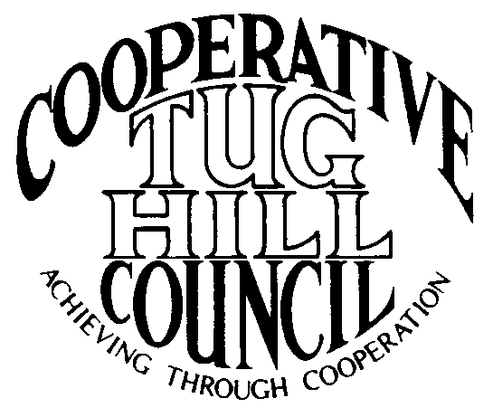 | Executive Committee  ROGER TIBBETTS, Chair  DOUGLAS DIETRICH, Vice Chair  MERIANNE SHELMIDINE, Secretary  IAN KLINGBAIL, Director  CARLA BAUER, Director  STEPHEN BERNAT, Director  ROSALIE WHITE, Director  Contact: Angie Kimball, Circuit Rider  PO Box 34, Redfield NY, 13437  Email: angela@tughill.org  Cell 315-480-6857  Home 315-599-8825

CTHC Fall Dinner Meeting Minutes 09/26/2013

The meeting was called to order at 6:58 pm by Chairman R. Tibbetts. Roll Call of Towns showed 13 towns in attendance for the meeting with representatives from Boylston, Florence, Harrisburg, Lewis, Lorraine, Martinsburg, Montague, Osceola, Pinckney, Redfield, Rodman, Williamstown and Worth present. Also present as guests were two of the Tug Hill Commissioners, three members of the Tug Hill staff, and twelve other guests for a total attendance of 40 people.

Introductions: New Associate Circuit Rider Beth Steria was introduced and the guests all introduced themselves to Mrs. Steria. After introductions the meeting was temporarily suspended for dinner. The meeting recommenced at 7:40 pm.

Minutes: The minutes of the Spring meeting of 04/25/13 were reviewed and a motion was made by D. Dietrich (Martinsburg) and seconded by L. Platt (Lewis) to accept the minutes as presented. All in favor.

Reports: Financial Report – A copy of the Financial Report as of September 23, 2013 was presented by Chairman R. Tibbetts for review by members. Year-to-Date Carryover: $36,746.35; Receipts to Date: $9,710.36; Distributions to Date: $4,781.30; Current Net Funds Available: $41,675.41. An updated Financial Projection through 2018 was presented which shows an increased reserve transfer to checking to cover a pay increase for the Associate Circuit Riders from $14/hour to $17/hour. Following review a motion was made by C. Bauer (Redfield) and seconded by M. Shelmidine (Lorraine) to accept the reports as presented. All in favor. The proposed budget for 2014 was presented by Chairman R. Tibbetts with a Disbursements total for all categories of $13,650 (see attached). A motion was made by L. Platt (Lewis) and seconded by G. Stinson (Rodman) to accept the 2014 budget as presented. All in favor.

Presentation - Tug Hill Commission Topics:
Special Areas – Montague, Rodman and Martinsburg have approved their Special Areas maps and they were presented to the body for approval to add them to the CTHC map. A motion was made by D. Dietrich (Martinsburg) and seconded by T. Yerdon (Redfield) to approve the Resolution for Local Reserve Plan Amendment and Filing (see attached) as presented. All in favor.
Core Forest – J. Bartow (Executive Director) discussed a tour that he and several others took of the Mulpus property. It is being very aggressively harvested. They are working on a fifty-year plan and are cutting 300-500 acres per year, with only about a dozen trees left per acre. They have put 35,000 acres up for sale including the land here that they have been harvesting. Marcy Timberland (former Harden property) has 4 parcels up for sale currently, with the State interested in acquiring two. The Conservation Fund is acting as a third party intermediary in these purchases. Woodwise (former Guchess property) is rumored to be contemplating filing 480A, which will be a huge impact in Redfield and Worth they decide to do so. He has been attending a state-wide stakeholders group regarding 480A and hopefully they can find some other options to this program to present to the State.
New CTHC Brochure – The new CTHC brochure design was presented to the membership for review and comment. Copies will be printed so they are available to hand out to the Towns and interested parties.

-Guest Speaker: Jackie Mahoney, Lewis County Trail Coordinator was introduced and gave an overview of her plans and what she is working on currently. She has met with several of the Towns and will be getting out to more as time allows.

Old Business: None

New Business: Fall Legislators Meeting – Will be held 10/28 or 10/30 at the Constableville Fire Hall. Hoping for a good turnout – last year had about 50 attendees. Get your issues in so they can be placed on the agenda. Current topics include 480A, Low Volume roads, Special Areas progress, STAR registration problems.
Any other New Business: None

Supervisor’s Topics: F. Yerdon (Osceola) reported their progress on their Certificate of Need for their ambulance service, which has still not been received. Even after they receive the paperwork they still have several months of work and more money before all the steps will be complete.
The Circuit Rider positions are all full again thankfully, so the outreach to the villages should be coming up soon.

With no other business before the Council, a motion was made at 8:19 pm by D. Dietrich (Martinsburg) and seconded by C. Bauer (Redfield) to adjourn the meeting. All in favor.

