Member Communities  Towns of Boylston Florence Harrisburg Lewis Leyden Lorraine Martinsburg Montague Osceola Pinckney Redfield Rodman Turin West Turin Williamstown Worth Nonmember Villages of Constableville Lyons Falls Port Leyden Turin  Website: tughillcouncil.com | 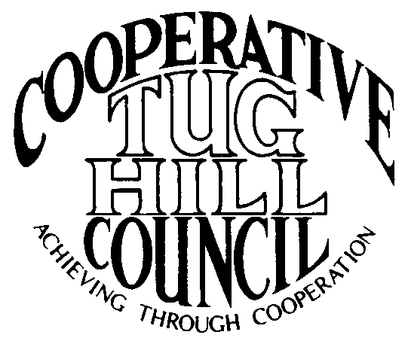 | Executive Committee  ROGER TIBBETTS, Chair  DOUGLAS DIETRICH, Vice Chair  CARLA BAUER, Secretary  IAN KLINGBAIL, Director  STEPHEN BERNAT, Director  ROSALIE WHITE, Director  PAULETTE SKINNER, Director  Contact: Angie Kimball, Circuit Rider  PO Box 34, Redfield NY, 13437  Email: angela@tughill.org  Cell 315-480-6857  Home 315-599-8825

Notes from the 480a Discussion from the
CTHC Spring Meeting April 30, 2015

Rob Davies, the NYS DEC Director of Lands and Forests was the speaker at the CTHC spring meeting and he discussed the Real Property Tax Law Section 480a. The discussion and questions and answers were as follows:
Mr. Davies reported that the 480a program has been around for about 40 years and there have been several attempts to revise the program in that time that have gotten nowhere. There have been problems with the program throughout its history. This year Governor Cuomo has decided to focus on forestry issues and charged DEC Commissioner Martens with coming up with some initiatives. Addressing the issues with 480a, a Harvest Notification filing with the DEC and a procurement preference for NY wood products are the three proposals that the Governor chose to have the DEC focus on. The DEC has drafted some legislation and through speaking to stakeholders has made some changes to their original draft documents (which is not the general process when drafting legislation rather than regulations).
Mr. Davies then addressed some of the issues with the existing 480a program. Forests are being sold off and parcels across the State are getting smaller. The current program requires 50 acres to enroll in the program and the DEC has gotten many requests to lower the acreage necessary to enroll. The current proposal would lower the minimum enrollable acreage to 25 acres for two of the proposed options. The tax shift created by enrollment of the properties in the program is a huge issue for municipalities, however, funding to address this is not in the DEC’s proposal, but he acknowledged that it should run parallel to it. The last time the tax shift was addressed was in 2005 and the State pays about $3 million to municipalities. If the tax shift reimbursement at 1% were to be brought current for this year it would cost about $4.5 million. If the State were to provide full reimbursement to the municipalities at the current level, it would cost approximately $17-$18 million. An additional goal of the proposed changes is to decrease the administrative burden on the DEC foresters. The program has become “desktop administration” due to decreased staff, and they would like to have foresters on the sites to inspect and make sure these programs were being followed correctly.
The proposed changes in the program would make the program available to more properties and encourage sustainable forests and encourage proper harvesting. The current proposal would also allow other things to be protected, such as wetlands, rocky outcrops and open space which are not currently covered in the 480a program. It would decrease the required acreage to 25 acres at a 40% exemption and everything except developed land and active agriculture properties would be eligible. Joining the program would be by time of harvest, and at least 10 acres of the property would have to be forest. There would be no more stumpage payments to the municipalities in this option.
There would continue to be a “traditional” 480a option for forest owners of over 1,000 acres at the 80% exemption, and additionally a “green certification required” option for owners of 25 acres or more at a 70% exemption. The old 480 program would be sunset out of existence, and owners in the traditional 480a currently who own less than 1,000 acres would have until their 10-year commitment expired to choose one of the new options, or leave the program.
In summary, Mr. Davies professed the overall goals of the proposed program were:
- Increase the acreage eligible for the program
- Decrease the barriers to participation and enrollment
- Decrease the tax shift to the Towns
- Promote 3rd party green certification audits
- Include smaller owners to have group certifications
- Decrease violations
- Lighten DEC’s workload

A question and answer period followed:
Question #1) How many acres are in 480a now and how would the new proposal change that? 1.2 million acres out of 16 million possible acres are enrolled currently.

Question #2) The effects of the tax shift will be devastating without reimbursement – if the new program goes in is it intended to reimburse the municipalities? Yes. Mr. Davies also noted that he did not believe the proposal would “go anywhere” without the reimbursement aspect addressed.

Question #3) We have 43 parcels in 480a already which is 8.5 percent of our total valuation, I am afraid that 25 acres will be a developers dream, allowing them to market properties as “eligible for a tax exemption”. Also, it will open the door to more of a burden on the taxpayers by adding open space to the proposal and allowing these smaller parcels in. What are your thoughts? Mr. Davies did not feel that there would be a huge rush to enroll or they would have seen it already with the 50 acre parcels.

Question #4) Who is going to carry the other side of this bill if not the DEC – it could result in a 40% shift in taxes in my town if all of these properties enroll? Mr. Davies responded that Julie Tighe from their Legislative unit, who is drafting the bill language, understands that the reimbursement issue is critical. It is her job to put the legislation together along with a side-by-side budget bill. He also reported that the DEC couldn’t handle ballooning enrollment either, and feels that the current proposal would still be triggered by a forest practice which should help keep enrollment from coming all at once as it will be driven to some extent by what the market will bear.

Question #5) Currently forest infrastructure in the towns is decreasing due to money constraints, isn’t it possible that when the State has a referendum to purchase new forest lands that they could add a bond or money to the proposals that could be paid to the Towns involved to help maintain infrastructure? Mr. Davies responded that the conservation easement program has helped to keep some lands as forests when the big forest owners left. The State pays a portion of the property taxes in that way.

Question #6) Would there still be a lien on the property with the new program? Mr. Davies responded that there would be a 10 year commitment/lien without all of the paperwork currently necessary.

Question #7) On the State level things sometimes start as one thing and end up as something else. I feel that running two separate bills is a very big problem, as the 480 bill could pass and the funding not. Mr. Davies responded that if this bill doesn’t get presented this session, it would probably become a budget bill, and that might never make it through the process. He felt that even at full reimbursement of this program that the amount of funds necessary is a “drop in the bucket”.

Some final comments: The timing on the bill language is to get the concepts and drafts to the Governor in May. After that will be discussions with the Governor and his with stakeholders, and then it would go to the Legislature. At this time Chairman Tibbetts thanked Mr. Davies for speaking to the Council and providing an opportunity for our members to speak; and the meeting continued.

